**Mr. Zimmer’s 8th Math Syllabus 2015-2016**

**Teacher:**  Mr. Zimmer

**Room:** 19

**Phone:** 313-827-2809 (office, leave message and we will return your call)

**Email:** zimmern@dearbornschools.org

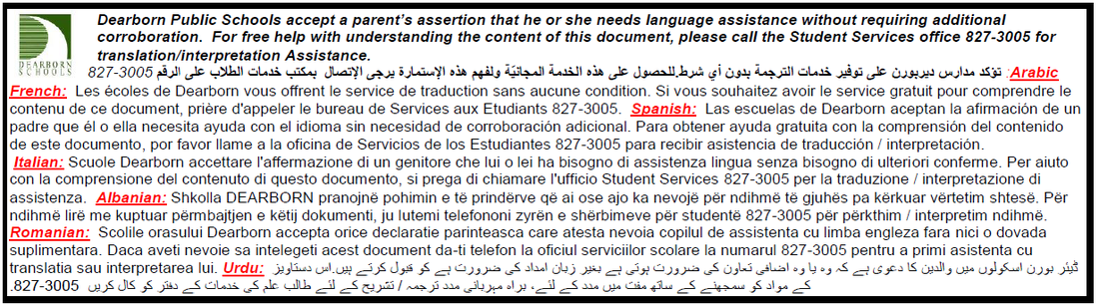

**Course Description:**

* 8th Math is a class which provides a formal development of mathematical skills and concepts necessary for students to succeed in the class. In particular, the instructional program in this course provides for the use of mathematical skills in a wide range of problem-solving situations. Topics include: (1) The Number System (2) Expressions and Equations, (3) Ratio and proportions, (4) Geometry, (5) Statistics and Probability
* **8th grade math Unit Plan 2016-2017**

|  |  |  |
| --- | --- | --- |
| **Month(s)** | **Main Unit** | **Slot Unit** |
| Sept 6th to Sept 30th | The Number System | Expressions and Equations |
| Oct. 1st to Dec. 23th | Expressions and Equations | Expressions and Equations |
| Jan. 9th to Feb 17th | Systems of Equations | Geometry |
| Feb 27th to March 31st | Geometry | Volume |
| April 10th to End-of-year | Statistics and Probability | Multistep Equations |

**8th Math Unit Plan is subject to change at any time.**

**Required Supplies:**

* Composition Notebook
* Folder or Binder
* Pencils and erasers **(No PENS!!!)**
* Planner/ Student ID
* Reading Book

The Eighth Grade will follow PBIS (Positive Behavior Interventions and Support) to promote positive student behavior.

All students will be given a daily planner. The planner is a tool to help you be successful in middle school. Please have your planner available every day at the beginning of each class period.

A 93-100

A- 90-92

B+ 87-89

B 83-86

B- 80-82

C+ 77-79

C 73-76

C- 70-72

D+ 67-69

D 63-66

D- 60-62

E <60

**Grading Policy:**

* **Mathematical Learning = 50% of Final Grade**

This will consist of:

* **Summative Assessments**

(Tests and Quizzes)

* **Formative Assessments**

(S.L.O.T./In-Class Work/Homework)

* **Teamwork and Cooperation = 50% of Final Grade**

This will consist of

* + **Peer-Evaluation**
  + **Self-Evaluation**
  + **Teacher Observation**

**Homework:**

* I will not assign your child homework simply for the sake of keeping him or her busy. The only homework from math class is the result of assignments that have not been finished during class time. Rather, I ask you spend your evenings doing things that are proven to correlate with student success. Eat dinner as a family, read together, play outside, and get your child to bed at a reasonable time.
* If students would like to get extra practice on any topic we cover in class they may do so through khanacademy.org. Each child will set up an account in class, and together we will learn how to search for important concepts.

**Office Hours:**

* If students are in need of extra help, or simply need a quiet place to complete work, they may attend office hours in Mr. Zimmer’s classroom.
* Office hours will be held on Thursday of every week from 3:15pm-4:15pm.
* There is no formal sign-up for office hours. Students are welcome to drop in when they would like. Please make transportation arrangements before attending.

**Extra Credit:**

* Make a Frayer Model Diagram for our classroom work wall. Students may define an important mathematical vocabulary work, and it will be posted on our word wall. Students may receive extra credit twice per marking period.
* Bring in a pack of pencils, pack of colored pencils, glue, a pack of printer paper or a pack of loose leaf papers. You can receive extra credit twice per marking period.

**Parent/Student/Teacher Contact:**

* If you need to contact Mr. Zimmer at any time please do so via email at zimmern@dearbornschools.org.
  + If you would like to speak on the telephone please include your contact information in the email, and I will contact your promptly.
* Please make a habit of check the classroom blog. This will contain important information about assignments, assessments, and upcoming events.

**Absences:**

* If you miss school, you are responsible for getting your make-up work
* You are responsible for getting your missed work and notes during an absence. Collect work from the absent work bin. Copy notes from your classmates and ASK FOR HELP.

**Non Negotiables**

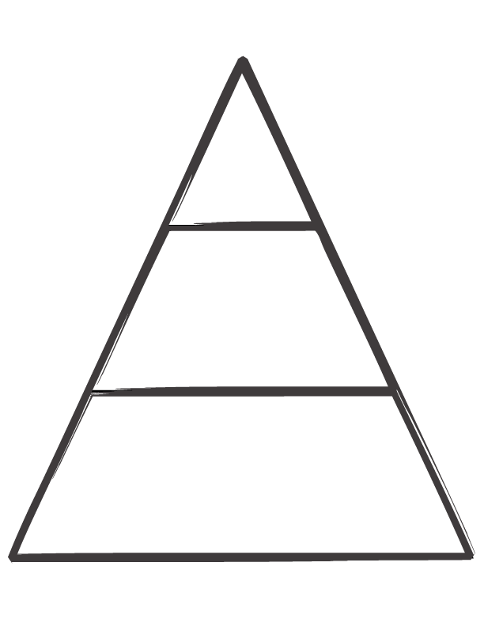

**School non- negotiables**

* Be on Time.

**How can I help my class?**

* Arrive to class prepared with planner and Student ID.
* Bring a positive attitude to school.
* Comply immediately when a reasonable request is made.

**How can I help my group?**

* Always use proper etiquette.

**7th Team non-negotiables**

* Always have something to read.

**How can I help myself?**

* Bring the materials needed for each class.
* Be seated and on task by the time the bell rings.
* Raise your hand and wait to be called on to speak.
* At the end of class: Remain in your seat until the teacher dismisses you.

**Classroom non-negotiables**

Come to class on time and be prepared (pencil, notebook, planner, reading book).

* Treat people with respect, the way you would like them to treat you.
* Raise your hand and wait patiently to be called on.
* Stay in your seat during instruction time, or when anyone is addressing the class.
* Always listen and follow directions the first time.

Dear Parent or Guardian,

I am your son/daughter’s 8th grade math teacher. I am extremely excited to begin this school semester. Our goal is to help your son/daughter to be successful in math. It is important that we all do our part to guarantee success in the class.

Please review the Syllabus and the Expectations in your son/daughter’s planner. I reviewed the course syllabus and PBIS with every student. I would appreciate it, if you and your student reviewed the syllabus and planner together then sign below to indicate that you have read and agree to comply with these policies. If you have any further questions regarding the course or the district policies, please feel free to contact us. Our contact information is above. Please cut the bottom portion of this page and keep the top.

Thank you in advance for your concern and interest in your child’s education.

**I have read and understood Mr. Zimmer’s 8th Grade Math Syllabus**

_________________________________

**Student Name (Printed)**

_________________________________ __________________ ___________

***Student Signature*** **Date Period**

**_________________________________**

**Parent/Guardian Name (Printed)**

_________________________________ _______________________

***Parent/Guardian Signature*****Date**

( )_______________________

**Parent/Guardian Phone Number**