Good Morning, Young Artists!!!

How about a little Lego fun? Have fun making a face and costume. You can use one from your own Lego collection, the Lego Movies or better yet- Make up your own!!!

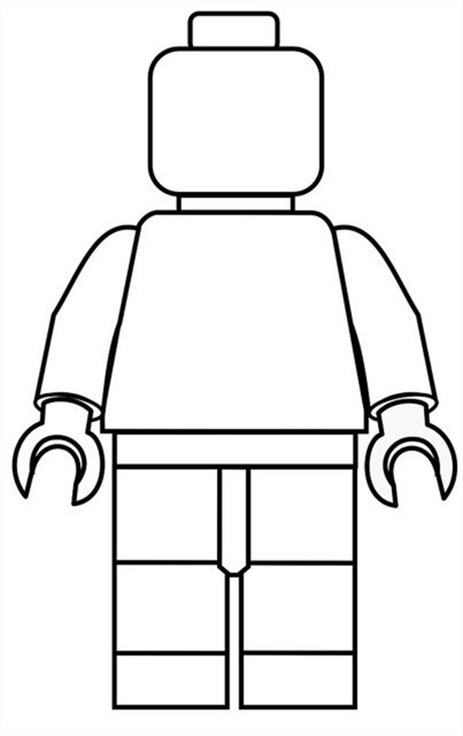

How about making a set of related characters? All SuperHeroes, or animals or robots or family members…..

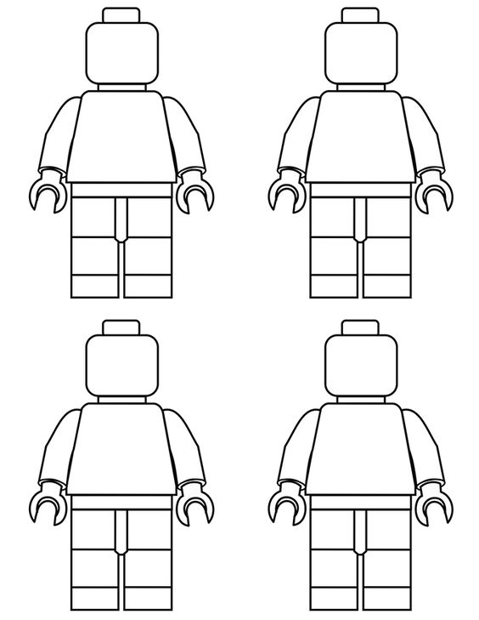

And how about just making some fun faces on the Lgo heads???/

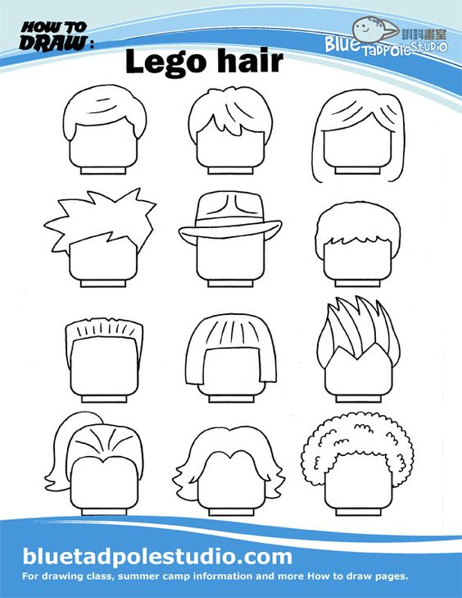

Have fun, I LOVE Lego stuff!

Please do all of your schoolwork, we are all back to grading what you are doing! Get outside for a bit, help out around the house and Be Kind!!!