**TEACHER: Ms. Hojeij/ Mr. Yahya**

**CONTACT INFORMATION:**

**Telephone: (313) 827-7100 BLOG-** [**http://iblog.dearbornschools.org/hojeijz/**](http://iblog.dearbornschools.org/hojeijz/)

[**http://iblog.dearbornschools.org/yahyam/**](http://iblog.dearbornschools.org/yahyam/)

**Email:** [**hojeijz@dearbornschools.org**](mailto:hojeijz@dearbornschools.org) **or yahyam@dearbornschools.org**

**Classroom: 207**

**COURSE DESCRIPTION**: Students will receive continued instruction in reading, writing, speaking, listening and the analysis of literature. These activities will expand student knowledge of different communication formats, focus on the writing process, and exercise abilities through projects, various forms of writing, and journaling activities.

MATERIALS ARE DUE TUESDAY SEPT 4!!!

**REQUIRED MATERIALS:**

* Woodworth Planner
* 1 subject notebook up to 100+ pages has to be **11x9 size** for LANGUAGE ARTS ONLY.
* Loose Leaf Paper

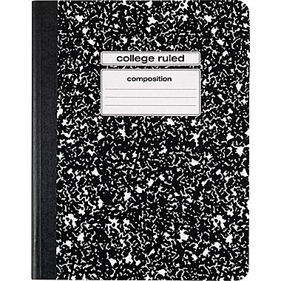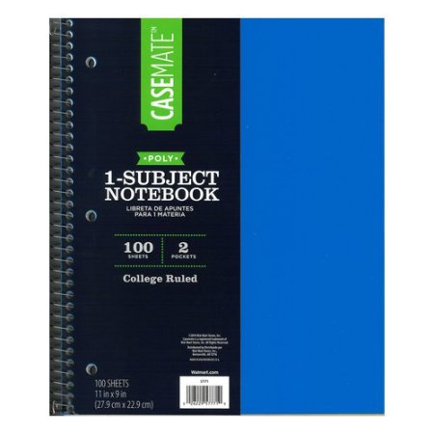

* 1 composition notebook for LANGUAGE ARTS ONLY
* Pencils, Blue/or Black Pens, 1 Red Pen, Pencil Pouch
* Stapler and sharpener
* Highlighters
* Colored Pencils
* Glue Sticks (you will need glue sticks for the rest of the year)
* Folder

**TEACHER POLICIES:**  
My rules and expectations follow the same guidelines as the PBIS program that is fully outlined in your student copy of the Woodworth Code of Conduct. Students must exhibit behavior that reflects **RESPECT, RESPONSIILTY, and SAFETY** at all times.

**Classroom Rules/ Expectations**:

**PROMPT:**  Be in your seat on TIME and ready to start class QUEITLY!! Walk in

and start BELLWORK immediately. If you are not in your seat doing the

BW silently, you will receive a tardy and no credit for that BW.

PROCEDURAL: Follow directions the FIRST time they are given.

**PREPARED/PRODUCTIVE**: **Bring all materials** (planner, paper, pencils & notebooks etc.) to class **daily. NO PASSES to your lockers to get your materials.**

POLITE: Always raise your hand and wait to be called on before speaking  
POSITIVE: RESPECT yourself, your school, and your fellow students and all property

**Consequences and Rewards:**

Consequences will be given using the PBIS system. Students will receive a verbal warning. After the first warning, students will have the appropriate infraction recorded on their FOCUS card. We will also be looking for positive behavior and students will be rewarded when they are doing what they are supposed to do.

**Homework**:

Homework will be assigned several times throughout the week. Homework is to be turned in the following day, unless otherwise directed. Late homework will NOT be accepted. If you are absent the day an assignment is due, you are expected to turn it in the day you return to school. If you are absent the day an assignment is assigned, it is your responsibility to ask about the work you missed. Homework must be completed neatly and thoroughly. Poor quality is not accepted under any circumstances. You may be asked to re-do an assignment if I feel you have not produced your best work.

**Projects**:

You will be expected to complete projects independently, as well as in groups throughout the school year. You will be given class time to work on projects. Please be prepared to work on them at home as well. Projects count as a summative assessment grade. You will be doing novel projects based on books that you will be reading throughout the year.

**Tests/Quizzes**:

Tests and Quizzes make up a large portion of your grade. You will be assessed at the end of a section or a unit. If you are absent the day of a test/quiz, you are to make it up the **very next day.** I expect you to study and be prepared the day of the test.

**Woodworth Retake Summative Policy**

* One retake per summative assessment (depends on the test)
* Record higher score
* Given on a designated Catch-Up Day
* When a student requests to re-take summative assignment, teacher will put date of retake into MISTAR comments and tell student the date of Catch-Up Day
* Teacher will enter which standard/skill student hasn’t met into the comments section of MISTAR in order to clarify reason for retake
* Seventy percent  or below to retake
* Retake should be a different version and/or questions of the original assessment
* All summative grades are included in the policy
* The minimum test/quiz score and standard/skill not met entered in the gradebook will be 50 percent (actual score typed into notes section)  Projects or essays graded using a rubric will not automatically bump up to 50 percent.

**Grading Procedures:**

Students’ grades are based on points earned for tasks completed in and out of class. Points for different assignments will vary. The points are all added together for the final marking period grade. Points are earned for Tests/Essays/Projects (Summative Assessment); Homework, Bellwork, Quizzes and Notebook Organization (Formative Assessments).Constantly check student connect for updates.

GRADING SCALE:

100 A+ 70-72 C-

93-99 A 66-69 D+

90-92 A- 63-65 D

86-89 B+ 60-62 D-

83-85 B 59 or lower E

80-82 B-

76-79 C+

73-75 C

**Student First Name**        **Student Last Name**

**_________________________________ ___________________**

**Parent Name (Please Print)** **Date**

**_________________________________ ___________________**

**Parent Signature** **Date**

**___________________________________** **___________________**

**Student Signature** **Date**

***Dearborn Public Schools accept a parent’s assertion that he or she needs language assistance without requiring additional corroboration*. *For free help with understanding the content of this document, please call  the Student Services office 827-3005 for  translation/interpretation assistance. Arabic***تؤكد مدارس ديربورن على توفير خدمات الترجمة بدون أي شرط.للحصول على هذه الخدمة المجانيّة ولفهم هذه الإستمارة  يرجى الإتصال بمكتب خدمات الطلاب على الرقم 3005-827.***French* Les écoles de Dearborn vous offrent le service de traduction sans aucune condition. Si vous souhaitez avoir le service gratuit pour comprendre le contenu de ce document, prière d'appeler le bureau de Services aux Etudiants 827-3005. *Spanish*Las escuelas de Dearborn aceptan la afirmación de un padre que él o ella necesita ayuda con el idioma sin necesidad de corroboración adicional. Para obtener ayuda gratuita con la comprensión del contenido de este documento, por favor llame a la oficina de Servicios de los Estudiantes 827-3005 para recibir asistencia de traducción / interpretación. *Italian*Scuole Dearborn accettare l'affermazione di un genitore che lui o lei ha bisogno di assistenza lingua senza bisogno di ulterioriconferme. Per aiuto con la comprensione del contenuto di questo documento, si prega di chiamare l'ufficio Student Services 827-3005 per la traduzione / interpretazione di assistenza. *Albanian*Shkolla DEARBORN pranojnë pohimin e të prindërve që ai ose ajo ka nevojë për ndihmë të gjuhës pa kërkuar vërtetim shtesë. Për ndihmë lirë me kuptuar përmbajtjen e këtij dokumenti, ju lutemi telefononi zyrën e shërbimeve për studentë 827-3005 për përkthim / interpretim ndihmë. *Romanian*Scolile orasului Dearborn accepta orice declaratie parinteasca care atesta nevoia copilul de assistenta cu limba engleza fara nici o dovada suplimentara. Daca aveti nevoie sa intelegeti acest document da-ti telefon la oficiul serviciilor scolare la numarul 827-3005 pentru a primi asistenta cu translatia sau interpretarea lui. *Urdu***ڈیئر بورن اسکولوں میں والدین کا دعوی ہے کہ وہ یا وہ اضافی تعاون کی ضرورت ہوتی ہے بغیر زبان امداد کی ضرورت ہے کو قبول کرتے ہیں.اس دستاویز کے مواد کو سمجھنے کے ساتھ مفت میں مدد کے لئے،براہ مہربانی مدد ترجمہ / تشریح کے لئے طالب علم کی خدمات کے دفتر کو کال کریں  3005-827.