Industrialization Changes Social Structure

    Industrialization generated wealth for some, but the laborers of the Industrial Revolution suffered. The working class was overwhelmed with poverty and experienced dangerous and harsh working conditions in factories and unsanitary living conditions in the crowded cities. They had long work hours but received little pay, and they were subject to injury and sickness. In addition, child labor was common among the poor working class families of the Industrial Revolution. However, the Industrial Revolution created wealth among factory owners, shippers, merchants, and bankers. These people made up the new and growing middle class. The middle and upper classes prospered from the advancements in technology that came with industrialization. The middle class transformed social structure in Britain. Members of the middle class often grew wealthier than landowners and aristocrats who had previously dominated society.  
  
Child labor was very common during the Industrial Revolution and children were even more at risk of sickness and injury.  
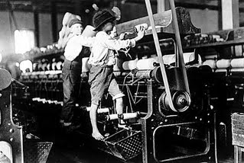  
  
The poor working class lived in the dirty and overcrowded cities where disease was widespread.    
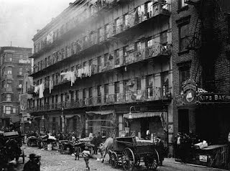

Urbanization brought the people who made up the working class from farms into cities where they served as a labor source for developing factories.  
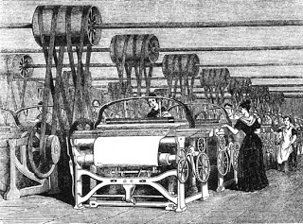

As you read and look at the pictures, describe each of the following AND how they fared in the Industrial Revolution:

Working class:

Children:

Middle class:

Factory owners:

Bankers:

Define “urbanization”.

How did industrialization change the social culture? Explain using examples.