The Urban Game

AIM: How did industrialization reshape the English countryside?

**Objectives:**

* Students will be able to understand the historical process of urbanization in Great Britain
* Students will be able to understand the impact of urbanization on the land and the people
* Students will simulate the haphazard “urban planning” that took place at the beginning of the Industrial Revolution
* Students will be able to understand the problems associated with the lack of urban planning

**Suggested Prior Knowledge:** It is suggested that teachers prepare their students prior to the simulation by covering the following topics—

* How did people live before the Industrial Revolution?
* What changes in agriculture and production made industrialization possible?
* How did new inventions spark industrialization?
* What ingredients are necessary for industrialization to take place?
* Why did the Industrial Revolution begin in Great Britain?

**Materials:**

* Blank piece of legal sized paper
* Pencil with an eraser
* Drawing guide (attached)
* Rounds (attached)
* PowerPoint presentation with Rounds and helpful visuals
* Change over time chart (attached)

**Opening Activity:**

1. Students read Background Material – Urban Game – the year is 1700 and the nation is England. This simulation is based on the development of Manchester, England.
2. Students complete half of the Change Over Time chart – BEFORE Industrialization using the Background Material reading.

**Set-up:** Make sure each student has a pencil, a piece of paper, and a drawing guide. (Students can use whatever symbols they want – they just need to be consistent. The drawing guide may help students who are less artistically confident.) Have them draw the following:

Draw a river across your paper connecting east to west. The river should be about 1 inch wide. Draw a wooden bridge across the river and draw 4 roads originating from each direction. Mark off a portion of the land in your village as the commons (land that can be used by all in the village). Draw 10 houses, 1 church, 1 cemetery, 1 store, 1 pub, 1 coal mine, and lots of trees.

Each student’s paper will look different. See the attached Sample image for a guide. Make sure students are drawing in pencil!

**Activity:** Read each round (you may display each round in the PowerPoint presentation as you go) – ask questions, elicit understanding, explain the events taking place in each round. Then have students add the objects noted. Students should not draw more or less than requested; students should not touch the commons until they are told to do so. This activity can take 2 to 3 days. Be sure to give students enough time to draw and understand the process.

**Closing Activity**: Students complete the other half of the Change Over Time Chart – AFTER Industrialization. You may wish to give students access to the PowerPoint presentation or to their own copy of the text of the rounds so they may refresh their memories of the details.

**Summary Activity:**

1. Student debate – Was it worth it?
2. Students write an essay comparing life before to life after industrialization.

The Urban Game – Background Material

The year is 1700 and the nation is England. The scene is a rural village. Over the next 100 years, a revolution as significant as the Neolithic Revolution will completely change life in your village.

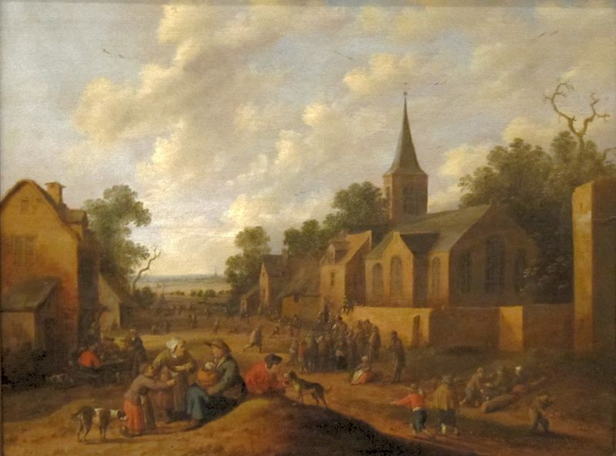Life here in village England is similar to other villages across Europe in the 18th century. Change traditionally comes very slowly. People generally moved at a much slower pace and had access to very little information about the world outside of their village. London, England’s largest city and one of the two real cities Europe, had a population of about 750,000 in 1750. Three out of every four Englishmen were rural and lived in small villages. Villages were inhabited by about 200 to 400 people. The tallest structure in the village was the church. The religion of England was Anglican (Church of England). Home life and work life were integrated as most work was done in nearby fields, in the home, or perhaps in an adjoining workshop.

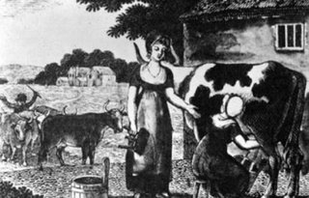The family was an economic unit as well as a social unit. Every member of the family worked very hard from sunup to sundown. Even small children had chores. The homes of villagers were small with earthen floors and inadequate light and ventilation. All members of the family slept in the same room and sometimes shared living quarters with livestock. Sons worked with the father farming and tending livestock. Daughters worked with the mother cooking, cleaning, sewing, and doing other domestic chores. Life expectancy was slightly over 40 years of age. Most people married in their teens and had babies before they were 20. It was common for women to die in childbirth so the average marriage lasted about 15 years. Stepfathers and stepmothers were common. One out of three children died before their first birthday; only one out of two children saw their 21st birthday.

Unlike France, the English were not rigidly divided into social or legal Estates. However, there was a distinct social class system. Most English were poor farmers. A few were middle class like the bourgeoisie of France. For the most part, the middle class lived in London. A small number of individuals were aristocrats and usually owned large tracts of land in the English countryside. For both peasant and aristocrat, the soil was the key to the economy. Land was the source of livelihood and well-being. Having enough land to produce adequate food, or to produce enough to sell, or even to rent, was the key to economic survival. These traditions 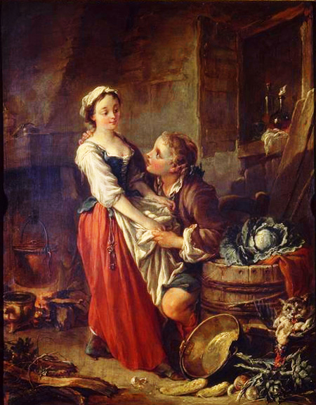concerning land guided daily living. These traditions were designed to ensure the stability and welfare of the greater community. Hence marriages and inheritance were geared to maintaining family property intact. Marriages were arranged by parents to maintain or better the economic status of their sons or daughters. However, not all could get married. A man usually had to own land on which to support a family before he dared marry. It was not uncommon for men to wait until their 30’s when they inherited land from their parents which enabled them to marry. If a woman did not bring land into a marriage, she had to have some kind of dowry. Daughters who inherited property from their parents had to pass it on to their husbands. All land was given to the eldest son (primogeniture) while younger sons might receive cash payment or wait for their older brother to die.

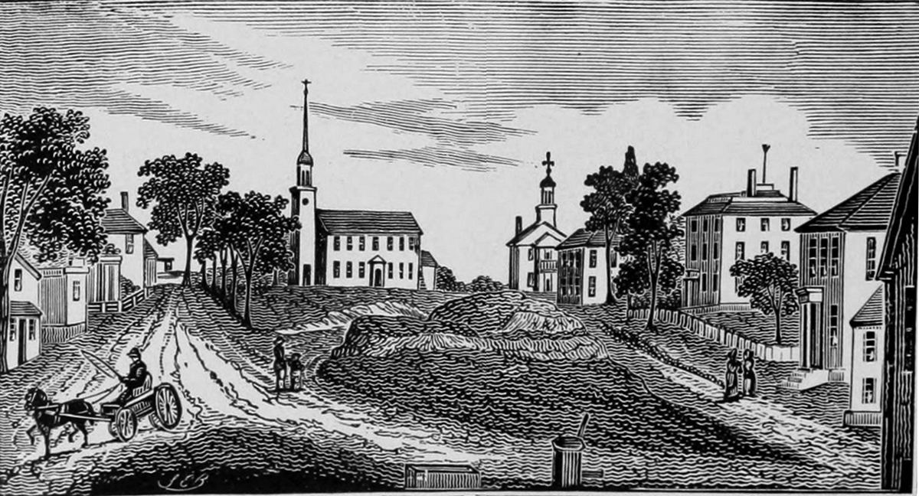The main occupation of England was farming. Unlike today, fences did not separate private and public lands. Every village had a public area called the commons. This land was available to anyone for pasturing, hunting, gathering of firewood, and growing of crops. So poor farmers who did not own their land could eke out a marginal living by depending on the commons. Unlike France, most English peasants or farmers did own their own land, however small.

Villages were connected by a system of dirt roads that became impassable during the wet season. As a result, transportation was often slow and trade beyond the village was not easy. Most English farmers never visited any place further than 25 miles from their birthplace, ever! People made their own food, clothes, furniture, tools, and homes. A few items that could not be produced could be obtained from wandering peddlers.

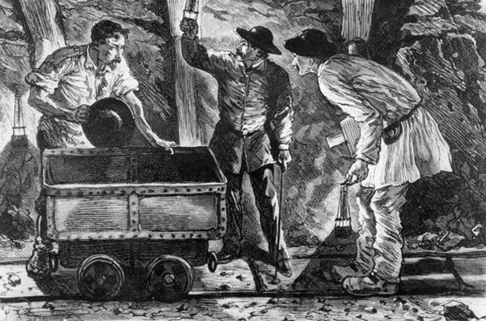

Finally, for fuel, there were two sources: firewood and coal. Nearly every English village had a coal mining operation. These mines employed a small number of village dwellers, especially in the winter. Coal was extracted from pits that were privately owned.

Name: ________________________________________________ Date: _________________

Change over Time: Industrial Revolution

|  |  |  |
| --- | --- | --- |
|  | **BEFORE Industrialization** | **AFTER Industrialization** |
| **People earned a living by…** |  |  |
| **Tools used were usually…** |  |  |
| **People traveled by…** |  |  |
| **Work hours were determined by…** |  |  |
| **The role of children was to…** |  |  |
| **Clothing and food were made by…** |  |  |
| **Sources of power included…** |  |  |
| **Other changes included…** |  |  |

The Urban Game – Rounds

**Round 1** – It is now 1745. England’s geography is unique in that no section of the country is more than 90 miles from the sea and there are many navigable rivers that crisscross the countryside. An enterprising young capitalist (you!) decides to invest money in the construction of a canal. This is not a public venture but rather a private one. The profits from your canal are astonishing! For example, one canal built in 1745, the Oxford Canal, yielded a 100% annual return for its investors for more than 30 years. This new revolution in transportation reduced the prices of raw materials and reduced the costs of transportation drastically. Coal could now be transported from the mine to the towns for half the price of horse-wagon transportation. **Construct the canal (it must be parallel to the river). Since you invested your money, thereby making a tidy profit, build yourself 1 nice home anywhere on the map you would like it to be.**

**Round 2** – It is now 1750. For a variety of different reasons (soap, sanitation, diet) there is a population explosion in England, and your village. The cursed Bubonic Plague which for centuries wiped out your village has been virtually eliminated due to the disposal of sewage in the canals and then ultimately the ocean. **Add 5 houses.**

**Round 3-** It is 1760. The people of your village need a bit more food and goods to meet the needs of the new inhabitants. Coincidentally, a number of other noteworthy events occurred around 1760. First, a number of new mechanical inventions for farms are developed. One is called the seed drill and another is the horse-drawn cultivator. Also, farmers begin to experiment with new, more productive farming practices like crop rotation, new fertilizers, and new livestock breeding techniques. Consequently, farm production is significantly increased. But there is one problem. Most farmers own small tracts of land. Why should they, or how could they, invest in expensive machines when their land is so small? What’s more, it’s almost impossible to buy more land from anyone! At the same time, pressure was placed on Parliament by large and small landowning farmers to make more land available. Where is that land to come from? The Commons, of course! A series of laws called the Enclosure Acts is passed by Parliament. This means that landowners can buy pieces of common land from the government. **Erase half of your commons and add 1 more nice house.**

**Round 4 –** It is now 1773. A man named Richard Arkwright invents a new machine that can spin and weave cloth a hundred times faster than could be done by hand in a farm cottage (the cottage industry/the domestic system/the putting-out system). He called his machine the Water Frame because its principle source of power was water. As a result, the first factory for producing cotton cloth was built. **Add 1 factory. Remember, the cotton factory must be placed on the riverbank. Canal water is not swift enough to generate the power to move the parts of the water frame. *Do not* add any smoke to this factory!**

**Round 5 –** It is now 1774. Workers are needed to work in this new factory. Since many people (women) cannot compete with the spinning and weaving of cloth made in the factory and there are large numbers of poor families who have lost their livelihood due to the Enclosure Acts, people begin moving to your village to find work. **Add 5 houses, 1 church, 1 pub, and 1 store. You may draw additional roads and 1 additional bridge. You may find at this point that you need to erase trees to fit in your new drawings – that’s fine; trees may be erased at any point through the rounds.**

**Round 6 –** The profits from the first textile factory are enormous. It should be no surprise that Richard Arkwright is referred to with two titles: the first millionaire and the father of the factory. New factories are built in your community. The early owners of these factories called themselves capitalists because they had the capital (money) to purchase the raw material, the building, the water frame, pay their workers a fixed wage, and make a profit! **Add 5 new factories.**

**Round 7 –** It is 1780. Unemployed workers from surrounding area flood into your community looking for work. Although wages are very low, they still look attractive to starving families. Housing is in great demand. For the first time a new kind of housing is constructed, called tenements. Here, dozens of families reside under one roof. **Add 5 tenements.**

**Round 8 –** It is now 1780. More workers need to live, eat, shop, drink, and worship. They need social support services to go along with this demand. **Since workers in the factories work 6 days a week, the only day of rest is Sunday. Add 1 church. People flock to your churches so make them convenient for their tired feet. Also, add 1 store, 1 pub, and 1 school for those families wealthy enough to send their children (boys only) to school.**

**Round 9 –** It is now 1782. Workers work long, hard hours in the factories. The average day begins at 6:00am and ends at 9:00pm. There is only a 30-minute break for lunch. After work, exhausted “stressed out” workers stop at their favorite pub for some relaxation. Alcohol begins to be consumed throughout England in record amounts. **Add 2 more pubs.**

**Round 10 –** It is now 1783. Workers barely eke out a marginal existence. There is never enough money to save and some workers go into debt. Few, if any, could afford to send their children to school. Still, there are a few families whose lifestyle is quite affordable, even luxurious. Who are they? They are the large landowning farmers and factory owners. Handsome manor houses are built and some are lavishly furnished with art. These new rich (nouveau riche) are not part of the old aristocratic rich. **Add 2 more special homes.**

**Round 11 –** The year is 1785. A man named James Watt invents a new machine called the steam engine. The steam engine replaces the water frame. First, it is far more efficient. Second, it allows factories to be built away from the river. This source of power is more mobile. Capitalists quickly replace their water frames with steam-powered weaving and spinning machines. The main business in England is still textile manufacturing. **Add 10 factories with smoke. Add smoke to all other pre-existing factories. Also, add 1 nicer house since people continue to get rich.**

**Round 12 –** The year is 1800. A man named Henry Cort has just invented the puddling process. This process makes it possible for coal, which is, fortunately, in abundant supply in England, to be used as the primary fuel in the new iron industry. Consequently, your town is thrust into the “New Age of Heavy Industry.” Large factory districts appear which manufacture iron at low prices, which can then be transported by your canal. **Add 1 new coal mine and a new iron bridge to replace the old wooden bridge.**

**Round 13 –** The year is 1815. Coal miners are busy mining coal because of great demand for home-heating, fuel for their steam engines, and production of iron. In the 1700’s coal miners were adults who worked in the winter to supplement their wages; by the 1800’s they are typically children between the ages of 8 and 14. The work is dangerous and unhealthy. Children become victims of “black lung,” accidents and explosions. Their growth is stunted as they spend most of their 14-hour day stooped over; they are malnourished. Casualty rates go up. **Draw 1 cemetery.**

**Round 14 –** It is 1820. The existing canals and dirt roads cannot accommodate the heavy industrial traffic. New experiments with transportation using the power of a steam engine are tried. The most successful one appears to be a steam-engine that pulls a series of wagons or cars on an iron track. The first railroad is tested and is quite effective. **Add 1 major railroad line connecting your factory districts to your coal mining regions.**

**Round 15 –** It is 1827. This new “revolution” in transportation draws thousands of people to your community. Soon there becomes a surplus of workers. Capitalists who wish to ensure their profits decide to hire women and children over men because they will perform the same factory labor at one-half to one-quarter the price. More and more children leave their homes to work in factories. Unemployed men are unable to find work. Depressed, ashamed, and angry at their wives and children toiling in factories, many men turn to crime and the social life of the pub. For the first time in England’s history, alcoholism appears in epidemic proportions. Family life that existed for hundreds of years in England is disrupted. Family members seldom eat together or see each other. **Add 1 jail and 2 pubs.**

**Round 16 –** It is 1835. Using steam engines, iron, and soon steel, British manufacturers introduced power-driven machinery in many industries. The production of shoes, clothing, ammunition, and furniture became mechanized, as did printing and paper-making. People used machines to cut and finish lumber, to process foods, and to make other machines. Some new inventions and innovative processes had important by-products. These by-products often developed into separate industries. For example, iron smelteries used coke, a by-product of coal, to improve the smelting process. Then someone discovered that the gasses that coal released during the coke-making process could be burned to give light. During the 1830s London and other large towns became the first communities to pipe in gas to burn in streetlights. Soon all around England hundreds of towns used gas to light streets and homes. **Add 20 street lamps.**

**Round 17 –** It is 1838. Let’s look at the working conditions in the factories. The two most important factories are textile and iron (steel). Working conditions were appalling. Many workers contracted the deadly factory fever or white lung disease; it was probably cancer, tuberculosis, or emphysema. Other workers were injured on the job in factory accidents. Children, weakened from lack of proper sleep or diet, stumbled into machinery and were mutilated. Women’s long hair came undone and caught in moving machinery. Regardless, if you were unable to work, you were fired. There was no health insurance. There was always a daily line of unemployed workers waiting to fill vacant jobs. **Add 2 hospitals and 1 more cemetery.**

**Round 18 –** It is 1840. The need for quicker and cheaper transportation quickens. Coal, iron, finished products, and raw materials must all be transported from one area of England to another. In the late 1830’s, a devastating potato famine drove hundreds of thousands of Irish to England. Here was the cheapest of labor possible to build more railroads. **Add 1 more railroad line.**

**Round 19 –** It is 1842. By this year, several million acres of good English land has been enclosed and sold to private parties. This created England’s landless poor and the economic benefits for the rich are obvious. These large landowning farmers purchase the newest power-driven machinery and can easily grow enough food to feed the working class of England. The small landowning famer is crushed by the enclosed commons. They cannot afford the machinery and cannot grow food profitably. Thousands of these folks leave their villages (where their ancestors had lived for hundreds of years) and move to towns and cities looking for work to feed their families. Some refused to leave but took jobs working for large landowning farmers. By the thousands, they moved to the bleak, uninviting towns of the north in new cotton mills. **Add 20 houses, 5 restaurants, 2 stores, 1 church, 5 factories, 1 pub, and 1 nicer house.**

**Round 20 –** It is 1845. There are some advantages for many of the urban dwellers. City life is quite different from country life. For the small but growing middle classes, a whole new cultural life is available. Museums, theatres, opera, restaurants, plays and concerts are made available. Whereas before only the aristocrats could afford the arts, now the middle class enjoys the fine life of culture and good living. **Add 2 theatres, 1 restaurant, and 2 private schools.**

**Round 21 –** It is 1850. There are no pollution controls so the air in your community looks dark. Windows, walls, even trees are covered with layers of soot and coke. The river that once flowed through your quiet village for hundreds of years is now unfit for drinking, bathing, or laundry. Malignant tumors grown in people’s bodies and the term cancer is first used in the medical profession. The average life expectancy for the poor classes is now 30 years of age. Your city is overcrowded and shrouded in factory smoke. The noise, the loss of privacy, the loss of family unity, shatters the peace of the old ways. Suicide rates double, then triple. **To accommodate the victims of urban life, add 1 cemetery, 1 jail, and 1 hospital.**