C:\Users\mcgladb\AppData\Local\Microsoft\Windows\Temporary Internet Files\Content.IE5\10Z1IMOP\MC900335508[1].wmfLet’s Look at World Religions: Buddhism

1. Buddhism is the largest religion in the world today.
2. There are over million Buddhists in the world today.
3. The countries with the largest Buddhist populations are:
4. The man who became the Buddha’s name was was born in Nepal to a rich and powerful family.
5. One of the main symbols of Buddhism is the because it represents
6. The holy book of the Buddhists is called the .
7. means “enlightenment”
8. How are Buddhism and Hinduism related?
9. The are the heart of the teachings of Buddha.
   1. Life is full of sufferings.
   2. Cravings are the root of sufferings.
   3. Suffering ends when craving ends.
   4. It is possible to stop cravings by following the Noble Eightfold Path.
10. Eightfold Path: (On the board)

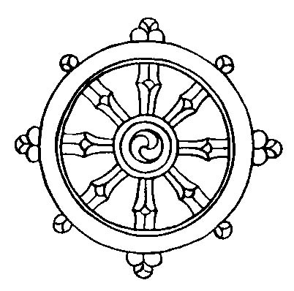

1. Buddhism adopted these ideas from Hinduism….(explain)
2. In Buddhism, the ultimate goal is (release from sufferings).
3. Explain which parts of the Eightfold Path you try to follow in your day to day life. Give examples of how you try to do so.