Hinduism

**Directions:** *Create a neat, colorful infographic about Hinduism. It needs to be cohesive (interrelated).*

***An infographic is a way of presenting information in a visual manner.*** *It includes both info(rmation) + graphics (pictures).*

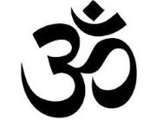Include the following vocabulary:

* Vedas
* Mokhsa
* Brahman (Brahma, Vishnu, Shiva)
* Reincarnation
* Karma
* Dharma
* Caste System

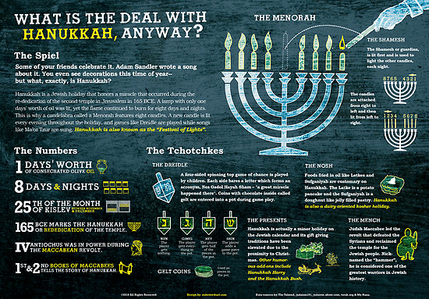

Examples:

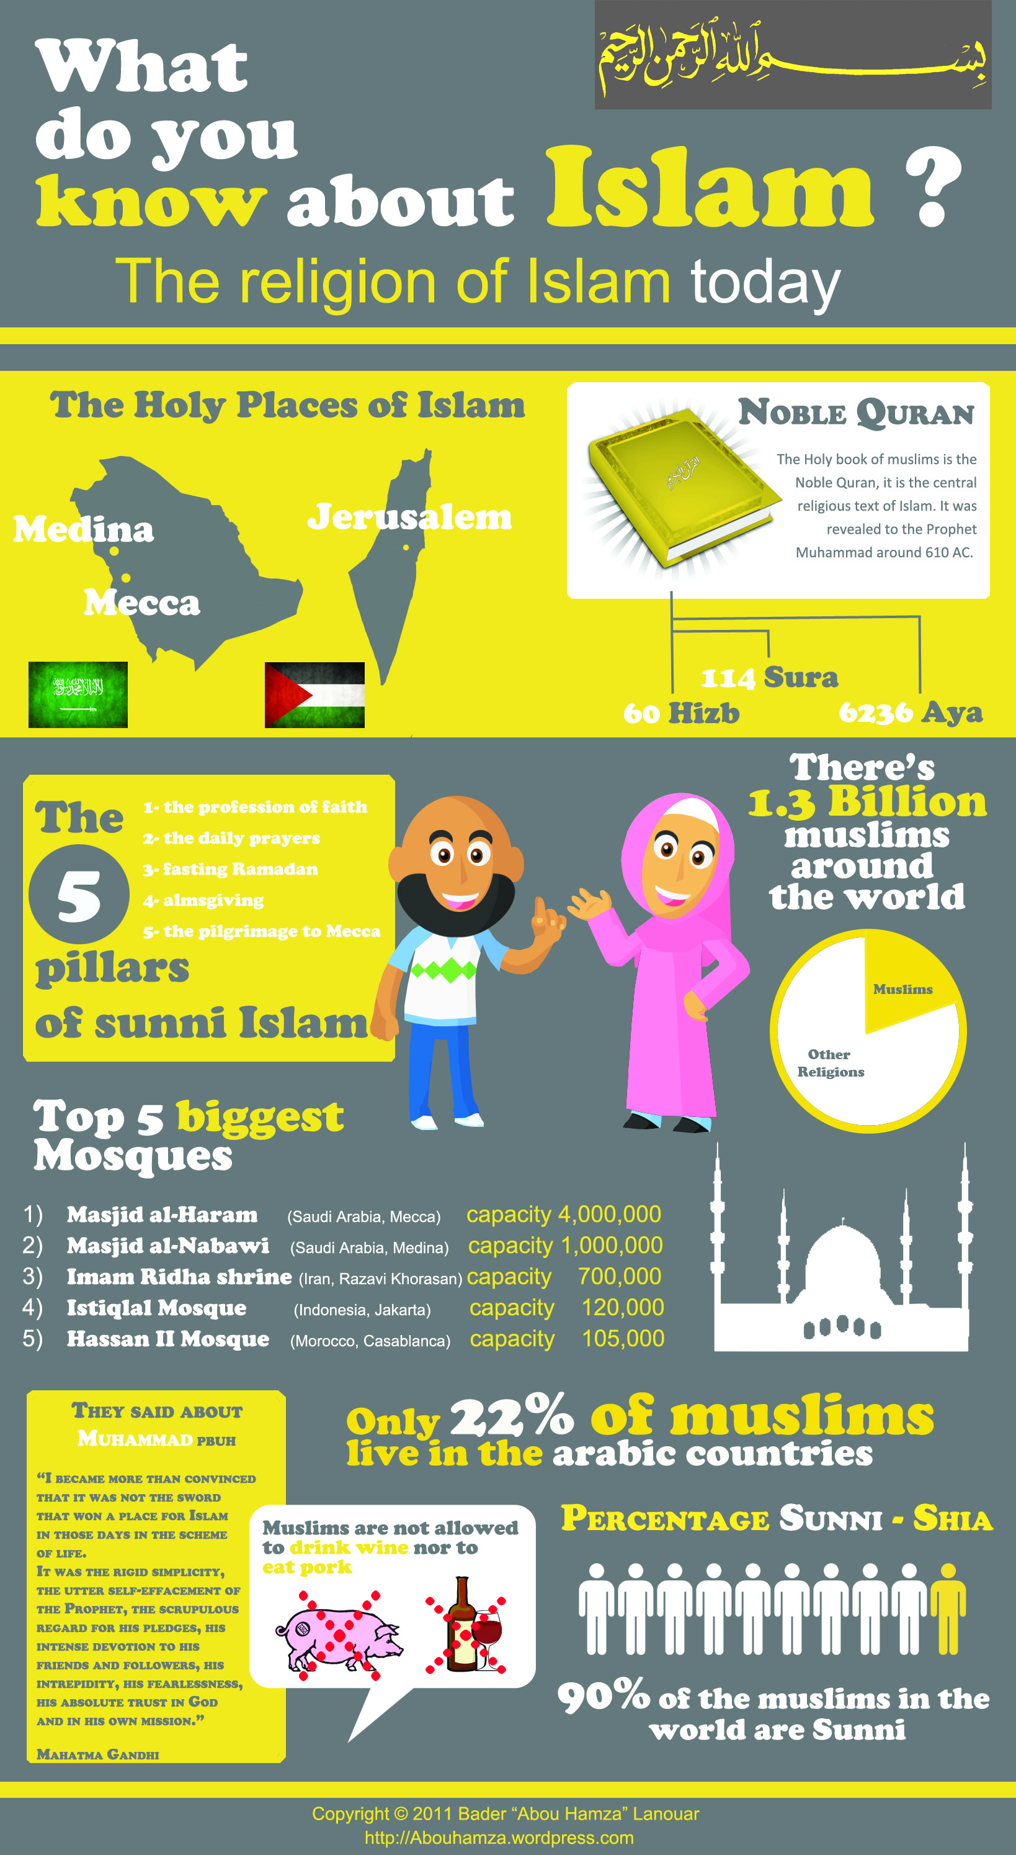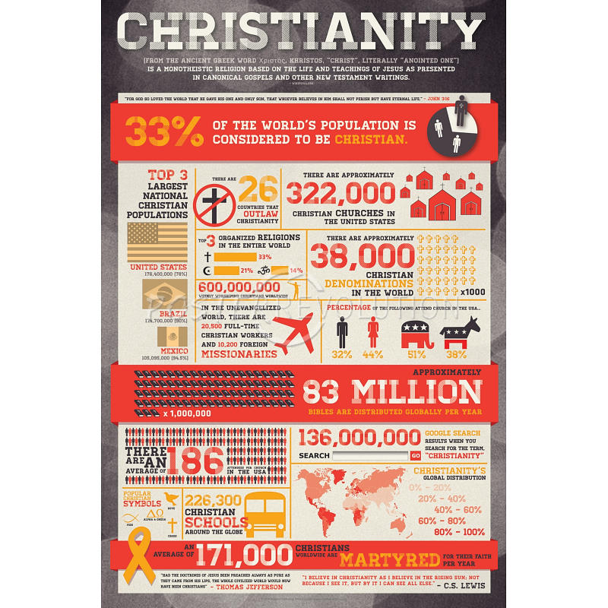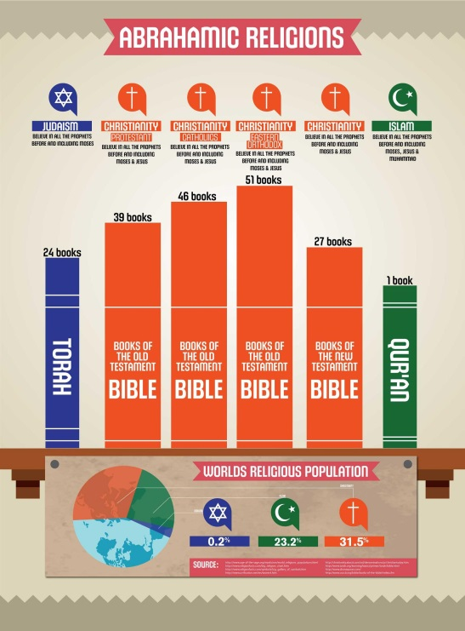

**Introduction to Hinduism (Talk to text ☺)**

Hinduism is the religion of the majority of people in India and Nepal. It also exists among significant populations outside of the sub-continent and has over 900 million adherents worldwide.

In some ways Hinduism is the oldest living religion in the world, or at least elements within it stretch back many thousands of years. Yet Hinduism resists easy definition partly because of the vast array of practices and beliefs found within it.

Unlike most other religions, Hinduism has no single founder, no single scripture, and no commonly agreed set of teachings. Throughout its extensive history, there have been many key figures teaching different philosophies and writing numerous holy books. For these reasons, writers often refer to Hinduism as 'a way of life' or 'a family of religions' rather than a single religion.

**Defining Hinduism**

Some claim that one is 'born a Hindu', but there are now many Hindus of non-Indian descent. Others claim that its core feature is belief in an impersonal Supreme, but important strands have long described and worshipped a personal God. Outsiders often criticize Hindus as being polytheistic, but many adherents claim to be monotheists.

C:\Users\mcgladb\AppData\Local\Microsoft\Windows\Temporary Internet Files\Content.IE5\S5TSRCHO\MC900435308[1].wmfBrahma is the first god in the Hindu triumvirate, or trimurti. The triumvirate consists of three gods who are responsible for the creation, upkeep and destruction of the world. The other two gods are **Vishnu** and **Shiva**. Vishnu is the preserver of the universe, while Shiva's role is to destroy it in order to re-create. **Brahma**'s job was creation of the world and all creatures. His name should not be confused with **Brahman**, who is the supreme God force present within all things.

**Karma** is a Sanskrit word whose literal meaning is 'action'. It refers to the law that every action has an equal reaction either immediately or at some point in the future. Good or virtuous actions, actions in harmony with dharma, will have good reactions or responses and bad actions, actions against dharma, will have the opposite effect.

At death many Hindus believe the soul is **reincarnated**, or carried by a subtle body into a new physical body which can be a human or non-human form (an animal or divine being), depending on one’s karma. The goal of liberation (**moksha**) is to make us free from this cycle of action and reaction, and from rebirth.

The code of behavior is one's dharma. This is determined by the place in society and the duties associated with it. There are four main social positions or **castes**; Brahmins (priests and teachers) Kshatriyas (rulers and soldiers), Vaishyas (merchants) and Shudras (workers).

Although it is not easy to define Hinduism, we can say that it is rooted in India, most Hindus revere a body of texts as sacred scripture known as the Veda, and most Hindus draw on a common system of values known as **dharma**.

**Fast Facts:**

* Hinduism **originated around the Indus Valley** near the River Indus in modern day Pakistan.
* About 80% of the Indian population regard themselves as Hindu.
* The main Hindu texts are the **Vedas** and their supplements (books based on the Vedas). Veda is a Sanskrit word meaning 'knowledge'.
* Hindus celebrate many **holy days**, but the Festival of Lights, **Diwali** is the best known.