World War I Day One

Dates of the Conflict
28 July 1914 – 11 November 1918
(4 years, 3 months and 2 weeks)

Location
Europe, Africa, the Middle East, the Pacific Islands, China and off the coast of South and North America

Result
- Allied victory
- End of the German, Russian, Ottoman, and Austro-Hungarian empires
- Formation of new countries in Europe and the Middle East
- Transfer of German colonies and regions of the former Ottoman Empire to other powers
- Establishment of the League of Nations.

Allied Powers | Central Powers
France  United Kingdom  Australia  Canada  India  Newfoundland  New Zealand  South Africa  Russia  Italy (1915–18)  United States (1917–18)  Japan  Romania (1916–18)  Serbia  Belgium  Greece (1917–18)  Portugal (1916–18)  Montenegro  Siam (1917–18) | Germany  Austria-Hungary  Ottoman Empire  Bulgaria (1915–18)

Based on the film we watched today and the chart above explain how a Serbian man assassinating an Austrian man lead to a war that cause the deaths of millions.

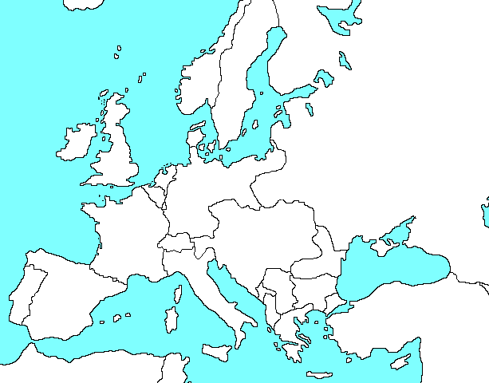
__________________________________________________________________________________________________________________________________________________________________________________________________________________________________________________________________________________________________________________________________________________________________________________________________________________________________________________________________________________________________________
Use your textbook to label to combatants of WWI and then shade in the Allied Powers Blue and the Central Powers Red.

