Limits and Derivatives

1. lim $\frac{\frac{3}{x}-3}{x-1}$ is equal to

x→1

1. Calculate lim $\frac{3+x-2x^{2}}{4x^{2}+9}$

x→∞

1. Let $\left\{\begin{aligned}f\left(x\right)= \frac{\sqrt{x+11}-4}{x-5} if x≠5, \\ f\left(5\right)=c\end{aligned}\right.$ and let f be continuous at x=5. Determine the possible value of c.
2. If sin x = ln y and 0<x<π, then determine $\frac{dy}{dx}$ in terms of x.
3. The equation of the tangent to the curve y = ex ln x, where x =1, is
4. Y = ex b) ex+1 c) y = e(x-1)

d) y = ex + 1 e) y = x-1

1. If y = ln(3x+6), then calculate $\frac{d^{2}y}{dx^{2}}$
2. Calculate lim $\frac{\tan\left(\frac{π}{4}+h\right)-1}{h}$

h→0

1. If f(x) = x cos x, the evaluate f ‘ (π/2) .

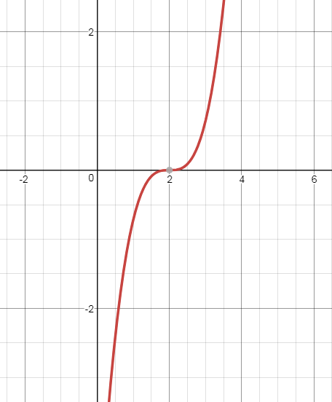

1. The graph of a function h is shown in here. Which of these statements is (are) true?
2. The first derivatives is never negative
3. The second derivative is constant
4. The first and second derivatives are equal to zero at the same point
5. I only b) III only c) I and II

d) I and III e) I, II and III

1. If f(x) is continuous at the point where x=a, which of the following statements may be false
2. If sin(xy) = y, then determine $\frac{dy}{dx}$

|  |  |  |  |  |
| --- | --- | --- | --- | --- |
| X | f | f’ | g | g’ |
| 1 | 2 | ½ | -3 | 5 |
| 2 | 3 | 1 | 0 | 4 |
| 3 | 4 | 2 | 2 | 3 |
| 4 | 6 | 4 | 3 | 1/2 |

1. The table shows the values of differentiable functions f and g

If P(x) = $\frac{f(x)}{g(x)}$, the evaluate P’(3)

|  |  |  |  |  |
| --- | --- | --- | --- | --- |
| X | f | f’ | g | g’ |
| 1 | 2 | ½ | -3 | 5 |
| 2 | 3 | 1 | 0 | 4 |
| 3 | 4 | 2 | 2 | 3 |
| 4 | 6 | 4 | 3 | 1/2 |

1. The table shows the values of differentiable functions f and g

If M(x) = f(x) ∙ g(x) , then evaluate M’(3)

|  |  |  |  |  |
| --- | --- | --- | --- | --- |
| X | f | f’ | g | g’ |
| 1 | 2 | ½ | -3 | 5 |
| 2 | 3 | 1 | 0 | 4 |
| 3 | 4 | 2 | 2 | 3 |
| 4 | 6 | 4 | 3 | 1/2 |

1. K(x) = g-1(x). Determine K’(3)

Applications

1. The maximum value of the function f(x) = x4 – 4x3 + 6 on [1,4] is
2. 1 b) 0 c) 3 d) 6 e) -27
3. If the displacement from the origin of a particle moving along the x-axis is given by s= 3 + (t-2)4, then the number of times the particle reverses direction is
4. 0 b) 1 c) 2 d) 3 e) 4
5. If the displacement from the origin of a particle moving along the x-axis is given by s= 3 + (t-2)3, then the number of times the particle reverses direction is
6. 0 b) 1 c) 2 d) 3 e) 4
7. The curve 2x2y +y2 = 2x + 13 passes through (3,1). Use the line tangent to the curve there to find the approximate value of y at x=2.8.
8. The position of a moving object is given by P(t) = (3t, et). Its acceleration is
9. Undefined
10. Constant in both magnitude and direction
11. Constant in magnitude only
12. Constant in direction only
13. Constant in neither magnitude and direction

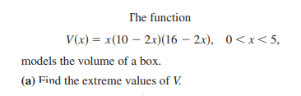

6.

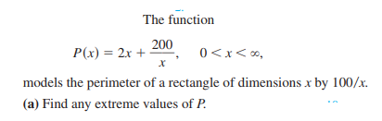

and interpret it in the context of the problem

1. 

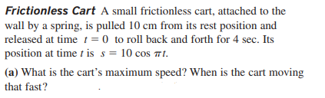

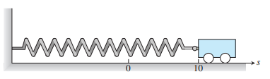

1. The volume of a box is given by V(x) = x(20-2x)(25-2x). What are the dimensions that will maximize the volume?
2. 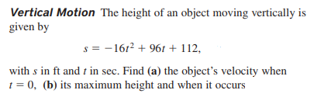
3. 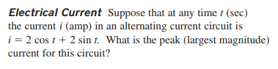
4. The sum of two non-negative numbers is 30. Find the numbers if the sum of their squares is the largest possible.
5. What is the largest possible area for a right triangle whose hypotenuse is 5 cm long, and what are its dimensions

Key

Limits and derivatives

1. -3
2. -1/2
3. 1/6
4. esinx▪cos x
5. C
$\frac{-16}{{(4x+1)}^{2}}$

$2$

6. –π/2
7. D
8. C
$\frac{y\cos{xy}}{1-xcos xy}$

9. -2
10. 16
11. 2

Aplications

1. D
2. B
3. A
4. 1.1
5. D
6. 144
7. The perimeter has a maximum when the rectangle is a square with the side 10. P max = 40 units
8. Area has a maximum when the rectangle is a square with side of 2.
9. Speed max = +/- 10π. The car reaches this max speed at t = ½, 3/2, 5/2 7/2 and when its location is at 0
10. 3.68, 12.64, 17.64
11. A) 96ft/sec

B) 256 ft

12. 2

13. both numbers are 15

14. 25/4 = 6.25 cm2