Differentiation and Limits No CALCULATOR!!!!!

1. What is the **minimum value of the slope of the curve** y = x5 + x3 – 2x?
2. Determine the point on the curve y = $\sqrt{2x+1}$ at which the tangent is parallel to the line x – 3y = 6
3. The function f(x) = x4 -4x2 has
4. One local minimum and two local maxima
5. One local minimum and one local maximum
6. Two local minima and no local minimum
7. One local minimum and no local maximum
8. Two local minima and one local maximum
9. The number of inflection points (change in curvature) of the function in #3 is
10. 0 b) 1
11. 2 d) 3
12. 4
13. The maximum value of the function y = -4 $x\sqrt{2-x}$ is….. Round your answer to the nearest hundredth.

In questions 6- 9, the position of a particle moving along a horizontal line y = 6 is given by

s = t3 -6t2 +12t – 8

1. For what time interval(s) does the object move to the right?
2. What is the minimum value of its speed?
3. For what time interval(s) is its acceleration positive
4. What is the particles location at t = 5? Is the particle speeding up or slowing down at this location?
5. The position of a particle moving on a line is given by s =(-5+(t-2)2)2 . Answer the following questions and remember NO CALCULATOR.
6. What is the initial position of the particle relative to (0,0)
7. What is the maximum displacement during the interval -0≤ t ≤ 4? Prove that this is a max not a min.
8. Is velocity + or – during the interval (0,2)
9. When is the acceleration zero?
10. What is the velocity when the acceleration is zero?
11. The two tangents that can be drawn from point (3,5) to the parabola y = x2 have slopes
12. 1 and 5 b) a and 4 c) 2 and 10
13. 2 and -1/2 e) 2 and 4
14. The function g(x) = $\frac{x^{2}-9}{3x-9}$ has
15. A vertical asymptote at x=3 b) a horizontal asymptote at y=1/3
16. A removable discontinuity at x=3 d) an infinite discontinuity at x=3
17. No asymptotes or discontinuities
18. Calculate the limit $\lim_{x→0}{\frac{sinx}{x^{2}+3x}}$
19. $\lim_{x→∞}{\frac{2x^{2}+1}{(2-x)(2+x)}}$ is
20. -4 b. -2 c. 1 d. 2 e. DNE
21. 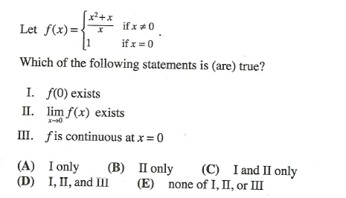

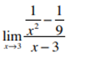

1. Calculate the limit
2. If f(x) = cosx sin3x, then f’(π/6) is equal to
3. ½ b) - $\sqrt{3}$/2 c) 0 d) 1 e) -1/2
4. If y = f(x2) and f’(x) = then dy/dx is equal to:
5. $2x\sqrt{5x^{2}-1}$ b. $\sqrt{5x-1}$ c. 2x $\sqrt{5x-1}$ d. none of these
6. If f(x) = $\frac{sinx^{2}}{x^{2}}$, then find f’(x).
7. Suppose f(3) =2, f’(3) = 5 and f’’(3) =-2. Then $\frac{d^{2}}{dx^{2}}(f^{2}\left(x\right))$ at x=3 is equal to
8. -20 b. 10 c. 20 d. 38 e. 42