Name____________________________

1.) Find the equations of the tangent and normal line to the Cissoid of Diovles y2(2-x)=x3 at x=1.

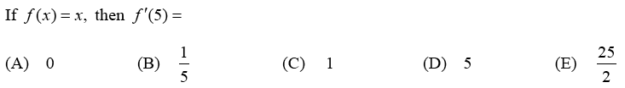

2.)

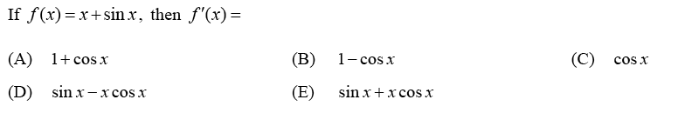

3.)

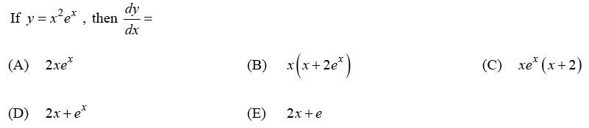

4.)

5.) $f\left(x\right)=\ln\left(x\right)$. $f^{'}\left(3\right)=$

A. 3 B. 1 C. $\frac{1}{2}$ D. $\frac{1}{3}$ E. $\frac{1}{9}$

6.) $f\left(x\right)=2x^{3}+2\sqrt{x}+\frac{3}{x}$ $f^{'}\left(1\right)=$

A. –3 B. 0 C. $1$ D. $4$ E. $10$

|  |  |
| --- | --- |
| **x** | ***f(x)*** |
| 2 | 7 |
| 4 | 18 |
| 6 | 22 |
| 8 | 25 |
| 10 | 21 |

(7) A table of f(x) is given at right. Find the best possible estimate of $f^{'}\left(5\right)$ using this table.

A. –3 B. –2 C. 1 D. 2 E. 3

8.) $f\left(x\right)={\left(3x+1\right)}^{10}$ $f^{'}\left(0\right)=$

A. 196830 B. 590490 C. –10 D. 30 E. 47

9.) Find $\frac{dy}{dx}$ if $\sin\left(6y\right)=\cos\left(3x\right)$.

10.) $6x+8x^{2}y^{3}-2y=18$

Find $\frac{dy}{dx}$ at $\left(1,2\right)$

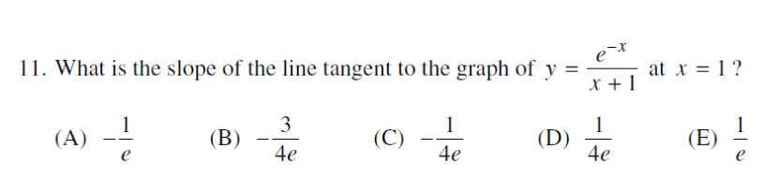

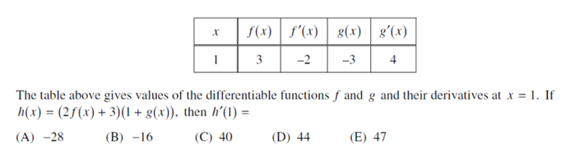

12.

|  |  |  |  |  |  |  |  |
| --- | --- | --- | --- | --- | --- | --- | --- |
|  | $$f\left(x\right)$$ | **P, Q, C, or none** | $$f^{'}(x)$$ | **Ans.** |  |  | **Answers** |
| **1** | $$\frac{2}{3}\left(5^{x}\right)$$ |  |  |  |  | $$α$$ | $$18\cos\left(6x\right)$$ |
| **2** | $$\frac{5}{x^{9}}$$ |  |  |  |  | $$β$$ | $$11\sec\left(11x\right)\tan\left(11x\right)$$ |
| **3** | $$6x^{11}\cos\left(x\right)$$ |  |  |  |  | $$γ$$ | $$\frac{2}{3}\left(5^{x}\ln\left(5\right)\right)$$ |
| **4** | $$\left(3x+5\right)e^{x}$$ |  |  |  |  | $$δ$$ | $$\frac{x}{\sqrt{x^{2}+8}}$$ |
| **5** | $$\frac{\cos\left(x\right)}{e^{x}}$$ |  |  |  |  | $$ε$$ | $$\frac{2}{x}$$ |
| **6** | $$3\sin\left(6x\right)$$ |  |  |  |  | $$ζ$$ | $$\frac{5x\cos\left(5x\right)-3\sin\left(5x\right)}{x^{4}}$$ |
| **7** | $$e^{-3x}$$ |  |  |  |  | $$η$$ | $$e^{x}\left(3x+8\right)$$ |
| **8** | $$\ln\left(3x^{2}\right)$$ |  |  |  |  | $$θ$$ | $$-\frac{6}{{\left(2x+1\right)}^{2}}$$ |
| **9** | $$\frac{1}{x}+\frac{3}{x^{2}}$$ |  |  |  |  | $$ϑ$$ | $${6x^{9}e}^{x^{2}}\left(5+x^{2}\right)$$ |
| **10** | $$\sec\left(11x\right)$$ |  |  |  |  | $$κ$$ | $$-\frac{45}{x^{10}}$$ |
| **11** | $$\ln\left(x^{3}\right)$$ |  |  |  |  | $$λ$$ | $$-\frac{1}{x^{2}}-\frac{6}{x^{3}}$$ |
| **12** | $$\sqrt{x^{2}+8}$$ |  |  |  |  | $$μ$$ | $$-120xe^{5x^{2}}$$ |
| **13** | $$3x^{10}e^{x^{2}}$$ |  |  |  |  | $$ν$$ | $$\cot\left(x\right)$$ |
| **14** | $$\frac{\sin\left(5x\right)}{x^{3}}$$ |  |  |  |  | $$ξ$$ | $$\frac{3}{x}$$ |
| **15** | $${-12e}^{5x^{2}}$$ |  |  |  |  | $$π$$ | $$6x^{10}\left(11\cos\left(x\right)-xsin\left(x\right)\right)$$ |
| **16** | $$\ln\left(\sin\left(x\right)\right)$$ |  |  |  |  | $$ϖ$$ | $$-3e^{-3x}$$ |
| **17** | $$\frac{3}{2x+1}$$ |  |  |  |  | $$φ$$ | $$-\frac{\sin\left(x\right)+\cos\left(x\right)}{e^{x}}$$ |

Solutions

1. Tangent y=2x-1, normal y= $-\frac{1}{2}x+\frac{3}{2}$
2. C
3. A
4. C
5. D
6. D
7. D
8. D

$\frac{dy}{dx}=-\frac{\sin\left(3x\right)}{2\cos\left(6x\right)}$

$\frac{dy}{dx}=-\frac{67}{47}$

Matching

$$1-γ$$

$$2-κ$$

$$3-π$$

$$4-η$$

$$5-φ$$

$$6-α$$

$$7-ϖ$$

$$8-ε$$

$$9-λ$$

$$10-β$$

$$11-ξ$$

$$12-δ$$

$$13-ϑ$$

$$14-ζ$$

$$15-μ$$

$$16-ν$$

$$17-θ$$

1. B
2. D