Geometry Semester 1 Review Name:

*Unit 1 – Essential Geometry*

1. For each of the geometric statements below, write in words what the statement is representing and then draw a picture of the geometric statement.

|  |  |  |
| --- | --- | --- |
| Geometric Statement | What is this saying? | Draw a picture |
|  |  |  |
|  |  |  |
|  |  |  |
|  |  |  |
|  |  |  |
|  |  |  |
|  |  |  |

2. Draw and use the proper markings to show the following:

a) The perpendicular bisector of a segment.

b) The angle bisector of an angle.

c) The midpoint of a segment.

3. Recall angle pairs. Answer each question and **draw a sketch** of each pair of angles below.

a) What is the relationship between vertical angles?

b) What is the relationship between angles that form a linear pair?

c) What are complementary angles?

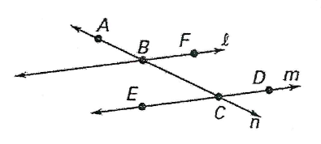d) What are supplementary angles?

e)Use the figure to the right to name two pairs of opposite rays

f) Use the figure to the right to name 3 collinear points.

g) Points B and E are always____________

4. Find the distance between the point (7,5) and the point (9, -1)? Then find the midpoint.

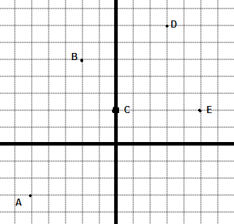

5. Use the figure to right.

a) A car travels from A to B and then to E. What is the total distance?

b) If F is the midpoint of DC, where is the location of F?

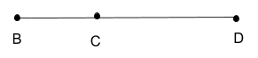6. If BD=74, BC=2x+7, and CD=4x+1, find x. Then find BC and CD.

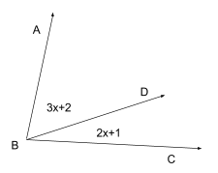

7. If m∠ABC=63, find x. Then find If m<ABC is 83o, determine m∠ABD and m∠DBC.

8. Complete the following proofs using a 2 column proof:

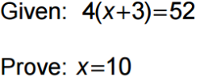a)

b) If <A and <B are complementary, and <C and <B are complementary, which of the following can represent measures of <A and <C?

a)m<A= 30o,m <C = 60o

b) m<A= 50o,m <C = 50o

c) m<A= 120o,m <C = 60o

d

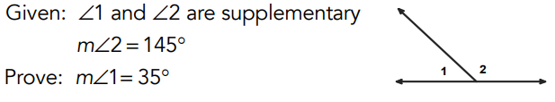9.

*Unit 2 – Properties of Parallel and Perpendicular Lines*

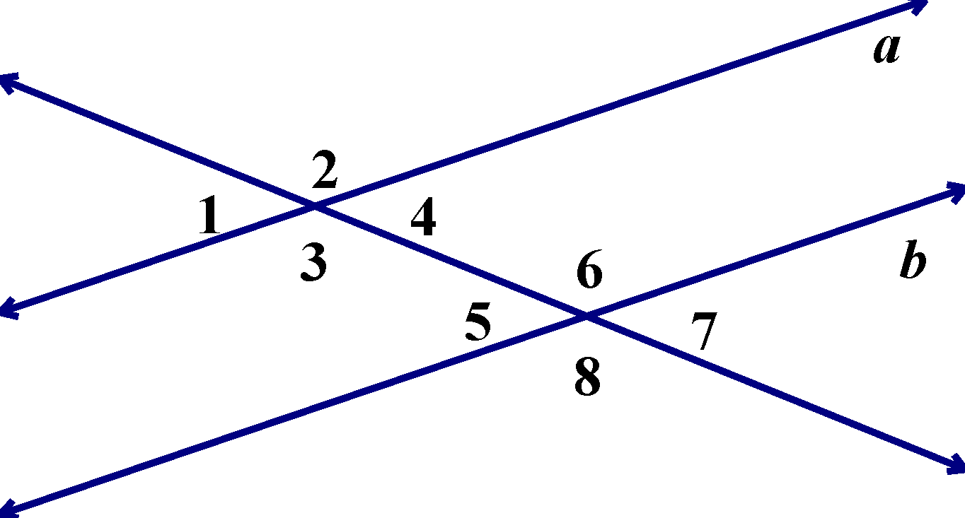

Use the following diagram for questions 9 – 21. 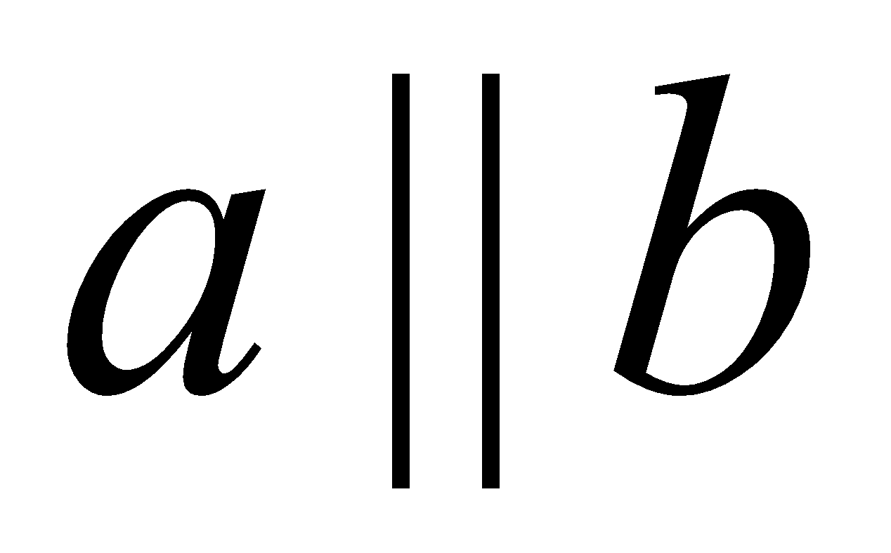.

10. Name all the pairs of vertical angles.

11. Name all the pairs of same-side interior angles.

12. Name all the alternate interior angles.

13. Name all the corresponding angles.

14. Name all same-side exterior angles.

15. Name all alternate exterior angles.

16. Name 4 linear pairs.

17. Which of the above types of angles are congruent? Which of the above type are supplementary?

18. Complete the following proof:

Given: 

Prove: 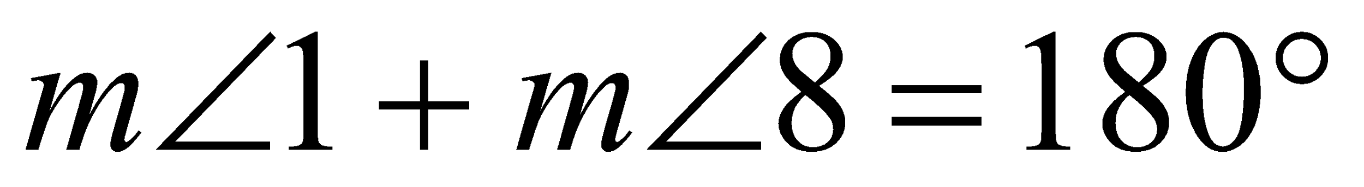

|  |  |
| --- | --- |
| Statements | Justifications |
| 1. | 1. |
| 2. | 2. |
| 3. | 3. Corresponding angles of parallel lines are congruent |
| 4. | 4. |

19. Complete the following proof:

Given: 

Prove: 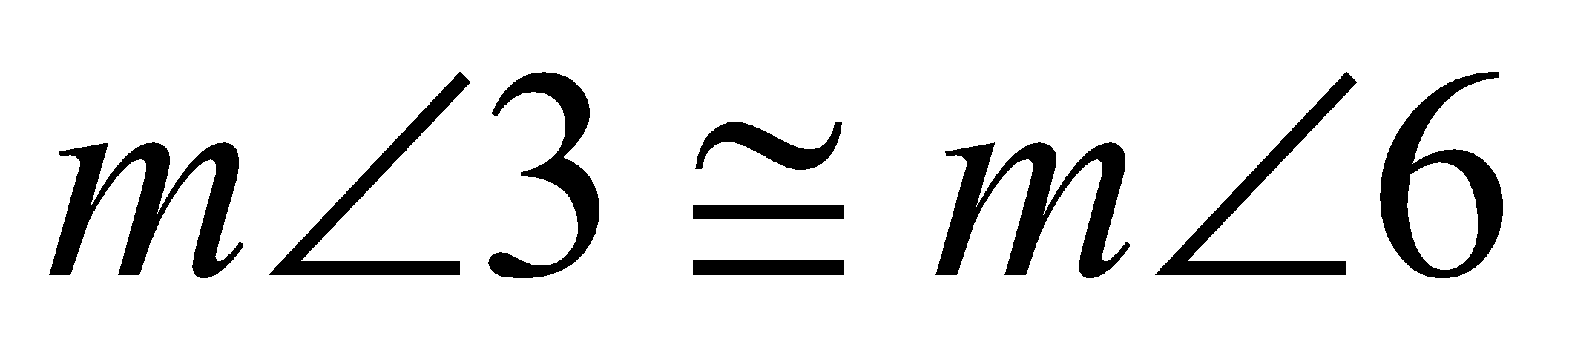

|  |  |
| --- | --- |
| Statements | Justifications |
|  |  |

20. If and , solve for x and find and .

21. If and , solve for x and find $m<7$ and $m<2$.

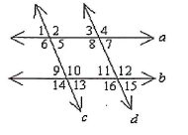22. Given a//b and c//d Prove <6 $≅$ <16

*Unit 3 – Triangles and Triangle Congruence*

23. Name all the valid postulates/theorems that can be used to prove that two triangles are congruent.

24. For the following triangles, determine whether they are congruent and by which theorem or postulate. If they are not congruent, explain why not.

|  |  |
| --- | --- |
|  |  |
|  |  |

25. Write a congruent statement for the following triangles: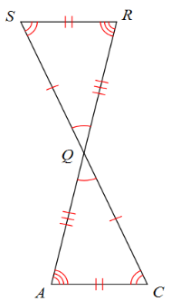

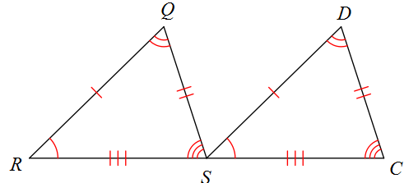

________________________________________ ___________________________________

26. Using the triangle from above left, complete the following congruence statements:

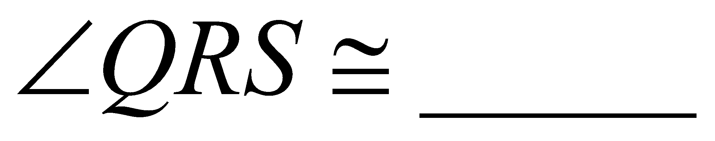; 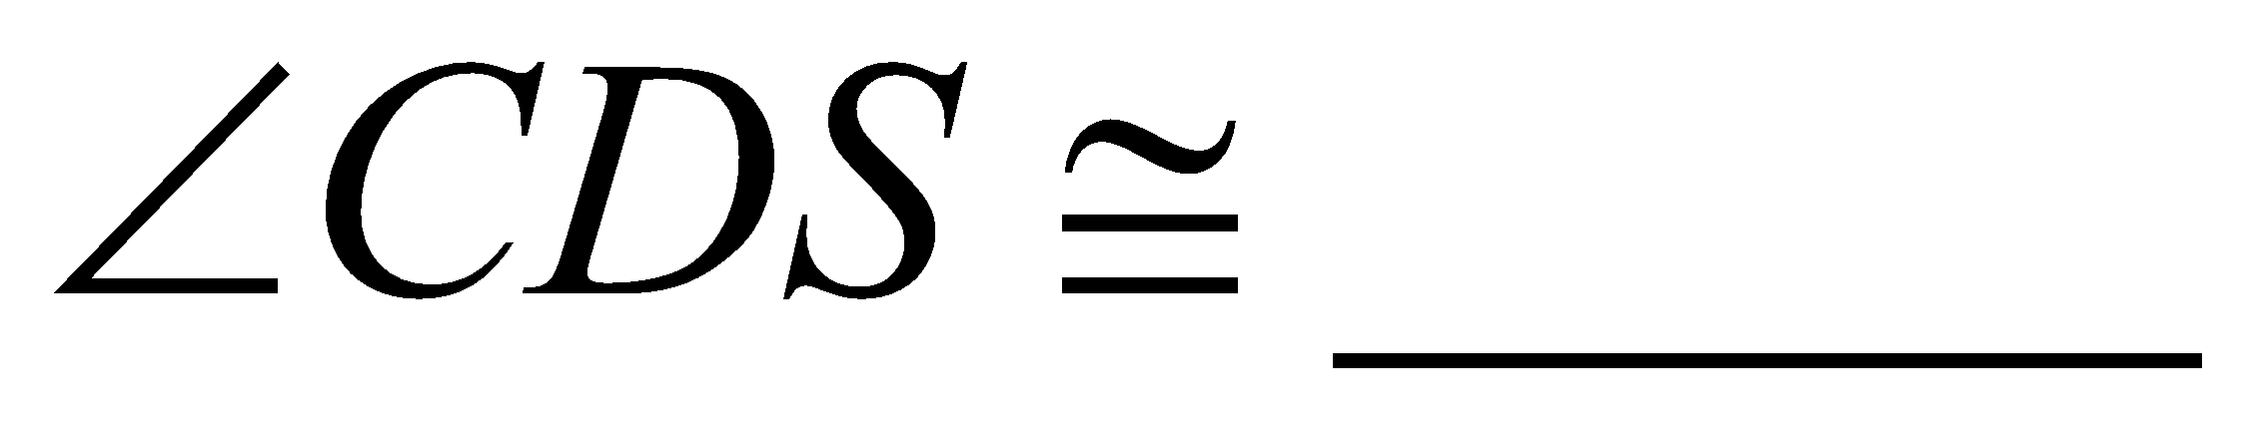; 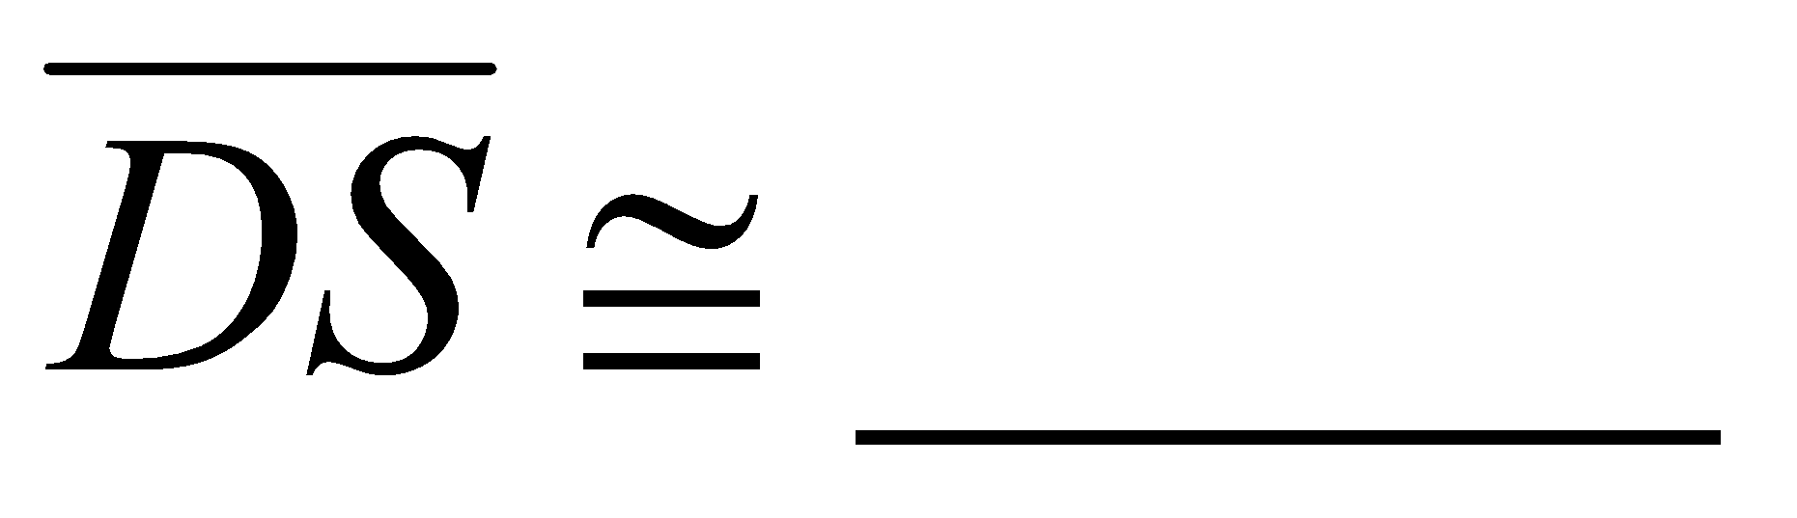; 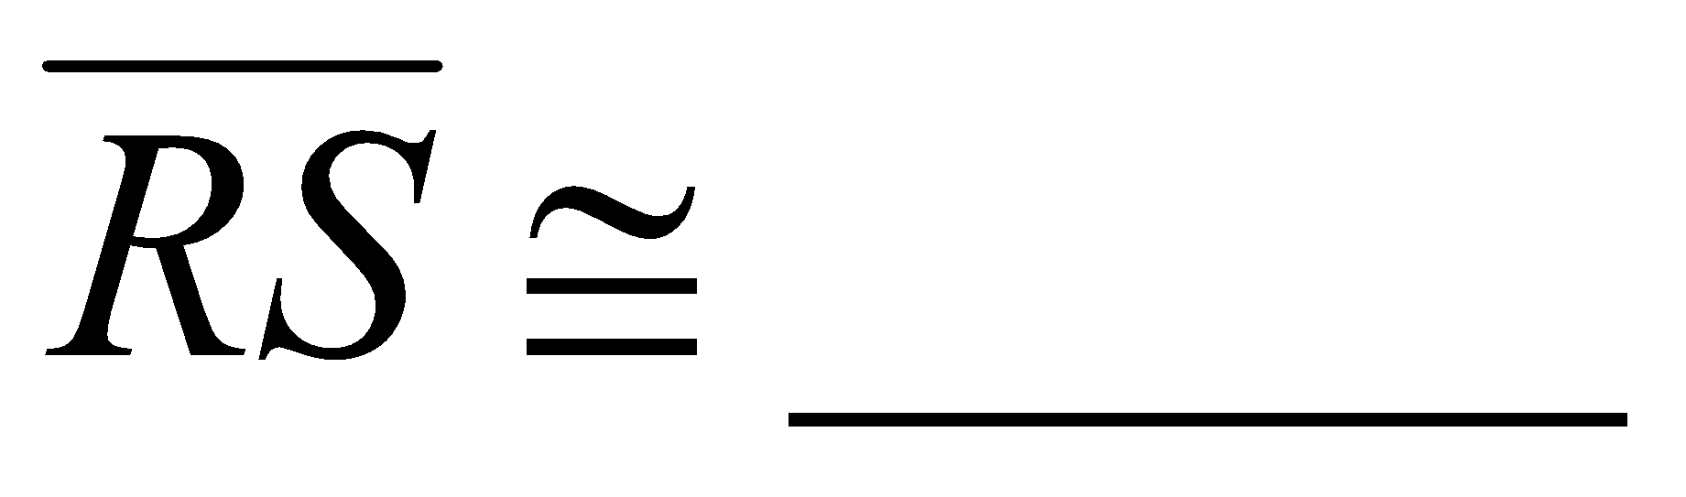 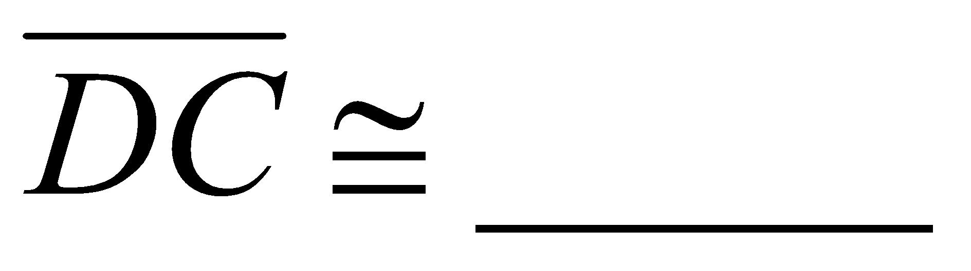

27. What additional information would be needed to prove the triangles are congruent using ASA?

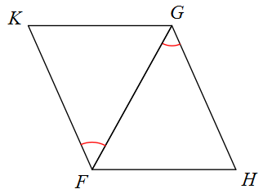

28. Given that ∆PQR ≅ ∆LMN, list all corresponding sides and all corresponding angles.

Corresponding Sides: _______________, __________________, ___________________

Corresponding Angles:_______________,__________________,___________________

29. Draw a picture to solve for x in the following problem: 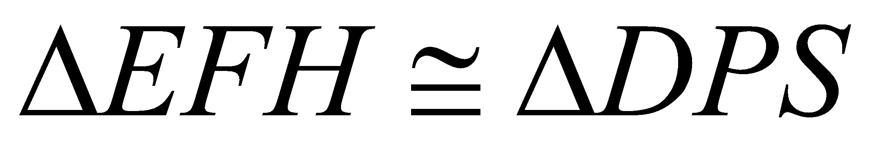, 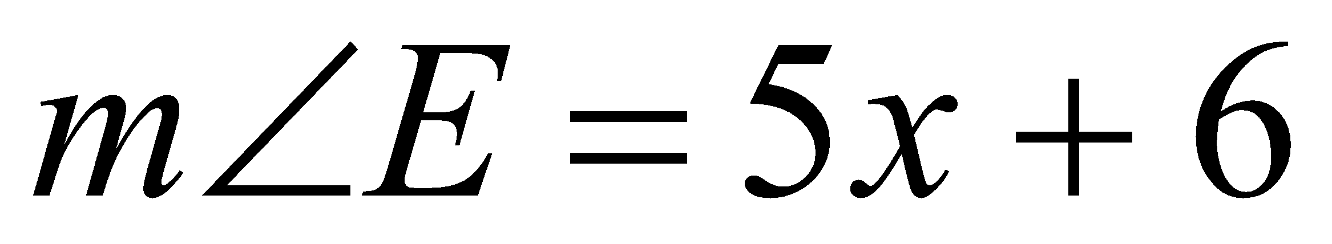; 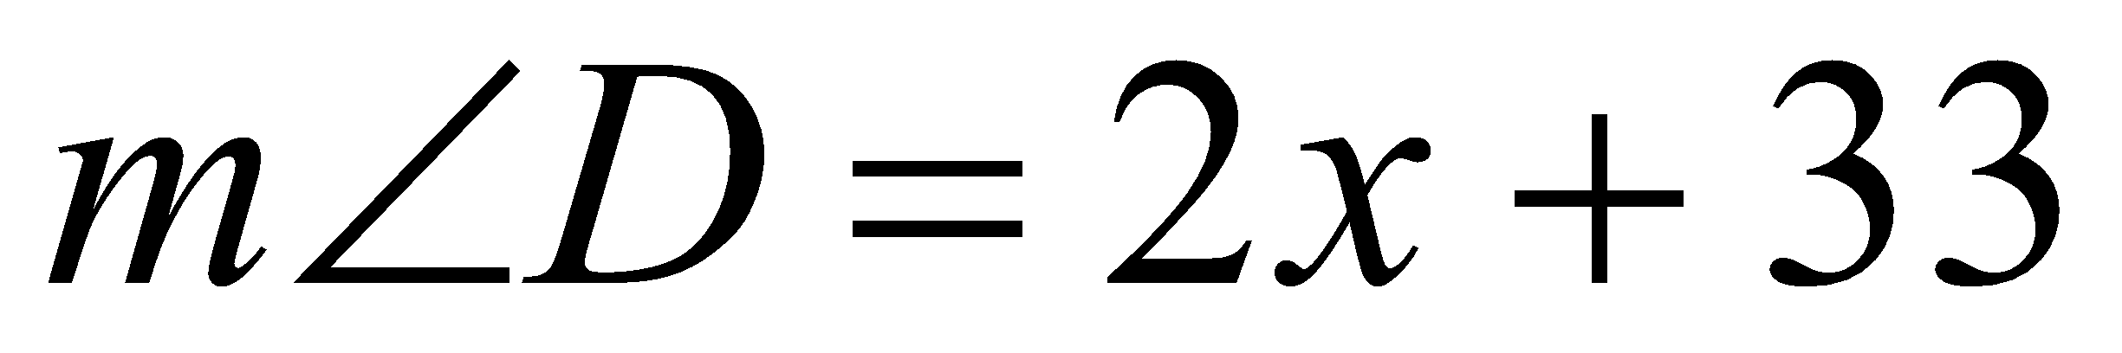; 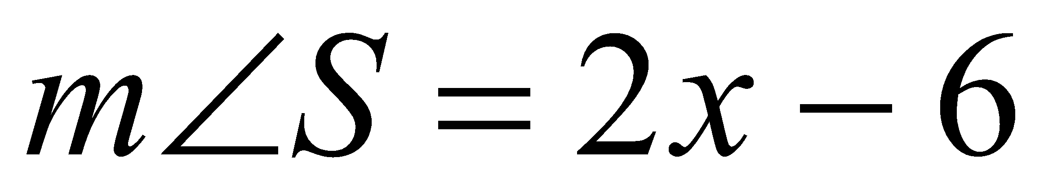.

30. Find all missing angles.

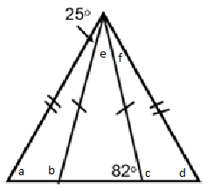

31. Solve for x in the diagram below.

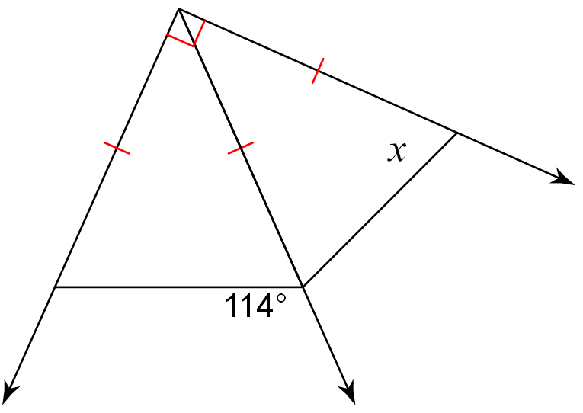

32. Complete the following proofs:

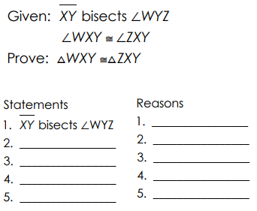

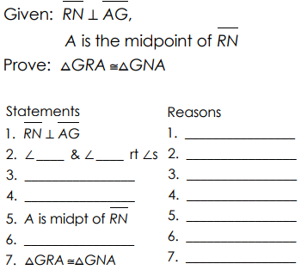

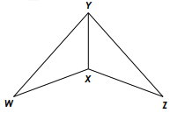

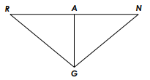

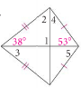33. Find the missing angles in the kite: 34. Find the missing variable in the trapezoid:



35. Find the measure of a and the value of each angle in the parallelogram:

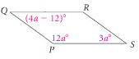

36. Find the values of the variables in the parallelogram:

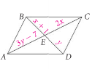

37. Name all quadrilaterals with the following properties:

1. Diagonals are perpendicular.
2. Only one pair of parallel sides.

38. ABCD is a parallelogram. Determine the value of x and y.

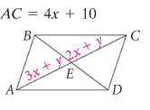

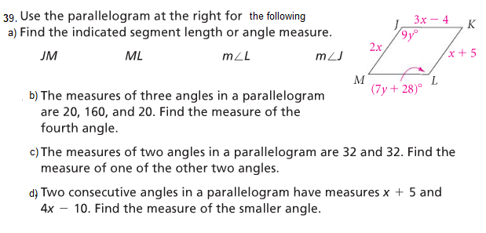

40. . Three vertices of a parallelogram are L(-1, 3), R(2, -1), and D(5, 4).

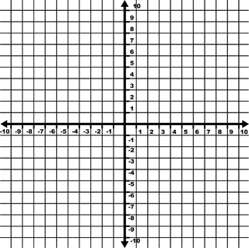a. Find an ordered pair and graph it (name it E) that could be the coordinate of the fourth vertex. Connect the points to draw your parallelogram.

E ( _____, _____)

Verify that it is a parallelogram

b. Find a second ordered pair that could be the coordinate of the fourth vertex and graph it, name it H. Connect your points in a different color to draw your parallelogram. H (_______, _______)

41.

The above building is being painted bright green. Paint costs $18/ gallon and each gallon covers 300 square feet.

a) Find the square feet you need to paint (only vertical surfaces, not the roof)

b) Find the number of gallons of paint needed.

c) Find the cost to paint the barn, just for the paint.