Harry Truman’s Address to Situation in Korea (1950)
At noon today, I sent a message to the Congress about the situation in Korea. I want to talk to you tonight about that situation, and about what it means to the security of the United States, and to our hopes for world peace.
Korea is a small country, thousands of miles away, but what is happening there is important to every American.
On Sunday, June 25th, communist forces attacked the Republic of Korea.
This attack has made it clear, beyond all doubt, that the international communist movement is willing to use armed invasion to conquer independent nations. An act of aggression such as this creates a very real danger to the security of all free nations.
The attack upon Korea was an outright breach of the peace and a violation of the Charter of the United Nations. By their actions in Korea, communist leaders have demonstrated their contempt for the basic moral principles on which the United Nations is founded. This is a direct challenge to the efforts of the free nations to build a kind of world in which men can live in freedom and peace.
This challenge has been presented squarely. We must meet it squarely....
The communist invasion was launched in great force, with planes, tanks, and artillery. The size of the attack, and the speed with which it was followed up, make it perfectly plain that it had been plotted long in advance.
As soon as word of the attack was received, Secretary of State Acheson...informed me that, with my approval, he would ask for an immediate meeting of the United Nations National Security Council. The Security Council met just twenty-four hours after the communist invasion began.
One of the main reasons the Security Council was set up was to act in cases such as this—to stop outbreaks of aggression in a hurry before they develop into general conflicts. In this case, the Council passed a resolution which called for the invaders of Korea to stop fighting, and to withdraw. The Council called on all members to help carry out this resolution. The communist invaders ignored the action of the Security Council and kept right on with their attack.
The Security Council then met again. It recommended that members of the United Nations help the Republic of Korea repel the attack, and help restore peace and security in the area....
These actions by the United Nations and its members are of great importance. The free nations have now made it clear that lawless aggression will be met with force. The free nations have learned the fateful lesson of the 1930’s. That lesson is that aggression must be met firmly. Appeasement leads only to further aggression and ultimately to war.
The principal effort to help the Koreans preserve their independence, and to help the United States restore peace, has been made by the United States. We have sent land, naval, and air forces to assist in those operations. We have done this because we know that what is at stake here is nothing less than our own national security and the peace of the world....
Under the flag of the United Nations, a unified command has been established for all forces of the members of the United Nations fighting in Korea. General MacArthur is the commander of this combined force.
The prompt action of the United Nations to put down lawless aggression, and the prompt response to this action by free peoples all over the world, will stand as a landmark in mankind’s long search for a rule of law among nations....
We know that it will be a hard, tough fight to halt the invasion, and to drive the communists back. The invaders have been provided with enough equipment and supplies for a long campaign. They overwhelmed the lightly armed defense forces of the Korean Republic in the first few days and drove southward.
Now, however, the Korean defenders have reorganized, and an increasing number of American troops have joined them. Our forces have fought a skillful, rear-guard delaying action, pending the arrival of reinforcements. Some of these reinforcements are now arriving; others are on the way from the United States....
We have the resources to meet our needs. Far more important, the American people are united in their belief in democratic freedom. We are united in detesting communist slavery.
We know that the cost of freedom is high. But we are determined to preserve our freedom—no matter what the cost....

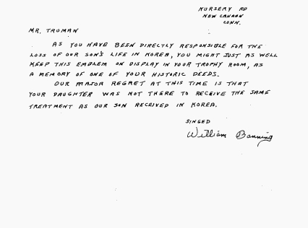
Write a letter to the father of the previous letter, explaining your side about whether America should or should not have fought in Korea. Use FACTS to back up your claims. You should have at least 2 paragraphs.

The White House
President of the United States
Harry S. Truman

Sincerely,
