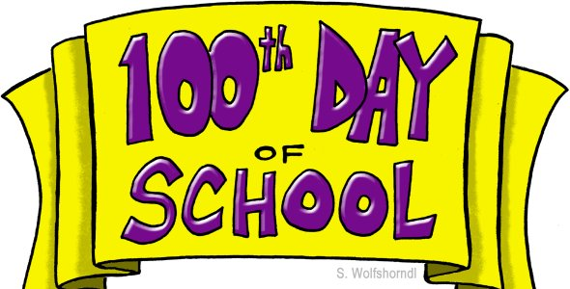

Dear Parents,

Our 100th day of school is coming very soon. It should be Wednesday, February 15th. To celebrate, the 2nd grade classrooms do two things.

The first is a project/poster. Students are asked to create a representation of 100 things. Students are encouraged to place their items in equal groups (10 groups of 10, 5 rows of 20, etc…) and write a number sentence to go with it (addition or multiplication). Make sure to use plenty of glue and give it time to dry. Be neat and be creative!! They will present their project to the class and then we will display it in the hallway.

The second activity will be our special snack. We call it “Gorp” :) To make our gorp in class we will combine different snacks to equal 100. Below is a list of suggested items we could use to help make our snack. If you would like to send something in, that would be awesome!! Please send it in on Monday, February 13th, so that I can hit Target if I need to.

Suggested items: (no nuts)

mini pretzels cheese puffs mini marshmallows

goldfish popcorn M & M’s

cheerios animal crackers veggie straws

Chex other cereal chocolate chips other...

Thank you!!!!