**Second Grade – Unit 5 PRE-Test**

**What is true about this pyramid?**  2.G.1

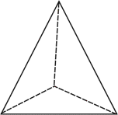

1) It has 3 edges. Yes No

2) It has 4 vertices. Yes No

3) It has 5 faces. Yes No

4) **Look at the chart. Fill in the missing boxes.**  2.G.1

|  |  |  |  |
| --- | --- | --- | --- |
| Name of Shape | Picture | Number of Sides | Number of Corners |
|  |  |  | 5 |
| Square |  |  |  |
| Circle |  |  | 0 |
|  |  | 3 |  |

**What is the name of this shape?**  2.G.1

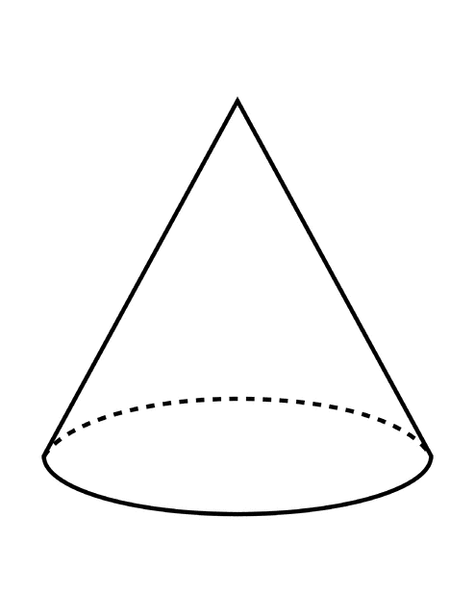 5) ______________________

6) What is one attribute about this shape?

______________________________________________________________________________

______________________________________________________________________________

**In which ways can you break apart one or both numbers to find the sum of 46 + 25?** 2.NBT.5

7) 40 + 20 + 11 Yes No

8) 40 + 6 + 20 + 5 Yes No

9) 46 + 20 + 4 Yes No

10) **Find the sum. Show how you added.**  2.NBT.5

36 + 17 =

11) **Subtract the two numbers to find the difference. Show your work.** 2.NBT.5

56 - 28 =

12) Explain your strategy.

______________________________________________________________________________

______________________________________________________________________________

______________________________________________________________________________

**Which addition problem(s) have a sum of 18?** 2.OA.2

13) 12 + 7 Yes No

14) 15 + 3 Yes No

15) 9 + 9 Yes No

16) **Write the fact family.** 2.OA.2

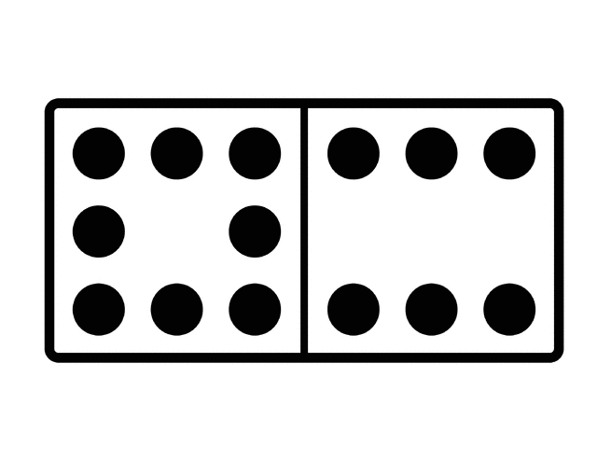

_______________________________

_______________________________

_______________________________

_______________________________

Julie scored 6 points for her basketball team in October and 8 points in November. She said she scored 14 points in both months because 6 + 6 = 12 and 2 more is 14. Is Julie correct? Explain using pictures and words. 2.OA.2

17)

Picture:

18) Explain your picture. _______________________________________________________

____________________________________________________________________________

____________________________________________________________________________