**Story Elements Poster Project**

**Directions**: Choose between “The School Play” and “Tuesdays of the Other June” and analyze your story choice for its literary elements. Create a visual display (poster) that is large enough to read, legible, and colorful! Make sure you have ALL of the requirements below!

**Your poster MUST include:**

* A **complete, hand drawn** pyramid of action

for your story that describes the main plot using story vocabulary (make it LARGE!)

* **Story vocabulary**
  + List the major and minor characters – identify protagonist and antagonist
  + Describe the setting
* **Answer the following questions IN A PARAGRAPH EACH using C.E.R. (claim, evidence, reasoning):**

1. *What type of conflict does your story have? (man vs. man, man vs. self, man vs. nature, man vs. society) Provide textual evidence from the story that proves you are right.*
2. **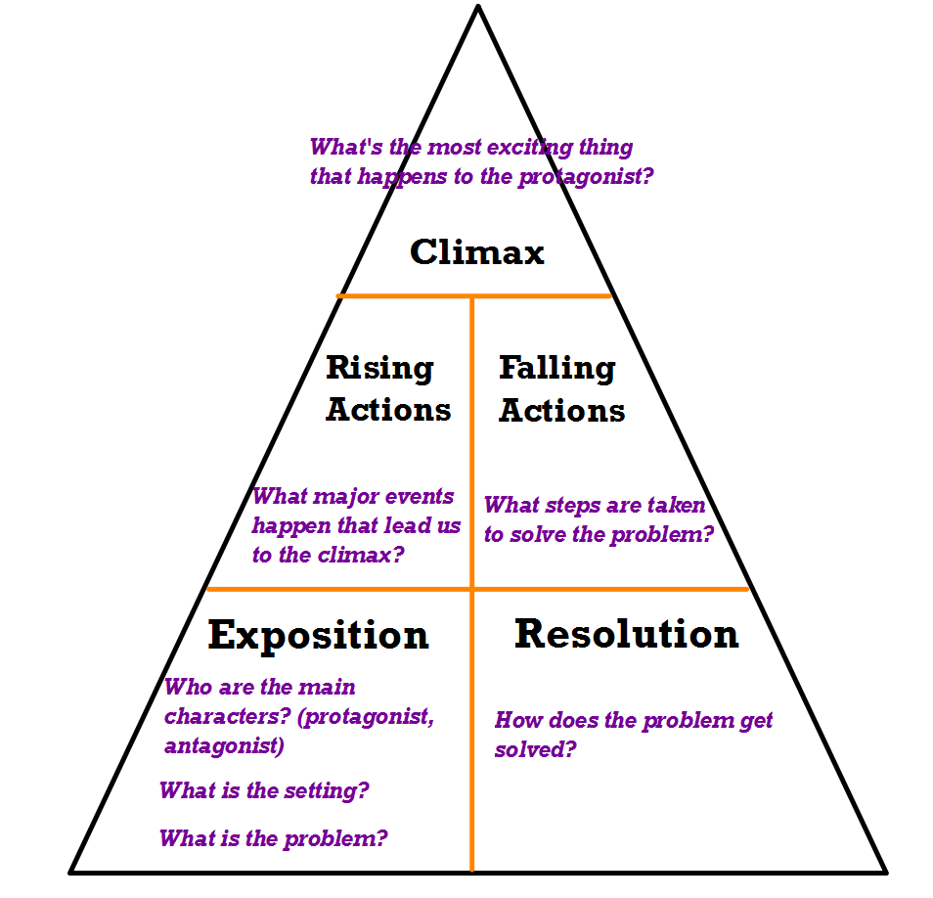***What is the point of view of your story? Provide textual evidence from the story that proves you are right.*

* **Pictures (one for each pyramid section)**
* **Color**
* **Title**
* **Complete sentences**
* **Correct spelling**

**Be Creative!!**

**Due: Friday, November 22nd**