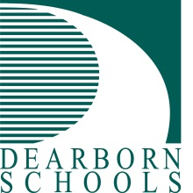
Press Release #54/2018-19
FOR IMMEDIATE RELEASE: June 2, 2020
Contact: David Mustonen, Communications Director
(313) 827-3006 MustonD@dearbornschools.org


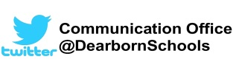
www.DearbornSchools.org
Students First-
Inspire, Educate, Celebrate

Dearborn will continue offering free student meals over summer
Free student meal distributions will continue throughout the summer at seven Dearborn Public School sites.
The district has been distributing the free grab-and-go meals since shortly after the Governor ordered schools to close in March. That program is slated to end on June 10, which is scheduled to be the last full day of school in the District.
However, Dearborn Schools received permission to continue serving free meals through the summer under the U.S. Department of Agriculture’s Summer Food Service Program.
The summer meal distribution will be once a week on Wednesdays starting June 17. Food will be handed out every Wednesday from 10 a.m. to noon at the seven locations. Each bag will contain seven breakfasts and seven lunches for each child under the age of 18. Each child will also get a half gallon of milk.
The distribution locations will continue to be Fordson, Dearborn and Edsel Ford high schools, Woodworth and Smith middle schools, Salina Intermediate, and McCollough/Unis School.
One person can pick up food for any child living in the home. The child does not need to attend that school.
The District has recently been providing 65,000 grab-and-go meals a week for children in the community. Those meals, which include lunch and breakfast, are funded through the U.S.D.A. School Lunch Program. Dearborn used that program to offer free lunch and breakfast to all its kindergarten through 12th grade students before the school closure in March.
“We know our families appreciate the student meal distributions, and we are glad to be able to continue to offer children these meals during the summer months,” said Food Service Director Jeff Murphy.
###
Photo caption
PR54 Dearborn summer meal program – Dearborn Schools staff stand next to hundreds of bags of food they packed at Dearborn High School before the Memorial Day break in May. Each bag contained a week’s worth of breakfasts and lunches for a student. Dearborn Schools will offer similar weekly free meal distributions over the summer this year.

