1. Introduction
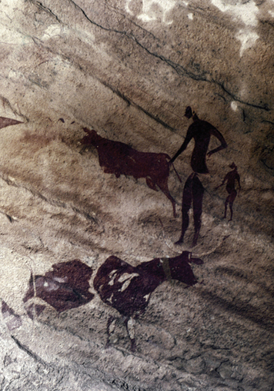
Scientists have identified and studied five important groups of hominids. Like the hominids before them, early modern humans hunted and gathered their food. In this chapter, you'll read about how early people learned, over thousands of years, to produce food by farming.
Humans discovered farming toward the end of the Stone Age. This period gets its name from the stone tools prehistoric people made and used. Historians divide the Stone Age into two periods. The first is the Paleolithic Age, or Old Stone Age. During this period, people got food by roaming from place to place to hunt wild animals and gather nuts, berries, and seeds from the plants they found.
By about 8000 B.C.E., some people had learned how to raise animals and crops for food. This knowledge enabled these people, for the first time, to live in one place. The Neolithic Age, or New Stone Age, had begun.
This gradual shift from hunter-gatherers (food collectors) to farmers (food producers) is one of the most important advances in human development. People built permanent shelters. They settled in larger communities. Together, they produced what they needed. People developed new skills and made a variety of things that improved the quality of their lives. Over time, they also began to exchange goods with people in other communities for the things they lacked in their own villages. In this chapter, you will explore the many ways in which the development of farming changed human life.

2. From Old Stone Age to New Stone Age
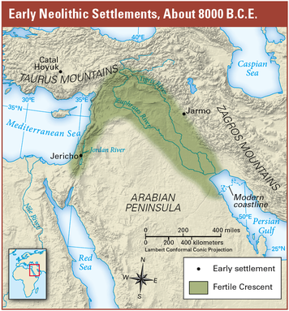
The Old Stone Age, or Paleolithic Age, began about 2 million years ago, with the first toolmaking hominids, and lasted until about 8000 B.C.E. It was during this time period that early modern humans developed. Like the hominids before them, early humans were hunter-gatherers. They wandered from place to place, hunting animals and gathering plants for food. Often, they took shelter in caves. Prehistoric cave painters left clues about their way of life.
The New Stone Age, or Neolithic Age, began when people started to farm and produce their own food. The discovery of farming did not happen all at once. Over thousands of years, people gradually learned to raise animals and plant crops. They eventually began to rely on these farms for their food. Now, rather than having to roam long distances in search of things to eat, people could settle down in one place.
The Neolithic Age began around 8000 B.C.E. and lasted until about 3000 B.C.E., when people learned to make tools out of metal instead of stone. During this time, farming developed in many places throughout the world, including parts of Europe, Africa, Asia, and the Americas.
Many Neolithic settlements were located in the Fertile Crescent, east of the Mediterranean Sea, where the land was fertile (good for growing crops). Here, people built towns such as Jericho (JER-ih-koh), Catal Hoyuk(CHAHT-ul hoo-YOOK), and Jarmo (see map).
People in settlements like these lived very different lives from earlier hunter-gatherers. They could now concern themselves with other matters such as building permanent shelters and forming larger communities. They could make better tools and clothing. And they could swap items they had with other communities to get the things they lacked. As you will see, these changes made life safer, more comfortable, and more interesting.

3. Creating a Stable Food Supply
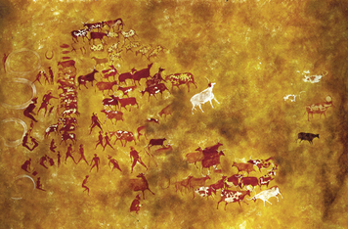
During the Paleolithic Age, people obtained food by hunting animals and gathering plants. They did not have a stable, or dependable, food supply. Wild plants and animals grew scarce when people stayed in one area for too long. And hunting was dangerous.Hunters were often injured or killed.
Gradually, people found ways to lessen their dependence on hunting and gathering.Instead of gathering wild plants, people discovered that they could plant seeds and harvest crops. Over time, farmers learned which seeds produced the most crops in the areas where they lived.
Early farmers also learned how to domesticate animals, to raise and use them for people's needs. They raised sheep, goats, and cattle for the meat. Goats and cattle also provided milk. Mules helped carry heavy loads and pull plows.
These two developments—the growing of crops and the domestication of animals—are called agriculture. The Neolithic Age began with the invention of agriculture. For the first time, people had some control over their food supply. Let's explore why this change was one of the most important advances in all of history.

4. Making Permanent Shelters
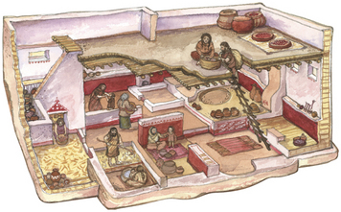
The first great change agriculture brought about was the use of permanent shelters.During the Paleolithic Age, people had lived in caves or rough, tentlike structures.These were temporary shelters because hunter-gatherers were nomads. They had to move often, to follow the wild animal herds or to find new plants to eat. As people settled down to farm during the Neolithic Age, they built shelters that were more permanent.
In many areas, people used mud bricks, packed together, to build houses that were round or rectangular in shape. Sometimes, people added stones and tree branches to the mud to strengthen the walls and roof. These houses had openings high in the walls.Historians believe that people may have climbed ladders to reach the openings and enter the house.
Inside were several rooms. Places to store food were built right into the floor. Pits for cooking were also dug into the floor, and lined with clay.People may have filled the pits with water, dropping in hot stones to make the water boil for cooking.
The development of permanent shelters was important in several ways. Houses gave people protection from harsh weather and wild animals.Houses made life more comfortable. People could cook food in new ways. The long-lasting shelters enabled people to settle together in larger

5. Establishing Communities
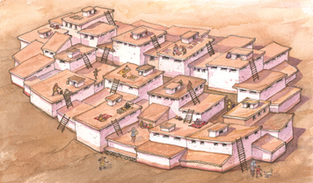
The ability to raise food by farming allowed people to settle in permanent shelters.These structures, in turn, enabled people to form larger communities. In Paleolithic times, small bands of perhaps 20 to 60 people wandered from place to place in search of food. As people began growing food, they settled down near their farms. As a result, towns and villages grew up, like those at Jericho (in present-day Israel) and Catal Hoyuk (Turkey).
Living in communities made it possible for people to organize themselves more efficiently. They could divide up the work of producing food and other things they needed. While some people grew crops, others built houses and made tools.
Village dwellers also learned to cooperate to do a task more quickly. For example, toolmakers could share the work of making stone axes and knife blades. By working together, they could make more tools in the same amount of time.
With many of their basic needs now met, people had more time and energy for other activities. They could invent new ways of making their lives more comfortable and much safer. Larger communities could defend themselves more easily against their enemies. The Neolithic town of Jericho, for example, was protected by strong stone walls. All of these changes in farming villages led to growing populations.

6. Developing New Jobs
Having a stable food supply allowed people to develop new kinds of jobs. In Paleolithic times, people's main job was finding enough food to survive. With farms providing steadier supplies of food, Neolithic people could develop more specialized skills.
A good example is the town of Catal Hoyuk, which dates back to about 6000 B.C.E. Historians believe that the townspeople of Catal Hoyuk worked in a variety of jobs. Besides farmers, there were weavers, basket makers, toolmakers, and traders.
Focusing on one job at a time gave people the opportunity to improve the ways they worked. In Catal Hoyuk, farmers learned how to grow more than 14 kinds of food plants. Clothing makers developed a way to spin and weave. They wove natural fibers such as wool and linen into comfortable cloth. In some regions, people mined flint so that stoneworkers could create sharper tools.
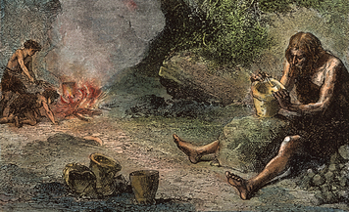
Neolithic people didn't merely want to survive. They wanted to make themselves, and their surroundings, more beautiful. They decorated their pottery and baskets with geometric shapes. Stoneworkers learned to polish stones to make shiny jewelry and mirrors. House builders added special rooms to honor the gods and goddesses they believed in.
One effect of the development of different jobs was to inspire workers to improve their skills. This led to newer and better ways of doing things. And different jobs added much greater variety to community life.

7. Beginning to Trade
Another major change introduced in Neolithic times was the growth of trade. Paleolithic hunter-gatherers rarely traded with other groups. They were mostly concerned with the animals, plants, and other resources they found nearby. As people settled in towns and villages, trade became a more common activity.
Usually, people trade to get resources they do not have in their own area. As Neolithic people became more skilled in their crafts, they wanted materials that would improve the strength and beauty of the things they made. Getting those resources became the job of traders.
Traders often traveled hundreds of miles in search of these materials. They crossed mountains on foot, rode donkeys across deserts, and sailed the Mediterranean Sea on ships.
What kinds of things were traders looking for? Popular items included flint and obsidian. Obsidian is a black glass found at volcanic mountains.Craftspeople used it to make knife blades, arrowheads, and mirrors. People also traded for “beauty products” like shell ornaments and a red ore called hematite. Women rubbed hematite on their lips and cheeks to make them redder.
The growth of trade allowed people to make use of more resources. It also brought them into contact with people from distant places. These contacts helped spread ideas and knowledge throughout the ancient world.

Summary
In this chapter, you learned how the development of farming changed people's lives between the Paleolithic Age and the Neolithic Age.
A Stable Food Supply During the Paleolithic Age, people lived as nomads, obtaining their food by hunting animals and gathering plants.Gradually, people discovered they could grow crops and domesticate animals. These two developments are called agriculture. Agriculture marked the beginning of the Neolithic Age.
Shelters and Communities As people began to farm, they built permanent shelters and formed communities. Towns and villages grew up near farms.
Jobs and Trade Living in communities allowed people to improve how they lived and worked. They created new jobs and traded for the resources they needed.

