Chapter 25
Geography and the Settlement of Greece
EQ: How did geography influence settlement and way of life in ancient Greece?

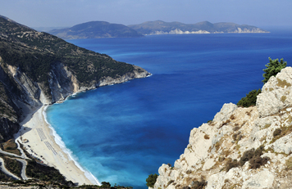
Section 1 - Introduction

In this chapter, you will learn about how geography affected the early settlement of ancient Greece. This remarkable culture flourished between 750 and 338 B.C.E. Ancient Greek art, ideas, and writings continue to influence many aspects of the modern world today.
Greece is a small country in southern Europe. It is shaped somewhat like an outstretched hand, with fingers of land that reach into the Mediterranean Sea. The mainland of Greece is a peninsula. A peninsula is land that is surrounded on three sides by water. Greece also includes many islands throughout the Mediterranean and the Aegean (ih-JEE-uhn) seas.
Mainland Greece is a land of steep, rugged mountains, almost entirely surrounded by turquoise blue seas. The ancient Greeks lived on farms or in small villages scattered throughout the country. These farms and villages were isolated, or separated, from each other by the mountains and seas.
In this chapter, you will explore how Greece's geography influenced settlement and way of life in ancient Greece. You will learn why people lived and farmed in isolated communities. You will also discover how the Greeks used the sea to establish colonies and trade relations with people from other lands.

Section 2 - Isolated Communities and the Difficulties of Travel
The mountains and the seas of Greece contributed greatly to the isolation of ancient Greek communities. Because travel over the mountains and across the water was so difficult, the people in different settlements had little communication with each other.
Travel by land was especially hard. People mostly walked, or rode in carts pulled by oxen or mules. Roads were unpaved. Sharp rocks frequently shattered wooden wheels, and thick mud could stop a wagon in its tracks. Only wealthy people could afford to ride horses.
Travelers could stop at inns on the main roads, but many inns provided only shelter. People had to bring their own food and other supplies with them. Slaves or pack animals carried bedding, food, and other necessities. With all these goods to take with them, the Greeks often traveled in groups, moving at a slower pace than someone traveling alone.

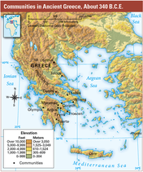
Traveling by water was easier than traveling by land. You can see on the map on this page that mainland Greece is a peninsula, made up of smaller peninsulas. Ancient Greeks were never far from the water. To the south of Greece is the Mediterranean Sea; to the east, the Aegean Sea; and to the west, the Ionian (ahy-OH-nee-uhn) Sea. The ancient Greeks soon learned to travel by ship.

The Greeks understood the dangers of the sea and treated it with great respect. Sudden storms could drive ships off course or send them smashing into the rocky shoreline. Even in open waters, ships could sink. These hazards encouraged Greek sailors to navigate close to shore, sail only during daylight, and stop at night to anchor.

Section 3 - Farming in Ancient Greece
Most people in ancient Greece made their living by farming. But farming wasn't easy in that mountainous land. Even in the plains and valleys, the land was rocky, and water was scarce. There were no major rivers flowing through Greece, and the rains fell mostly during the winter months.

With limited flat land available, Greek farmers had to find the best ways to use what little land they had. Some farmers built wide earth steps into the hills to create more flat land for planting. A few farmers were able to grow wheat and barley, but most grew crops that needed less land, particularly grapes and olives. Greek farmers produced a lot of olive oil, which was used for cooking, to make soap, and as fuel for lamps.

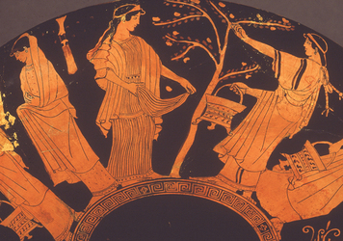
Ancient Greek farmers grew food for their own families. In addition to small vegetable gardens, many farmers planted hillside orchards of fruit and nut trees. Some Greek families kept bees to make honey. Honey was the best-known sweetener in the ancient world.
Greek farmers also raised animals. But because cattle need wide flat lands for grazing, the ancient Greeks had to raise sheep and goats, which can graze on the sides of mountains. Sheep supplied wool for clothing, while goats provided milk and cheese. Greek farmers kept some oxen, mules, and donkeys for plowing and transportation. Many Greek families also kept pigs and chickens.

The shortage of good farmland sometimes led to wars between Greek settlements, with each one claiming land for itself. As you will see, some settlements also had to look beyond the mainland for new sources of food and other goods.

Section 4 - Starting Colonies
As the populations of Greek communities increased, the existing farmland no longer produced enough food to feed all of the people. One solution was to start colonies, or settlements in distant places. Many Greek communities sent people across the sea, in search of new places to farm so that they could ship food back home. People who set up colonies are called colonists.

The ancient Greeks made many preparations before starting a journey to a new land. Often, they began by consulting an oracle to ask the Greek gods whether their efforts would be successful. An oracle was a holy person who the Greeks believed could communicate with the gods.

Next, the colonists gathered food and supplies. They took a flame from their town's sacred fire so they could start a sacred fire in their new home.
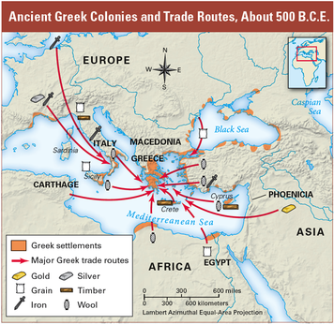
Greek colonists faced many hardships. They had to take a long sea voyage and then find a good location for their colony. They looked for areas with natural harbors and good farmland. They tried to avoid places where the local people might oppose the new colonies. Finally, they had to build their new community and make it successful.
The Greeks established colonies over a period of more than 300 years, from 1000 to 650 B.C.E. The first group of settlers started a colony called Ionia, in Asia Minor, in what is present-day Turkey. Later groups started colonies in Spain, France, Italy, and Africa, and along the coast of the Black Sea.

These colonies helped spread Greek culture. Some flourished through farming and trade. Colonists continued to enjoy whatever rights they once held in their home country of Greece, including the right to participate in Greek athletic games.

Section 5 - Trading for Needed Goods

Many Greek settlements on the mainland relied on trade with each other to get needed goods. Some had enough farmland to meet their own needs, so they were less dependent on trade.
The Greeks traded among the city-states, with Greek colonies, and in the wider Mediterranean region. Olive oil and pottery from the mainland were exchanged for such goods as grain, timber, and metal.
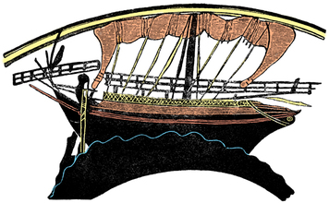
Most goods were carried on ships owned by merchants. These ships were built of wood, with large rectangular cloth sails. Merchants had ships built, not for speed, but for space to hold goods. Because these ships traveled only about three to five miles per hour, journeys were long. A one-way trip from the mainland could take two months.
Navigating these ships was difficult. The Greeks had no compasses or charts. They had only the stars to guide them. The stars could tell sailors a ship's location, but not what hazards lay nearby. No lighthouses warned sailors of dangerous coastlines. Despite these dangers, adventurous sailors carried more and more goods, and trade flourished along the Mediterranean coast.

