Chapter 21
Three Chinese Philosophies
EQ: How did Confucianism, Daoism, and Legalism influence political rule in ancient China?
  - Introduction

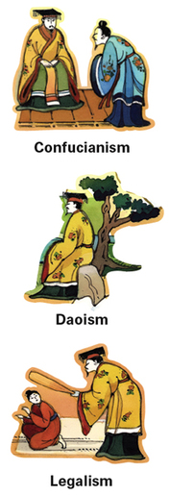
One of China's earliest dynasties was the Shang dynasty. China's next line of rulers belonged to the Zhou (joh) dynasty. In this chapter, you will learn about the Zhou and explore three Chinese philosophies that arose during this dynasty.
The Zhou dynasty lasted from about 1045 to 256 B.C.E. During its later years, different leaders fought for control in China. The country was thrown into disorder. These troubles led Chinese thinkers to ask serious questions about the best way to have peace and order in society. Three very different answers emerged and became the philosophies of Confucianism (kuhn-FYOO-shuh-niz-uhm), Daoism (DOW-iz-um), and Legalism.
The following scene illustrates the differences between these schools of thought. Imagine that it is 250 B.C.E. The ruler of a small kingdom has sent three advisers to learn about the three philosophies. Upon their return, he asks them, “What should I do to rule well?”
The first adviser has learned about Confucianism. He tells the king, “Lead by example.” The second adviser has studied Daoism. He says, “If you must rule, rule as little as possible.” The third adviser has learned about Legalism.He says, “Set clear laws and harshly punish those who disobey them.”
In this chapter, you will learn why the three advisers gave such different answers. You will explore Confucianism, Daoism, and Legalism and learn how each philosophy influenced political rule in ancient China.

21.2 - The Zhou Dynasty

Around 1045 B.C.E., the Zhou, a group of people in northwestern China, moved into the central plains. They overthrew the Shang dynasty and established a new dynasty. For several centuries, the Zhou dynasty ruled over a group of states in China. But in the later years of the dynasty, wars between these states plunged China into disorder.
The Early Years: Stability and Feudalism After overthrowing the Shang dynasty, the Zhou established their own dynasty to rule over China. To justify their conquest, they claimed that they had been given the Mandate of Heaven, a divine right to rule China.
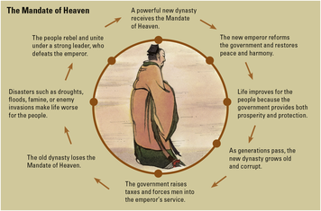
According to this belief, Heaven was a power that controlled human destiny. The king was the son of Heaven. As long as the king governed his people well, Heaven gave him the right to rule. If the king did not govern well, Heaven would send signs of its displeasure, such as earthquakes and floods. When the king lost the support of Heaven, others had the right to overthrow him. The Zhou and later groups believed in the Mandate of Heaven.
Using a system of relationships called feudalism, the Zhou increased the stability of the government. Under feudalism, the king owned all the land. He gave large pieces of the land to loyal supporters, called lords. In exchange, these lords sent soldiers to fight against enemies who threatened their king. The lords were rulers of their own lands, or states. They had absolute power over the peasant farmers who worked those lands. Peasants had their lord's protection. In return, they gave a portion of their crops to the lord.

The Later Years: Conflict and Creative Thought For a time, feudalism maintained political stability in China. But by the 700s B.C.E., the system was starting to break down. The lords of individual states became more ambitious and more powerful.Eventually, the power of some lords rivaled that of the king.
Between about 770 and 453 B.C.E., a number of small states often quarreled with one another. They eventually grouped into six or seven larger states that fought for power.These wars brought some 250 years of disorder to China. This historical time is often called the Warring States period.
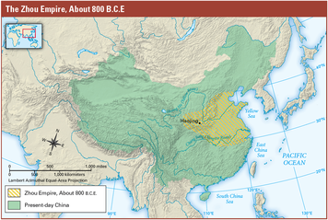
Such unrest led Chinese thinkers to ask important questions about human nature and about how best to govern. Some rulers hired scholars to advise them on how to create order and increase their royal power.
So many ideas were offered that the Chinese later called them the “Hundred Schools of Thought.” The three major schools of thought that emerged were Confucianism, Daoism, and Legalism. Each of these philosophies had a major influence on Chinese culture. Let's take a closer look at their origins, teachings, and influence, beginning with Confucianism.

21.3 - Confucianism

Confucianism is based on the teachings of Kongfuzi, who is called Confucius (kuhn-FYOO-shuhs) by Western society. This philosophy deeply influenced Chinese government and culture.
The Founder of Confucianism Confucius lived from about 551 to 479 B.C.E. He was born in the small state of Lu, in eastern China. He experienced firsthand the disorder that erupted when lords fought for power. Between 722 and 481 B.C.E., his own state was invaded many times.
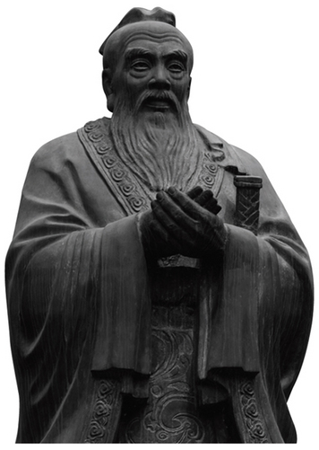
Confucius deeply respected Chinese traditions such as reverence for ancestors and learning. But he also saw that society and government had to change, if peace and order were to exist. In particular, rulers needed to govern wisely. Confucius wanted to teach men of good character to serve society as honest and fair government officials.
The Teachings of Confucianism The goal of Confucianism was to achieve a just and peaceful society. Confucius taught that society worked well when all people used standards of good behavior in their roles and in their relationships with others.
According to Confucianism, there are five basic relationships between people: ruler and subject, husband and wife, father and son, older sibling and younger sibling, and friend and friend. All people must respect and obey those who are above them in status. In particular, they must respect their elders. In return, those with authority, such as rulers, fathers, husbands, and older siblings, must set a good example. They should be kind, honest, wise, and faithful. Confucius taught, “Do not do to others what you would not want done to you.”
The Influence of Confucianism The philosophy of Confucius attracted a number of students who spread his ideas and teachings. After his death, some of these students collected his sayings in a book called The Analects. Later scholars further developed Confucianism.
Confucianism had a very practical effect on the government of a later dynasty, the Han dynasty. In China, civil servants were traditionally the sons of nobles. However, that did not ensure that they had the ability and wisdom to do their jobs well. The influence of Confucianism led Han leaders to hire civil servants on the basis of their ability. To be qualified, government workers were expected to know the Chinese classics in detail. For example, they had to know the proper behavior required of people in the various roles in society, from laborers to government officials. To prove that candidates had this knowledge, they had to take exams that the emperor himself might grade.
The teachings of Confucius had a major influence on Chinese culture. Values such as respect for elders, proper behavior, and love of scholarship became deeply woven into Chinese society. Even today, the sayings of Confucius are wise and practical. Here are two examples from The Analects:

Confucius said to his follower:
The gentleman first practices what he preaches
and then preaches what he practices.
Confucius said to his student:
Shall I teach you what knowledge is?
When you know a thing, say that you know it;
when you do not know a thing,
admit that you do not know it.
That is knowledge.

21.4 - Daoism
The second great philosophy to come out of China's time of trouble was Daoism (also spelled Taoism). Like Confucianism, it tried to provide answers to the problems that prevented right living and good government.
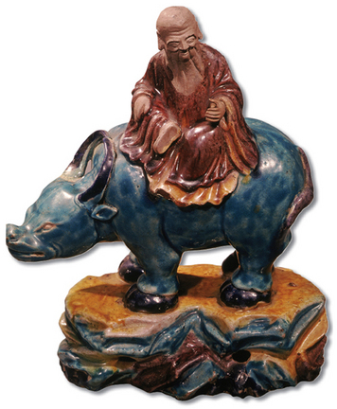
The Founder of Daoism According to tradition, the great sage, or wise man, of Daoism was Laozi (low-dzuh). His name is sometimes spelled “Lao-tzu.” Laozi was said to be the author of a work called the Dao De Jing (dow duh jing). The English version of the title is The Classic of the Way and Its Power.
Some modern scholars think that Laozi was a real man who lived in the late 500s B.C.E. Other historians believe that he was merely a legend. Scholars do agree that the Dao De Jing was actually written over time by many writers.
Old stories of Laozi's life tell how he came to write the Dao De Jing. These stories say that Laozi worked as an adviser to the Zhou court for many years. When he was 90 years old, he tired of government work and decided to leave China. When he came to the Chinese border, a guard recognized him. The guard was upset that the great teacher's wisdom would be lost to China. He asked Laozi to record his thoughts before leaving. So Laozi sat down and wrote a small manuscript of only 5,000 characters, the Dao De Jing.
The Dao De Jing preached a return to a simple and natural way of living. Here is an example of one passage:
If you do not want your house to be molested by robbers,
Do not fill it with gold and jade.
Wealth, rank, and arrogance add up to ruin,
As surely as two and two are four.
The Teachings of Daoism Daoism was based on the ancient Chinese idea of the Dao (dow), or “the Way.” Dao was the force that gave order to the natural universe. Daoism taught that people gained happiness and peace by living in harmony, or agreement, with the way of nature.
To Daoists, nature is full of opposites, like life and death, or light and darkness. True harmony comes from balancing the opposite forces of nature, called yin and yang. Yin means “shaded,” and yang means “sunlit.” In the same way, human life is a whole made up of opposites. It is impossible to have good without bad, beauty without ugliness, or pleasure without pain.
The Daoists taught that people followed the way of nature by living simple lives of quiet meditation. Notice, the Daoists said, how nothing in nature strives for fame, power, or knowledge. Similarly, people should neither feel self-important nor work to gain possessions or honors.Instead, they should accept whatever comes, like a blade of grass that bends when the breeze blows.
The Daoists believed that everyone must discover the Dao for themselves. Too many laws and social rules conflict with the way of living naturally and following the Dao. According to these teachings, the best rulers were those who ruled the least. The Dao De Jing says, “Governing a large country is like frying a small fish. You spoil it with too much poking.” It also tells rulers to be weak and let things alone.
The Influence of Daoism Daoism encouraged rulers to govern less harshly. But Daoism's more important influence was on Chinese thought, writing, and art. In time, Daoism developed into a popular religion.

21.5 - Legalism
The third major philosophy that came out of China's time of trouble was Legalism. It was very different from Confucianism or Daoism. It offered new answers about how to solve problems that interfere with order and good government.
The Founder of Legalism Legalism was based on the teachings of Hanfeizi (hahn-fay-dzoo). Hanfeizi (also spelled Han-fei-tzu) lived from 280 to 233 B.C.E. He was a prince of the royal family of the state of Han. Hanfeizi lived to see the end of the Warring States period and of the Zhou dynasty.
Like Confucius, Hanfeizi was very concerned with creating peace and order in society. But he did not think that the Confucian teachings about proper behavior were the answer. Many of his ideas survive today in a book named after him, Hanfeizi.
The Teachings of Legalism Those who followed Legalism believed that most people are naturally selfish. Left to themselves, Legalists said, people will always pursue their own self-interest. They cannot be counted upon to have a good influence on one another. Therefore, it was not enough for rulers to set a good example. Instead, they should establish strict laws and enforce them, either with rewards for good behavior or with harsh punishments for bad behavior. Civil servants should be watched carefully and punished for doing a poor job. People who were caught criticizing the government should be banished to China's far northern frontier.
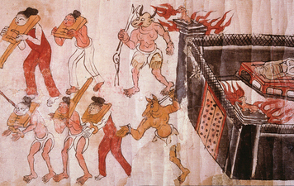
In Hanfeizi's time, rulers were frequently overthrown. To solve this problem, Hanfeizi taught that rulers must have absolute power backed by military might. Rulers should trust no one, not even their own families. Hanfeizi wrote, “He who trusts others will be controlled by others.”

The Influence of Legalism Legalist philosophy had an almost immediate influence on government in China. At the end of the Warring States period, the Qin (chin) dynasty seized control of China. Qin rulers read and admired the writings of Hanfeizi. These rulers wanted to build a strong central government and a well-organized society. To achieve these goals, they adopted strict Legalist ideas. People were forbidden to criticize the government. Anyone caught doing so was severely punished. Many people were p

