Unit 1 Final Exam Review

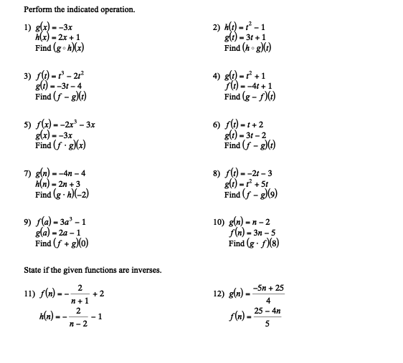

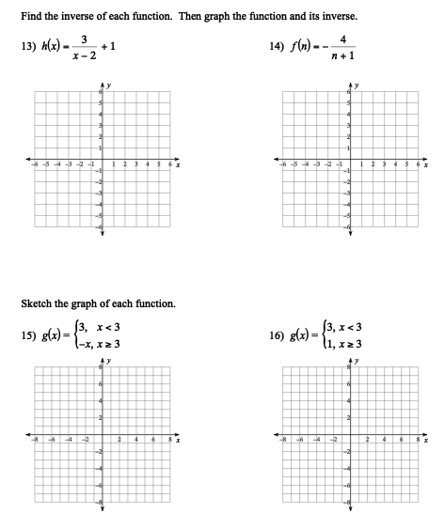

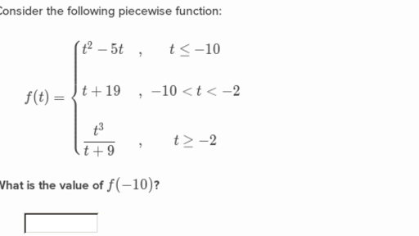17. Consider the following piecewise function:

18. Determine if the following function is continuous using algebraic reasoning.

F(x) =

19. Write an equation for the following piecewise function:

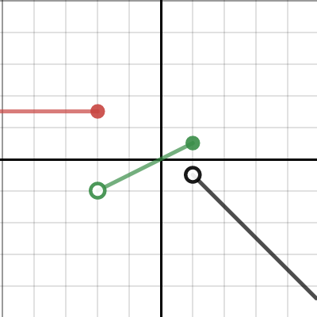

Unit 2 Final Exam Review Guide

Characteristics of FUN!ctions (I/D/C/Extrema)

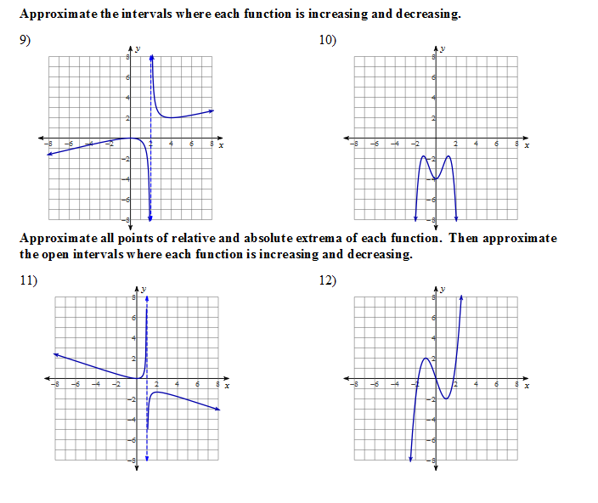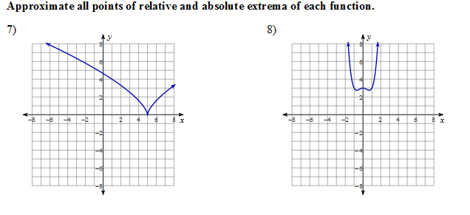Who puts the fun in functions? You do

13. Sketch a graph of a function that contains the points (-3,0), (0, 3) and (3,-4), is only decreasing over the interval 0 ≤ x ≤ 3.

Even and Odd Functions

Even I find it odd that functions are so FUN!!

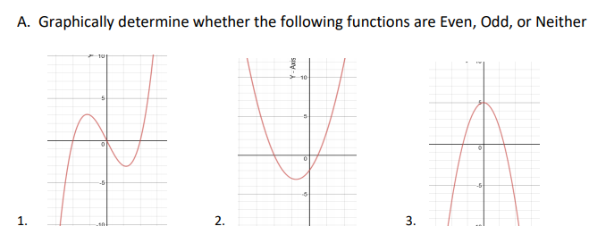

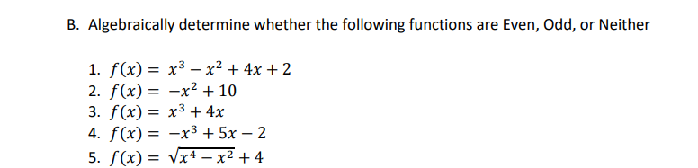

6. Identify the function as even, odd or neither.

f(x) = x(x-5)(x+6)

Unit 3 Final Exam Study Guide

Solving Trig Functions: F.TF.4 and F.TF.6

I can apply the unit circle, exact values and inverses to solve trig functions.

1. Solve each of the equations over the given domains.

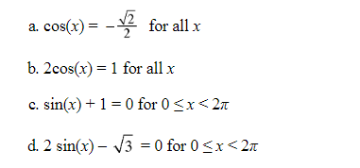

Solve the following equations. Your answer should be an exact value.

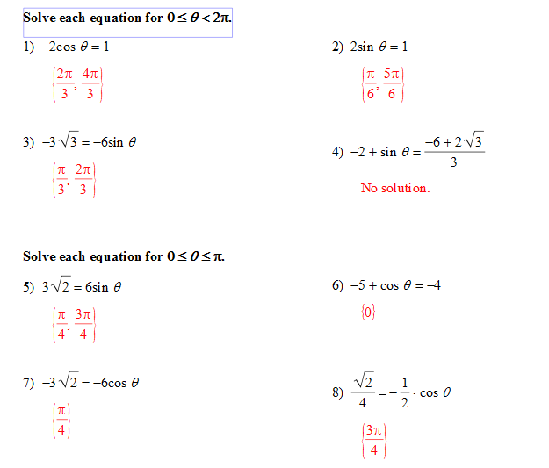

Graphing Trig Functions: F.TF.4 and F.IF.7e

1. 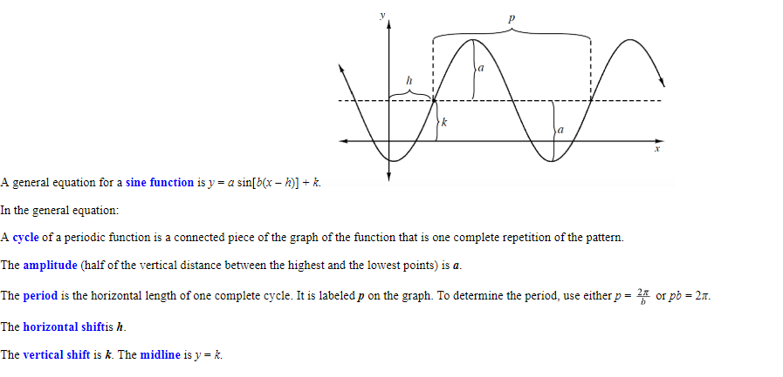Label each part of the graph with the appropriate term or letter.

(White out before copying)

1. Graph 2 cycles of the following equations. Identify the amplitude, period. Equation for the midline and the number of cycles from 0 to 2π.
2. Y = 3cos (x/4) b. 3cos(2x)
3. y = ½ cos 2x + 1 d. y = 4 sin 2x + 3
4. 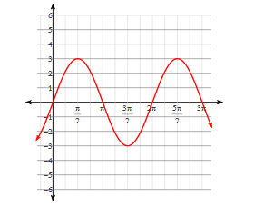Identify the midline, amplitude, number of cycles and period then write the equation for each graph below.

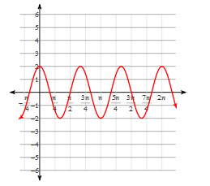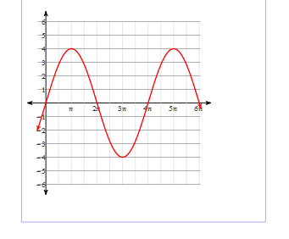

Characteristcis of Functions F.IF.4

I can interpret. Describe and graph key features (including dectreasing, increasing intervals and minima and maxima points) of a given function.

1. Identify the increasing and decreasing intervals (use inequalities) and global/local minima and maxima.

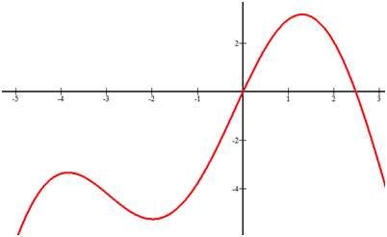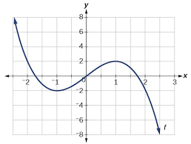

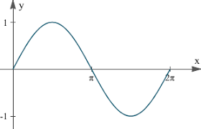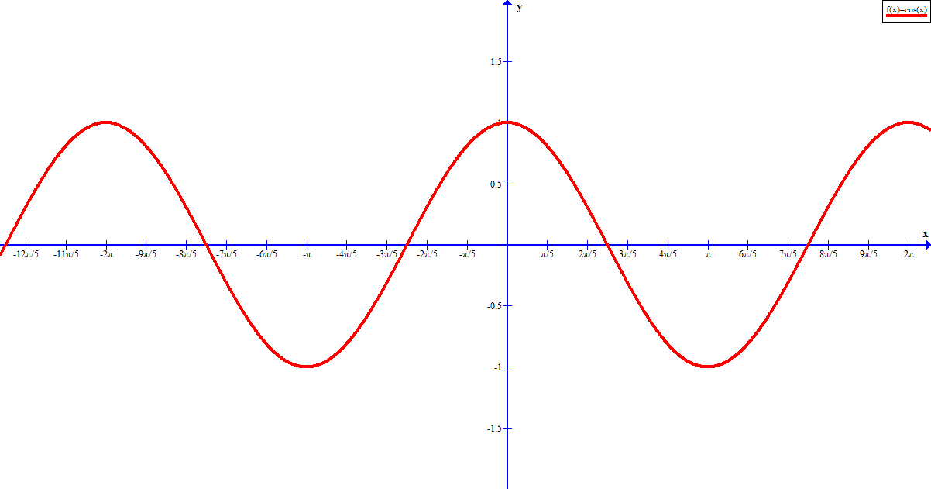

1. Sketch a graph the meets the given criteria.
2. Has a y-intecept of -4, is increasing only on the interval 0 ≤ x ≤ 3, is constant over the interval -6 ≤ x ≤ 0 and is decreasing from -∞≤ x ≤ -6.
3. Includes the points (0,0),( -4,-3) and (2,-3) and is constant only on the interval -∞≤ x ≤ -4.

The Trig Basics F.TF.3 and F.TF.4

I can identify reference angles, conterminal angles and apply them to fond exact values of trig functions.

1. What is the reference angle for:

a. $θ=\frac{15π}{6}$            b. $θ=-\frac{4π}{3}$  c. $θ=-\frac{π}{3}$ d. $θ=\frac{9π}{4}$

1. Determine the angle between 0 and 2π that is coterminal with the given angle. Sketch each angle in the unit circle. Identify the coordinate points for each.

a. $θ=\frac{15π}{6}$            b. $θ=-\frac{4π}{3}$  c. $θ=-\frac{π}{3}$ d. $θ=\frac{9π}{4}$

1. Determine the exact value of the given trigonometric expression.

a. $\cos{\frac{11π}{6}}$                b. $\sin{\frac{5π}{4}}$               c. $\cos{-\frac{5π}{6}}$

d. $\tan{0}$                e. $\sin{\frac{7π}{4}}$               f. $\cos{-1}$

g. $\tan{\frac{π}{6}}$                h. $\tan{\frac{3π}{4}}$               i. $\cos{\frac{5π}{6}}$

1. Sketch the following angles in a unit circle and find the value of tan (θ)
2. $θ=\frac{π}{6}$ b. $θ=-\frac{4π}{3}$  c. $θ=-\frac{π}{3}$ d. $θ=\frac{9π}{4}$