* **1-76.** **See below:**
  1. See graph below. At least 2 (or 3) employees are needed to fill a minimum number of orders. An acceptable domain is *n* ≥ 2 (or 3).  
     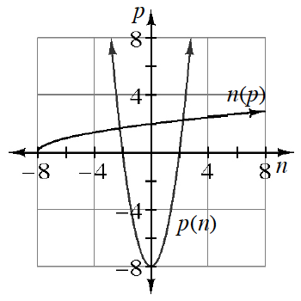
  2. 192 orders
  3. 8 employees
  4. 6 employees
  5. *n* = 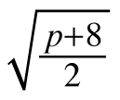
  6. The graphs and equations are inverses of each other. The domain of the equation in part (e) should be restricted to *p* ≥ 0.
* **1-77.** **See below:**
  1. *x*and *y*are switched in the table. The graphs are reflections across the line *y* = *x*. The equations “undo” each other.
  2. The inverse is a function, so *f* is invertible.*f*–​1(*x*) = 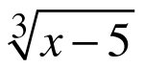 + 2
* **1-78.** **See below:**
  1. Students can switch the inputs and outputs in both the table and the graph to create the inverse. The graph of the inverse can also be obtained by reflecting *y* = *g*(*x*) across the line *y* = *x*,which is the focus of part (b).
  2. To generate the inverse of a function, the inputs become the outputs and vice versa. To generate a graphical representation of the inverse, a graph can be reflected over the line *y* = *x*.
  3. The inverse is not a function, so *g* is not invertible and the inverse cannot be denoted by *g*–1.
* **1-79.** **See below:**
  1. Answers vary.
  2. *f*–1(27) produces two values according to Ty’s equation for the inverse, 7 and 1. This is a problem because this means it is not a function.
  3. No, with the exception of the *f*–1(0), each input has more than one output.
* **1-80.** **See below:**
  1. Two possible solutions: *f*(*x*) = 3(*x* – 4)2 for *x* ≥ 4, *f*–1(*x*) = 4 + 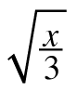;*f*(*x*) = 3(*x* – 4)2  for *x* ≤ 4, *f*–1(*x*) = 4 – 
* **1-81.** **See below:**
  1. no
  2. yes
  3. no
* **1-82.** **See below:**
  1. *f*–1(*x*) = 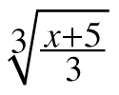
  2. *g*–1(*x*) = 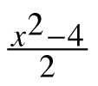 for *x* ≥ 0
  3. *h*–1(*x*) = 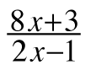 for *x* ≠ https://ebooks.cpm.org/images/shared/1-2.gif