­­­Name:____________________________________________________ Hour: _____ **ALGEBRA 2 SEMESTER 1 FINAL REVIEW**

**Unit 1: Function Family**

1) **NC** Draw a rough sketch of each of the parent functions

|  |  |  |  |
| --- | --- | --- | --- |
| a) Linear  Equation:  Image result for coordinate graph | b) Absolute Value  Equation:  Image result for coordinate graph | c) Quadratic  Equation:  Image result for coordinate graph | d) Square Root  Equation:  Image result for coordinate graph |
| e) Cubic  Equation:  Image result for coordinate graph | f) Cube Root  Equation:  Image result for coordinate graph | g) Exponential Growth  Equation:  Image result for coordinate graph | h) Logarithmic  Equation:  Image result for coordinate graph |

2) **NC** g(x)=b(x-m)2+r What happens to the function when….

|  |  |  |
| --- | --- | --- |
| |b|>1 | m>0 | r>0 |
| 0<b<1 | m<0 | r<0 |
| b<0 |

3) **NC** Find the requested information for the graph below. Make sure you use the correct parentheses and/or brackets.

Increasing: Decreasing:

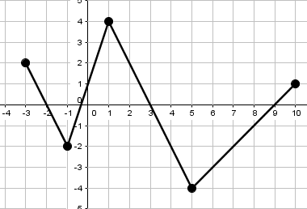

Domain: Range:

4) **NC** For each graph below, list the transformations. Then, write the equation of the graph.

|  |  |
| --- | --- |
| a) Transformations:       New Equation: | b) Transformations:       New Equation: |

5) Find the domain & range for the following 2 functions: (Hint: It might help to draw a rough sketch!)

a) $f\left(x\right)=3{\left(x-2\right)}^{2}-5$ b) $g\left(x\right)=\sqrt{x-5}+2$

**Unit 2: Systems**

1) **NC** Solve the system by graphing. 2) **NC** Solve the system using any method.

5x+3y=9 5x+y=9

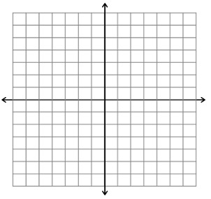x-3y=9 10x+2y=20

3) Graph the following system of inequalities. 4) Are the points below a solution to

$y<-3x-4$ $5x+3y≥9$?

$y≥\frac{1}{2}x+3$ a. (-2, 10) b. (2, -3) c. (4, 3) d. (1, 1)

5) Maria is hosting a party. She places an order at Pizza Hut for 5 pizzas and 4 breadsticks for a total of $51. Halfway through the party, she realizes that she will need one more pizza and 2 more order of breadsticks. This time she was given a total of $15. How much does a pizza cost? How much does a breadstick cost?

6) **NC** Janelle is selling cookies (x) and brownies (y) at a bake sale. A cookie costs $1.50 and a brownie costs $2.00. She needs to make at least $50 to make a profit but she only has 20 cookies to sell. Write a system of linear inequalities to model this problem. (You don’t have to solve)

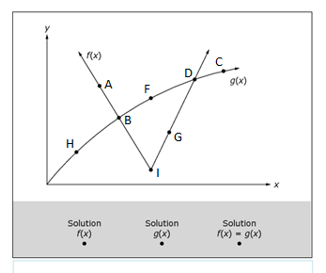7) The graphs of $y=f(x)$ and $y=g(x)$ are shown. **A.REI.D.11**

|  |  |
| --- | --- |
| Solutions for… | List **all** the points (2 pts each) |
|  |  |
|  |  |
|  |  |

8) Find where the system intersects: $f\left(x\right)=x^{2}+5x-10;g\left(x\right)=x+2$

**Unit 3: Rational/Radical**

1) **NC** Simplify: 2) **NC** Simplify:

3) **NC** Convert to radical form: $x^{\frac{4}{5}}$ 4) **NC** Convert to exponential form:

5) **NC** Simplify: 6) Simplify:

a)

b)

7) **NC** Simplify: 8) **NC** Simplify:

9) **NC** Solve: 10) Solve

11) =7 12) 13)

**Unit 4: Quadratics**

1) Which of the following equations shows the minimum or maximum of h(x)? Is it a max or min?

h(x)=2(x+3)(x+1) h(x)=2(x+2)2-2 h(x)=2x2+8x+6

2) Factor to find the x-intercepts

a) $x^{2}-13x+30$ =0 b) $x^{2}+5x-14=0$

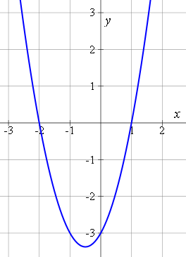3) **NC** The graph below can be represented by which of the following equations:

1. y = (x – 2)(x + 1)
2. b) y = (x – 1)(x + 2)
3. c) y = (x + 1)(x + 2)
4. d) y = (x – 1)(x – 2)

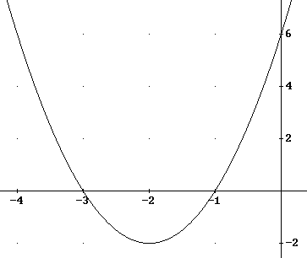4) **NC** Select all of the functions that can represent the following graph:

1. 2x2+ 4x +3
2. 2(x + 3)(x + 1)
3. 2(x + 2)2 -2
4. 2(x – 3)(x – 1)
5. 2x2 +8x +6
6. 2(x – 2)2 – 2

5) **NC** Solve the following equations using any method.

a) b) c) =0

6) How many times does each of the following functions intersect the x-axis?

a) $y=3x^{2}+\frac{2}{3}x-\frac{1}{3}$ b) $f\left(x\right)=\frac{4}{3}x^{2}-4x+3$ c) $f\left(x\right)=2x^{2}-\frac{1}{2}x+\frac{3}{2}$