10-4 Solving Quadratic Equations
I can solve quadratic equations by graphing and using square roots
Vocab
VoV

Quadratic Equation______________________________________________________________

Standard Form of a Quadratic Equation______________________________________________________________

X-interept____________________________________________________________

Y-intercept___________________________________________________________

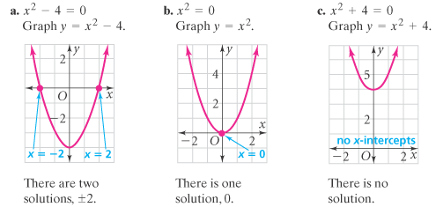

Solve by graphing the related function.  x² – 9 = 0  Choose the best answer and fill in the blanks:  A. This graph has 2 real solutions _____ and  ____ because________________________  B. This graph has no real solutions because___________________________  C. This graph has one real solution _____  because ________________________ | 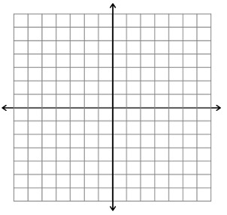
Solve by graphing the related function.

x² +5 = 0

Choose the best answer and fill in the blanks:
A. This graph has 2 real solutions _____ and

____ because________________________

B. This graph has no real solutions because___________________________

C. This graph has one real solution _____

because ________________________

Solve by graphing the related function.

4x² = 0

Choose the best answer and fill in the blanks:
A. This graph has 2 real solutions _____ and

____ because________________________

B. This graph has no real solutions because___________________________

C. This graph has one real solution _____

because ________________________

Solve by graphing the related function.

2x² -8 = 0
Choose the best answer and fill in the blanks:
A. This graph has 2 real solutions _____ and

____ because________________________

B. This graph has no real solutions because___________________________

C. This graph has one real solution _____

because ________________________

Solve by graphing the related function.

x² +16 = 0
Choose the best answer and fill in the blanks:
A. This graph has 2 real solutions _____ and

____ because________________________

B. This graph has no real solutions because___________________________

C. This graph has one real solution _____

because ________________________

Solve by finding square roots.  x² +16 = 0  Choose the best answer and fill in the blanks:  A. This equation has 2 real solutions _____  and ____ because_____________________  B. This equation has no real solutions because___________________________  C. This equation has one real solution____  because ____________________________ | Solve by finding square roots.  x² = 80  A. This equation has 2 real solutions _____  and ____ because____________________  B. This equation has no real solutions because___________________________  C. This equation has one real solution____  because____________________________
Solve by finding square roots.  4x² + 9 = 41  Choose the best answer and fill in the blanks:  A. This equation has 2 real solutions _____  and ____ because____________________  B. This equation has no real solutions because___________________________  C. This equation has one real solution____  because____________________________ | Solve by finding square roots.  4x² + 6 = 7  A. This equation has 2 real solutions _____  and ____ because____________________  B. This equation has no real solutions because___________________________  C. This equation has one real solution____  because____________________________

Solve by finding square roots.  3x² + 1 = 54  Choose the best answer and fill in the blanks:  A. This equation has 2 real solutions _____  and ____ because____________________  B. This equation has no real solutions because___________________________  C. This equation has one real solution____  because____________________________ | Solve by finding square roots.  3x² - 75 = 0  Choose the best answer and fill in the blanks:  A. This equation has 2 real solutions _____  and ____ because____________________  B. This equation has no real solutions because___________________________  C. This equation has one real solution____  because____________________________
Solve by finding square roots.  3x² - x² = 10  Choose the best answer and fill in the blanks:  A. This equation has 2 real solutions _____  and ____ because____________________  B. This equation has no real solutions because___________________________  C. This equation has one real solution____  because____________________________ | Solve by finding square roots.  2x² - 10 = -4  Choose the best answer and fill in the blanks:  A. This equation has 2 real solutions _____  and ____ because____________________  B. This equation has no real solutions because___________________________  C. This equation has one real solution____  because____________________________

- How many solutions can a quadratic equation have?

- How can you determine the number of solutions from the graph?

