Name(s)
Equation: ________________________  Vertex: ____________________  Axis of Symmetry:____________________  Zeros:__________________________  Minimum or Maximum | Graph
Equation: ________________________  Vertex: ____________________  Axis of Symmetry:____________________  Zeros:__________________________  Minimum or Maximum | Graph
Equation: ________________________  Vertex: ____________________  Axis of Symmetry:____________________  Zeros:__________________________  Minimum or Maximum | Graph
Equation: ________________________  Vertex: ____________________  Axis of Symmetry:____________________  Zeros:__________________________  Minimum or Maximum | Graph
Equation: ________________________  Vertex: ____________________  Axis of Symmetry:____________________  Zeros:__________________________  Minimum or Maximum | Graph
Equation: ________________________  Vertex: ____________________  Axis of Symmetry:____________________  Zeros:__________________________  Minimum or Maximum | Graph

Equation: ________________________  Vertex: ____________________  Axis of Symmetry:____________________  Zeros:__________________________  Minimum or Maximum | Graph
Equation: ________________________  Vertex: ____________________  Axis of Symmetry:____________________  Zeros:__________________________  Minimum or Maximum | Graph
Equation: ________________________  Vertex: ____________________  Axis of Symmetry:____________________  Zeros:__________________________  Minimum or Maximum | Graph
Equation: ________________________  Vertex: ____________________  Axis of Symmetry:____________________  Zeros:__________________________  Minimum or Maximum | Graph
Equation: ________________________  Vertex: ____________________  Axis of Symmetry:____________________  Zeros:__________________________  Minimum or Maximum | Graph

Equations
Y = -2(x + 2)² + 3 | Y = 1/3(x - 4)² - 5 | Y = 1/5(x -2)² + 4
Y = -3(x + 5)² + 2 | Y = - (x + 5)² - 2 | Y = 5/4(x + 1)² - 3
Y = 2/5(x + 4)² – 5 | Y = (x -3)² | Y = 7/4(x -1)² - 3

Vertices
(-2, 3) | (4, -5) | (2, 4)
(-1, -3) | (-5, 2) | (3, 0)
(-5, -2) | (1, -3) | (-4, -5)

Axes of Symmetry
(x = 2) | (x = 4) | (x = -4)
(x = -5) | (x = -2) | (x = 3)
(x =1) | (x =-1) | (x = -5)

GRAPHS
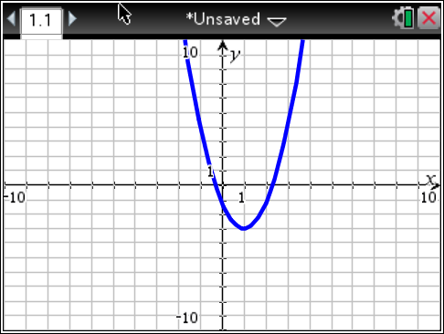 | 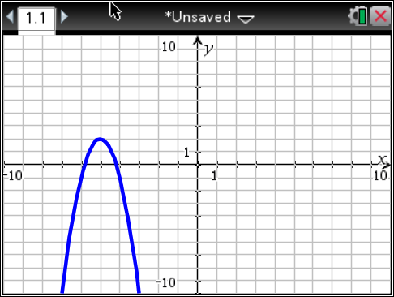
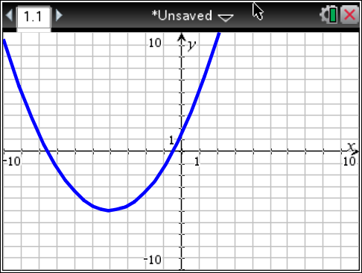 | 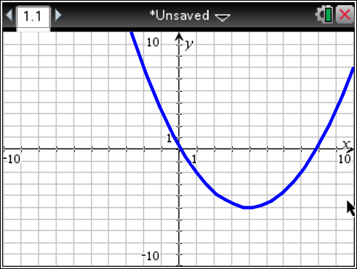
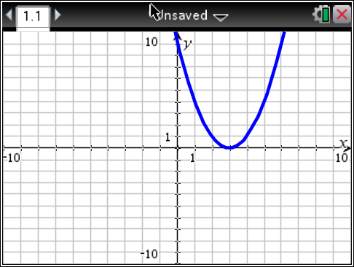 | 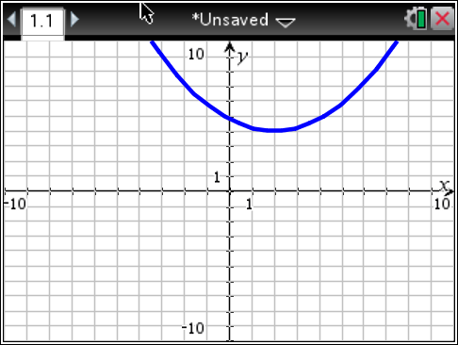
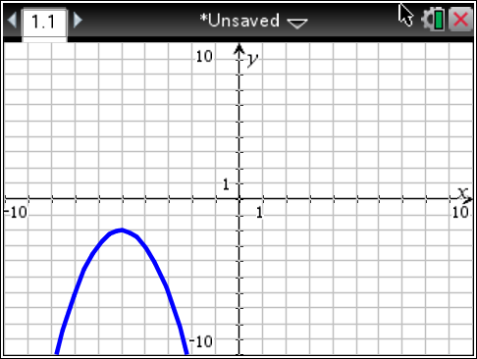 | 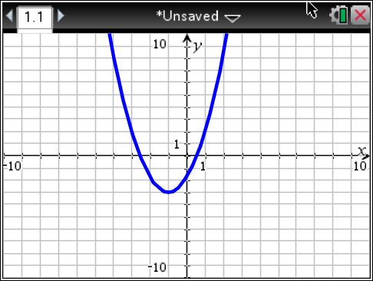
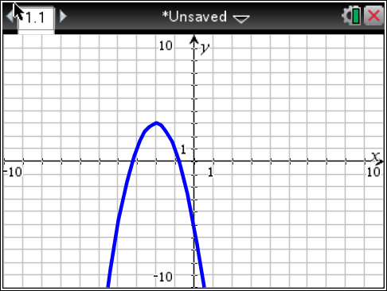 | This section is intentionally left blank.

EXIT TICKET

Graph the equation in your calculator. Identify the vertex and axis of symmetry. Identify a, h and k and describe how they affect the parabola. Is the parabola a minimum or maximum?  a:___________________________  h: ____________________________  k: ____________________________  Vertex:___________________  Axis of Symmetry: ______________  Minimum or Maximum | Sketch the graph here. Label the vertex and axis of symmetry.  y = -0.5(x + 1)² - 2  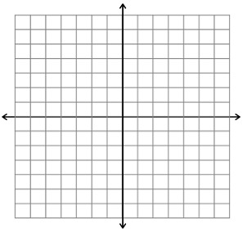

EXIT TICKET

Graph the equation in your calculator. Identify the vertex and axis of symmetry. Identify a, h and k and describe how they affect the parabola. Is the parabola a minimum or maximum?  a:___________________________  h: ____________________________  k: ____________________________  Vertex:___________________  Axis of Symmetry: ______________  Minimum or Maximum | Sketch the graph here. Label the vertex and axis of symmetry.  y = -0.5(x + 1)² - 2

