If a is positive the parabola opens_____ If h is positive the parabola shifts_____ If k is positive the parabola shifts_____

If a is negative the parabola opens_____ If h is negative the parabola shifts_____ If k is negative the parabola shifts_____

a: h: k:

Vertex (h,k):

Axis of Symmetry (x=h):

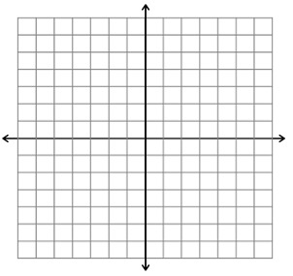

a: h: k:

Vertex (h,k):

Axis of Symmetry (x=h):



a: h: k:

Vertex (h,k):

Axis of Symmetry (x=h):



If a < 1 ( ), the parabola ________

If a > 1 ( ), the parabola ________