If a is positive the parabola opens_____ The c value represents the _______________

If a is negative the parabola opens_____

a: b: c:

Axis of Symmetry

Vertex

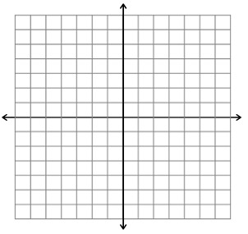

a: b: c:

Axis of Symmetry:

Vertex:



a: b c:

Axis of Symmetry:

Vertex:



If a < 1 ( ), the parabola ________

If a > 1 ( ), the parabola ________