1. Find the equation of the parabola.  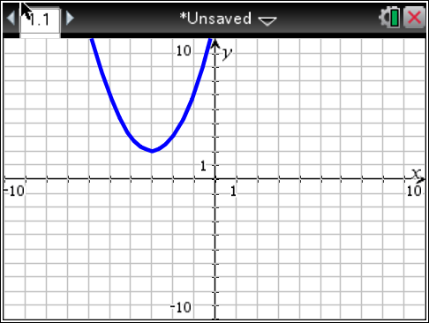 | 2. Find the equation of the parabola.  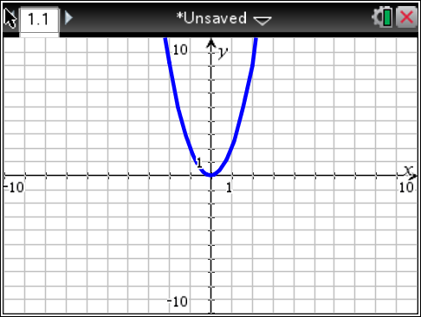
3. Find the equation of the parabola.  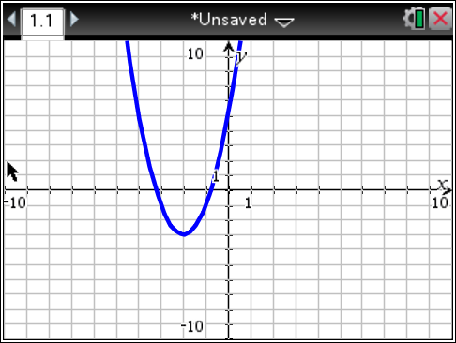 | 4. Find the equation of the parabola.  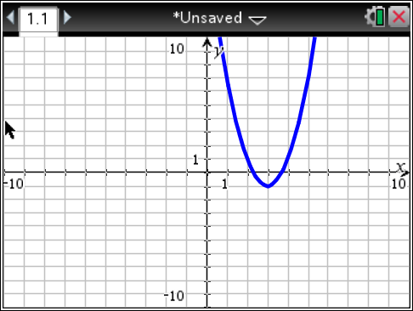
5. Find the equation of a parabola that has a vertex of (4,5) and contains the point (-2,-2). | 6. Find the equation of a parabola that has a vertex of (0,3) and has the point (7,0).
7. Find the equation of a parabola that has a vertex of (5,0) and has the point (0,-12). | 8. Find the equation of a parabola that has a vertex of (2, 0) passing through the point (1, 3).

