Vertex form of a Quadratic Function__________________________________

a: h: k:

Vertex: Axis of Symmetry:

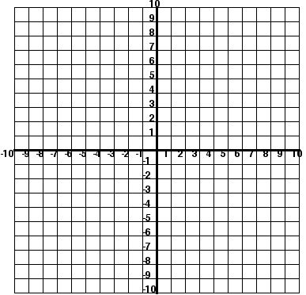
Vertex Form: f(x) = 2(x – 1)² + 5

a:________________________

h: ________________________

k: ________________________

Vertex (h, k):_______________

Axis of Symmetry (x = h): __________

Minimum or Maximum

Steps for Graphing in Vertex Form

