**Parabola Practice**

**Graph each of the following parabolas. Be sure to fill in all required information for each graph. You may use a calculator to find the intercepts and vertex. You may need to convert into standard form!**

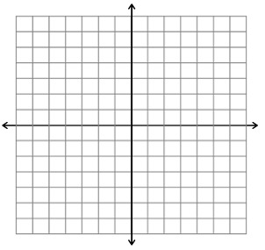1.) y = x2 – x - 6

Standard Form: Vertex:

Opens (circle): Up or Down Min. or Max.

Y-Intercept: Zero(s):

Domain: Range:

2.) y = 2x2 – x - 1



Standard Form: Vertex:

Opens (circle): Up or Down Min. or Max.

Y-Intercept: Zero(s):

Domain: Range:

3.) y = 2x2 + 2x - 4



Standard Form: Vertex:

Opens (circle): Up or Down Min. or Max.

Y-Intercept: Zero(s):

Domain: Range:

4.) y = (x – 2)2

Standard Form: Vertex:

Opens (circle): Up or Down Min. or Max.

Y-Intercept: Zero(s):

Domain: Range:

5.) y = 2(x – 1)2 + 1



Standard Form: Vertex:

Opens (circle): Up or Down Min. or Max.

Y-Intercept: Zero(s):

Domain: Range:

6.) y = 2x2 - 4



Standard Form: Vertex:

Opens (circle): Up or Down Min. or Max.

Y-Intercept: Zero(s):

Domain: Range: