1. Copy equation number 1 in the space below.
2. Identify the slope (m) and the y-intercept (b) of equation 1.
(You may need to convert it to y = mx +b).
3. Write the slope (m) in the space provided.
4. Write the y intercept (b) in the space provided.
5. Use a red crayon to graph equation 1 on the graph.
6. Repeat all of the steps above with equation 2. Use a blue crayon to graph the equation.
7. Answer the questions in complete sentences.

Station 1
 | Equation 1 | Equation 2
Equation

Slope intercept form

y = mx + b
Slope (m)
Y – intercept (b)
Graph | 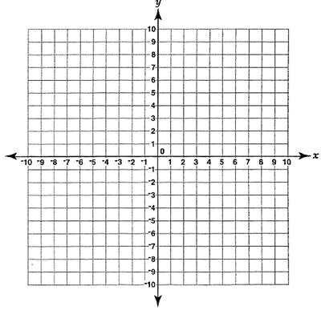

1. Do the two lines you graphed intersect (touch)?

If yes identify the ordered pair (x, y) where they meet _____________________

If no, describe the relationship of the two lines. _____________________________________
__________________________________________________________________________

2. Compare the slopes of equation 1 and equation 2. Are the slopes the same, different or opposite reciprocals?

3. Compare the y- intercepts of equation 1 and equation 2. Are the y intercepts the same or different?

 | Equation 1 | Equation 2
Equation

Slope intercept form

y = mx + b
Slope (m)
Y – intercept (b)
Graph

Station 2

1. Do the two lines you graphed intersect (touch)?

If yes identify the ordered pair (x, y) where they meet _____________________

If no, describe the relationship of the two lines. _____________________________________
__________________________________________________________________________

2. Compare the slopes of equation 1 and equation 2. Are the slopes the same, different or opposite reciprocals?

3. Compare the y- intercepts of equation 1 and equation 2. Are the y intercepts the same or different?

 | Equation 1 | Equation 2
Equation

Slope intercept form

y = mx + b
Slope (m)
Y – intercept (b)
Graph

Station 3
 | Equation 1 | Equation 2
Equation

Slope intercept form

y = mx + b
Slope (m)
Y – intercept (b)
Graph

Station 4

1. Do the two lines you graphed intersect (touch)?

If yes identify the ordered pair (x, y) where they meet _____________________

If no, describe the relationship of the two lines. _____________________________________
__________________________________________________________________________

2. Compare the slopes of equation 1 and equation 2. Are the slopes the same, different or opposite reciprocals?

3. Compare the y- intercepts of equation 1 and equation 2. Are the y intercepts the same or different?

Summary
 | When the lines Intersect | When the lines are Parallel | When the lines are the Same | When the lines are perpendicular
Describe the relationship of the slope of the two lines…

Describe the relationship of the y-intercept of the two lines…

Predict how each pair of lines will look when graphed.
1. y = 2x + 5
Y = -1/2x – 2

I predict the lines will______________ because____________________________________.

2. Y = 3x + 15
-3x + y = 15

I predict the lines will______________ because____________________________________.

3. Y = 3x + 5
y = 3x - 7

I predict the lines will______________ because____________________________________.

