Graph the following equations:

**2x+ 4y = 8**

**y = -1/2x + 2**

Graph the following equations:

**y= -2x + 1**

**2x + y = - 1**

Graph the following equations:

**-2x + y = – 3**

**y = x - 1**

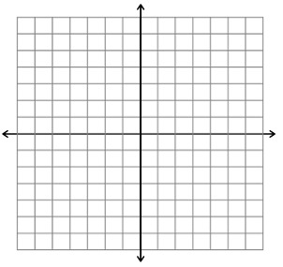

Infinitely many solutions because the two lines are the same. Any x value will give you the same y value for both equations.

One solution at the set of ordered pairs where the two lines cross.

No solutions because the two lines never intersect.

**No Solution**

**One Solution**

**Infinitely Many**

**Solutions**

**Parallel Lines**

**Intersecting Lines**

**Same Line**