Graph the solutions on a number line.

1. x ≤ 7 2. x > -8 3. 1 > x



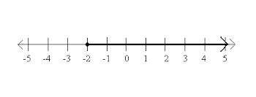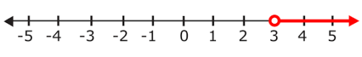Write an inequality for the graph.

1. 2. 3.

Define a variable and write an inequality to model each situation.

1. The temperature in a refrigerated truck must be kept at or below 38°F.

2. The temperature of water must be 33°F or higher to keep it a liquid.

Solve the inequalities.

1. n - 7 > 2 2. 7 + b <13 3. 12 + d + 3 <10

4.  > **-**6 5. -7c <28 6. 2z + 7 <z + 10

7. 2(3 + 3g) > 2g + 14 8. 3j + 2 - 2j <-10

1. Jim Harbaugh called me yesterday to help him with some math. He solved the inequality

-5x > 20 like this. What should I tell him so he gets the correct solution?

2. Big Sean is taking an online algebra class. He submitted this work to his professor. Is he correct? If not, tell him how he can correct his mistake.

****(2t + 8) >4 + 6t

Write and solve an inequality for each word-problem.

|  |
| --- |
| 1. Suppose Abdullah and Ian are planting trees. Together they can plant 8 trees per hour. What is the greatest number of hours that Abdullah and Ian would need to plant at most 40 trees. |
| 2. Suppose the physics club is going on a field trip. Members will be riding in vans that will hold 7 people each including the driver. At least 28 people will be going on the trip. What is the lease number of vans needed to make the trip? |
| 3. Zeinab is going to a carnival. Suppose it costs $5 for her to enter the carnival. Each ride costs $1.25. She has $15 to spend at the carnival. What is the greatest number of rides that she can go on? |
| 4. Keith is renting a car to drive William to see Vanilla Ice in concert. The cost to rent a car is $19.50 plus $.25 per mile. If he has $44 to rent a car, what is the greatest number of miles that he can drive? |
| 5. The student council is sponsoring a concert as a fund-raiser. Tickets are $3 for students and $5 for adults. The student council wants to raise at least $1000. If 200 students attend, how many adults must attend? |
| When do you need to flip the inequality symbol? __________________________________________.  Write an example of an inequality that would require you to flip the inequality sign when you solved the problem: |