Example:

Graph 3x + 5y = 15

Method 1

Convert to Slope Intercept Form and graph.

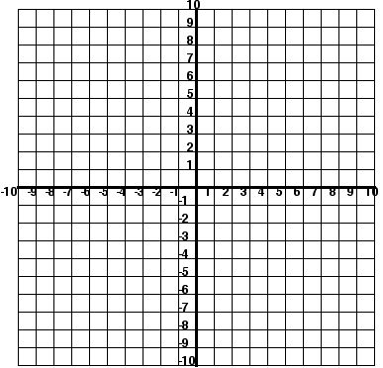

Example:

Graph 3x+ 5y = 15

Method 2:

Find the x and y intercepts and graph

