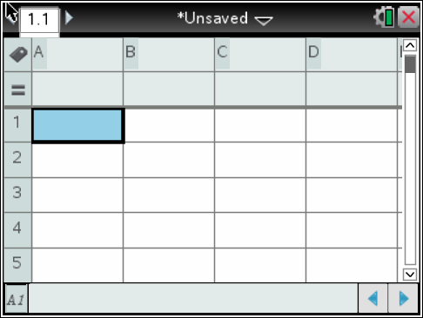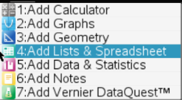**Input Data:**

1. Home🡪New Document🡪Lists & Spreadsheets 🡪

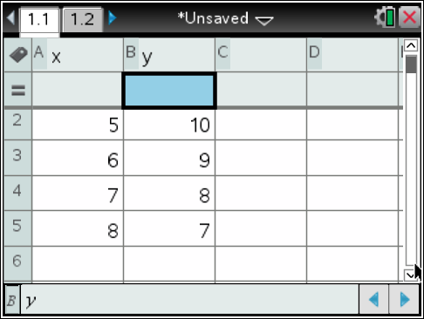2. Type the name of the x-axis data in Box A

3. Type the name of y-axis data in Box B

4. Enter the data in the appropriate column

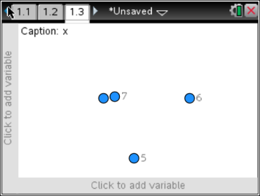**Creating a Scatterplot:**

(Note: Your graph may look different at this point – we have not assigned the variables yet!)

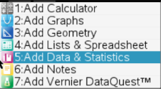5. Ctrl🡪Doc🡪Data & Statistics

6. Add the variable to x axis and to the y axis.

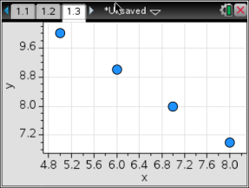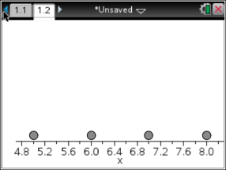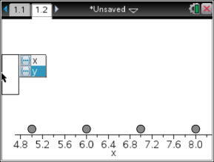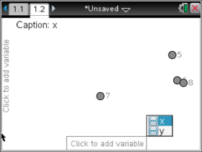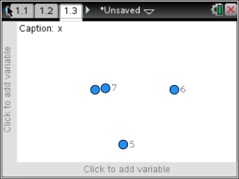

**Find the line of Best Fit:**

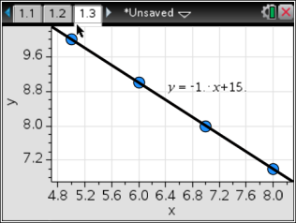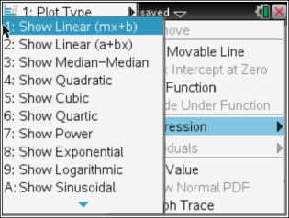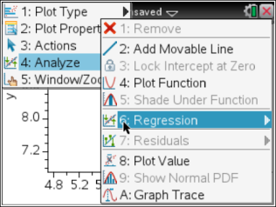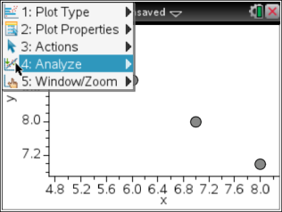8. Menu🡪Analyze🡪Regression🡪Show linear (mx + b)

9. Poof! There’s your line of best fit and equation in y = mx + b form.

**Correlation Coefficient:**

10.) Go back to your data table on page 1 (You can push CTRL 🡪 Left Arrow to “turn” the page.)

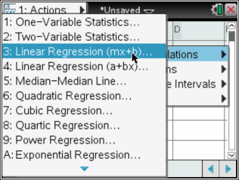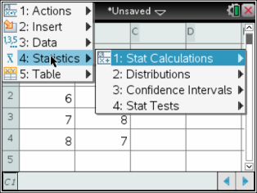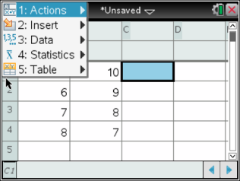11.) On the data table: **Menu 🡪 Statistics 🡪 Stat Calculations 🡪 Linear Regression (mx + b)**

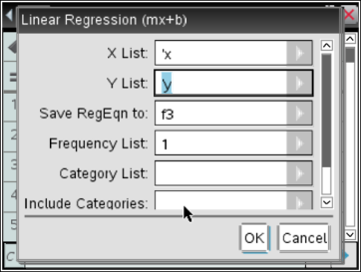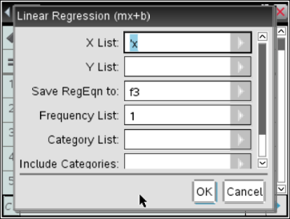12.) When you get to the Linear Regression “pop-up”, you need to:

set the x list: and y list:

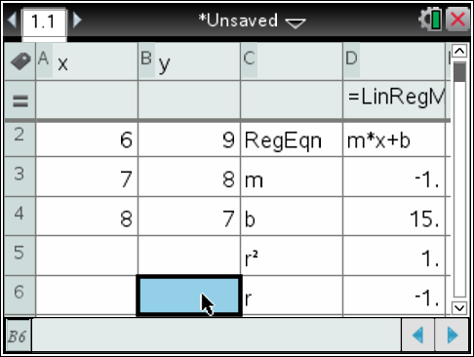13.) After you click ok, you should see the regression information fill in the table.

14.) Identify the **‘r’** value which represents the correlation coefficient.

15.) Using the correlation coefficient, determine if the correlation is positive, negative, or none and if it is strong or weak.

Name: ____________________ Date: __________ Hour: _____

Practice finding the line of best fit with each of the given data sets. Identify the slope, y-intercept and equation for each line.

1.)

|  |  |
| --- | --- |
| ***Ice Cream Sales vs Temperature*** | |
| **Temperature °C** | **Ice Cream Sales** |
| 14.2° | $215 |
| 16.4° | $325 |
| 11.9° | $185 |
| 15.2° | $332 |
| 18.5° | $406 |
| 22.1° | $522 |
| 19.4° | $412 |
| 25.1° | $614 |
| 23.4° | $544 |
| 18.1° | $421 |
| 22.6° | $445 |
| 17.2° | $408 |

1. What is the slope and y-intercept?

2. What type of correlation is there (if any) between temperature and ice cream sales?

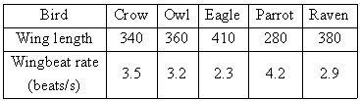

2.)

1. What is the slope and y-intercept?

2. What type of correlation is there (if any) between wing length and wing beat?

3.)

1. What is the slope and y-intercept?

2. What type of correlation is there (if any) between height and weight?

|  |  |
| --- | --- |
| Height  Inches | Weight  Pounds |
| 44 | 47 |
| 50 | 57 |
| 38.5 | 32 |
| 39 | 42 |
| 41 | 36 |
| 48 | 62 |
| 51 | 47 |
| 53 | 65 |
| 50.5 | 65 |
| 46.5 | 52 |
| 45 | 43 |
| 48 | 61 |

4.)

|  |  |  |  |  |  |  |  |  |
| --- | --- | --- | --- | --- | --- | --- | --- | --- |
| Speed (mi/h) | 10 | 15 | 20 | 25 | 30 | 35 | 40 | 45 |
| Stopping Distances (ft.) | 27 | 44 | 63 | 85 | 109 | 136 | 164 | 196 |

1. What is the slope and y-intercept?

2. What type of correlation is there (if any) between speed and stopping distance?

Find slope (m), y-intercept (b) and correlation coefficient (r)



