6-2 Slope intercept form of a linear equation Part 2

Linear? Yes No  m = _____  y-intercept = _____  equation y = mx + b: _______________ | Linear? Yes No  m = _____  y-intercept = _____  equation y = mx + b: _______________
  X | Y
  -2 | 4
  -1 | 6
  0 | 8
  1 | 10
  2 | 12
  X | Y
  0 | -3
  1 | -1
  3 | 1
  6 | 3
  7 | 5

Determine if each ordered pair is a solution to the function.

Ordered Pair | Work or Explanation | Solution?
(0, 0)

(0,1)

(2,5)

(-2, -3)

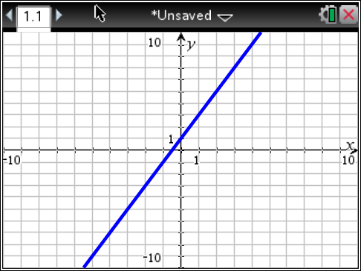
Determine if each ordered pair is a solution to the function f(x) = -3x + 2
Ordered Pair | Work or Explanation | Solution?
(0, 5)

(-1,5)

(1,-1)

(-2,5)

Evaluate the function f(x) = -3x + 1 for the given domain values.  {0,1,2} | Mrs. Talley sells pencils for $0.25. Her profit for each pencil she sells is $0.05. Her profit can be represented by the function rule P(x) = 0.05x, where x represents the number of pencils sold and P(x) represents her total profit. How much profit does Mrs. Talley make if she sells 50 pencils? 100 pencils? 1000 pencils?
Slope Intercept Practice Part 2

Linear? Yes No  m = _____  y-intercept = _____  equation y = mx + b: _______________ | Linear? Yes No  m = _____  y-intercept = _____  equation y = mx + b: _______________
  X | Y
  -2 | -10
  0 | -5
  2 | 0
  4 | 5
  6 | 10
  X | Y
  -12 | 2
  -9 | 8
  -6 | 14
  -3 | 20
  0 | 26

Determine if each ordered pair is a solution to the function.

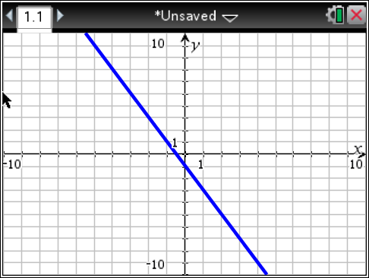
Ordered Pair | Work or Explanation | Solution?
(0, -1)

(-1,1)

(1,-1)

(-2, 3)

Determine if each ordered pair is a solution to the function.
Ordered Pair | Work or Explanation | Solution?
(0, -1)

(-1,6)

(1,5)

(-2,5)

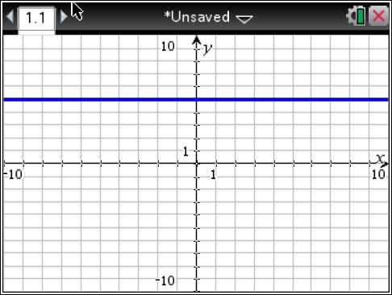

Determine if each ordered pair is a solution to the function f(x) = x + 5
Ordered Pair | Work or Explanation | Solution?
(0, 5)

(-1,4)

(1,6)

(-2,5)

Evaluate the function f(x) = -2x – 3 for the given domain values.  {-3,-1,0} | Evaluate the function f(x) = -x - 10 for the given domain values.  {0,1,2}
Jenna sells highlighters for $0.50. Her profit for each highlighter she sells is $0.10. Her profit can be represented by the function rule P(x) = 0.10x, where x represents the number of highlighters sold and P(x) represents her total profit. How much profit does Jenna make if she sells 25 highlighters? 50 highlighters? 100 highlighters? | Myles sells slushies for $2.00. His profit for each slushie he sells is $0.50. His profit can be represented by the function rule P(x) = 0.50x, where x represents the number of slushies sold and P(x) represents his total profit. How much profit does Myles make if he sells 25 slushies? 50 slushies? 0 slushies?
Melony sells mittens for $5.00. Her profit for each pair of mittens she sells is $2.50. Her profit can be represented by the function rule  P(x) = 2.50x, where x represents the pairs of mittens sold and P(x) represents her total profit. How much profit does Melony make if she sells 30 pairs of mittens? 60 pairs of mittens? 75 pairs of mittens? | Yousif sells trains for $10.00. His profit for each train he sells is $4.00. His profit can be represented by the function rule P(x) = 4.00x, where x represents the number of trains sold and P(x) represents his total profit. How much profit does Yousif make if he sells 10 trains? 45 trains? 70 trains?

