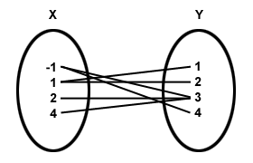 | x y  1 2  2 4  1 6  3 8  4 10  5 12
x y  1 2  2 4  3 6  4 8  5 10  6 12 | 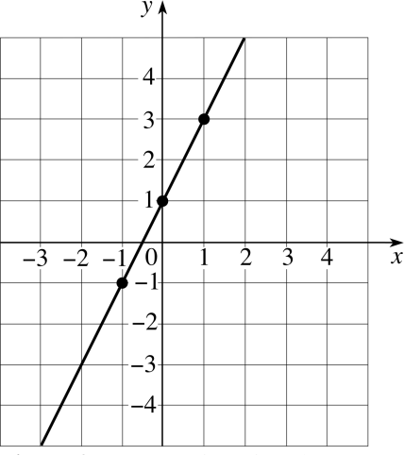
{(2,5), (5,2), (6,3), (4,9), (8,2)} | A vertical line
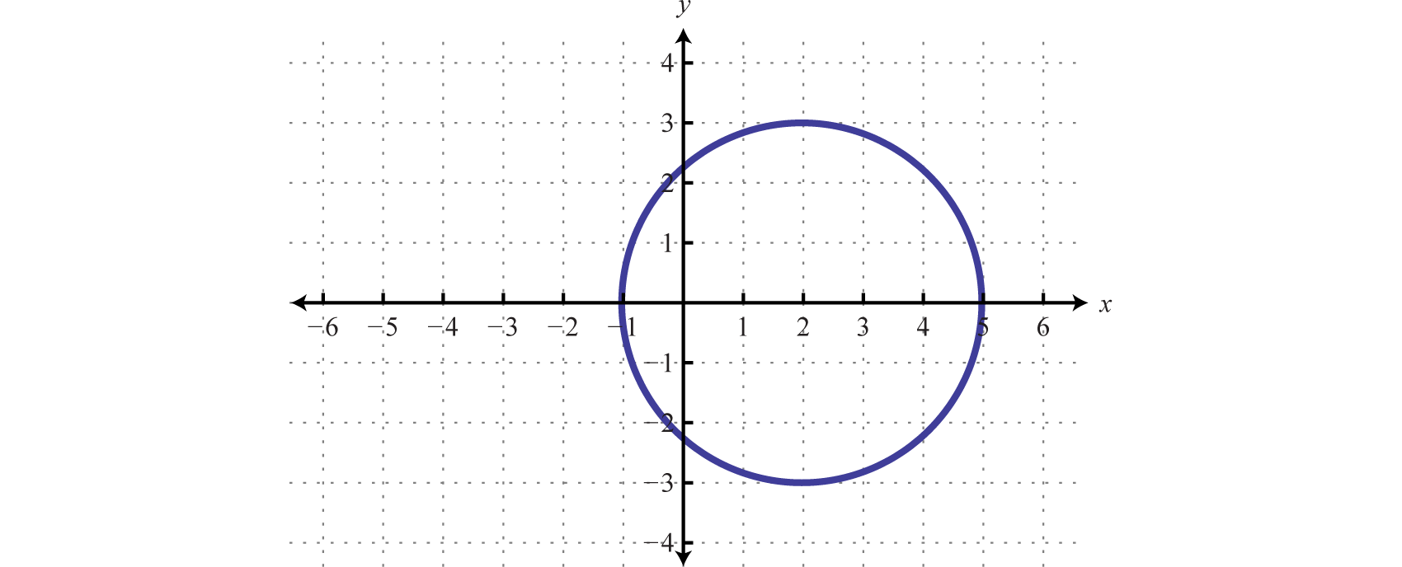 | 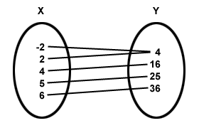
{(-2,10), (-3,10), (5,10), (1,10),(0,10)} | A horizontal line

1. Open your notebook to the Table of Contents. Fill in Page 6, Function or Not a Function and todays date.
2. Go to page 6 of your notebook. Draw a line down the middle of the page. Label the left column “Function” and the right column “Not a Function”.
3. Examine the relations on the blue paper. Determine which relations are functions. Place the relations in the appropriate column. Have a teacher check your work. Glue the relations in your notebook.

