**ALGEBRA 1 CLASS GUIDE**

**Dearborn High School**

**2015-2016**

**Mrs. Cindy Talley**

**Room: A5**

**Voice Mail: (313) 827-8314**

**Email:** **talleyc@dearbornschools.org**

**CURRICULUM:** This class follows the Common Core for Algebra 1 by addressing Solving Equations/Inequalities, Function Essentials, Linear Function Applications and Essentials, Systems of Linear Equations, Exponent Properties, Exponential Functions, Adding/subtracting/multiplying Polynomials, Factoring Quadratics, Understanding and Solving Quadratics, Literal Equations, Family of Functions, and Unit Analysis.

**CLASS RULES:** BE NICE

TELL THE TRUTH

OFFER TO HELP

CLEAN UP

DON’T GIVE UP

**CLASS POLICIES:**

* Be present each day and arrive to class on time, the school attendance and tardy policies will be enforced.
* Bathroom passes will not be issued during instructional time or during the first 10 or last 10 minutes of class.
* The use of electronic devices is not permitted in class and will result in the device being confiscated and turned in to the main office for parent pickup.

**SUPPLY LIST:**

* One 3-ring binder (1” wide) with 4 dividers *(may be kept in class)*
* Notebook paper
* One subject spiral notebook (*Provided)*
* #2 Pencils with erasers
* Homework Folder
* Ti-Nspire Calculator – *(Provided in class, Recommended for home. iPad app available.)*
* Nice to have: Individual Pencil Sharpener/Erasers/Highlighters/Ruler/Colored Pencils

**GRADING SCALE:**

A 93 -100% A- 90 – 92%

B+ 87 – 89% B 83 – 86% B- 80 – 82%

C+ 77 – 79% C 73 – 76% C- 70 – 72%

D+ 67 – 69% D 63 – 66% D- 60 – 62%

E 59 – 0%

**FORMATIVE GRADES** (20% of overall semester grade):

**Classwork:** Classwork grades are recorded about twice a week and reflect the student’s active participation in class. Classwork grades are not eligible for make up or resubmission.

**Homework:** Homework is collected randomly, about once a week, and may be corrected and resubmitted for a higher score until a test or quiz is given on that material. Grades for missed assignments will not be recorded or changed after a student has taken a quiz or test on that material.

**SUMMATIVE GRADES** (80% of overall semester grade):

**Quizzes/Tests/Projects:** Quizzes are given throughout the units to assess student learning and discover areas for improvement. Tests and projects are given at least once per unit to show mastery of unit concepts. Tests can be retaken only if the student has completed ALL of the assignments for the sections covered on the test prior to the original test date. There are no retakes for quizzes or projects.

**Final Exam:**  A comprehensive final exam is given at the end of the semester covering all material given during the entire semester and counts for approximately 10% of the overall semester grade. All students are expected to complete a final exam during the scheduled finals week. If the exam is not taken, it could result in a 0% “E” grade for this assessment.

**EXTRA HELP:** I amavailable before school by appointment from 6:45 to 7:15.

**COMMUNICATION:** The best way to contact Mrs. Talley is through email. You can expect a response within 24 hours.

Parents/guardians and students are encouraged to sign up for REMIND and the Team Talley iBlog for information and reminders.

**Team Talley iBlog address**: http://iblog.dearbornschools.org/talley/

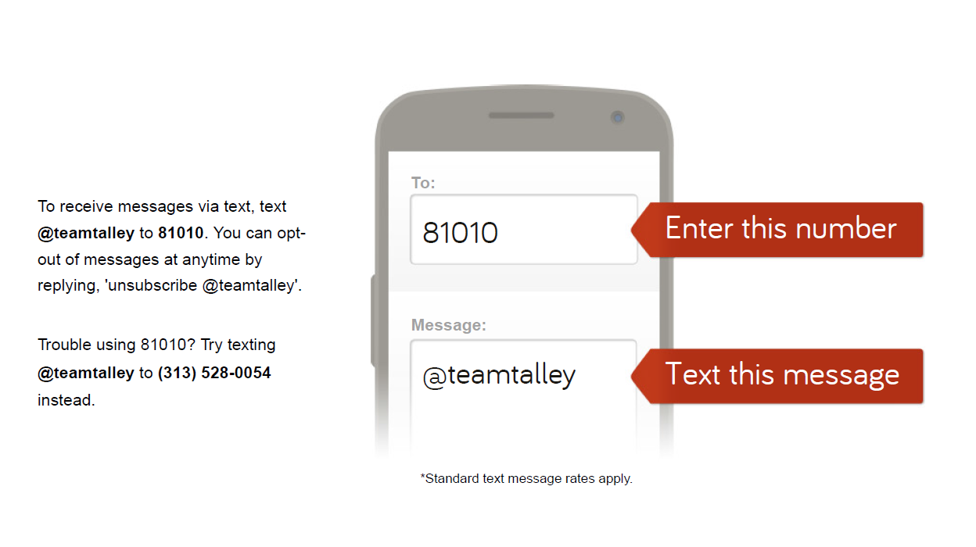

**Policies and Procedures Contract** – **Due Monday, September 14, 2015**

**Student Name:** ___________________________________________ **Hour:** _______

Student Email:________________________________________

**Parent/guardian #1 Name:**______________________________________________

Parent/guardian #1 Phone: __________________________________

Parent/guardian #1 Email: ___________________________________

**Parent/guardian #2 Name:**______________________________________________

Parent/guardian #2 Phone: __________________________________

Parent/guardian #2 Email: __________________________________

Please review the class overview then sign below stating that you have read and understand the policies and procedures.

_____________________________________________ ________________

Parent/guardian Signature Date

Questions, Comments or Concerns: ___________________________________________________________________________________________________________________________________________________________________________________________________________________________

