A relation is ____________________________________________________

A function is ____________________________________________________

D | I | X | R | O | Y

Find the Domain and Range of the relation {(5,2), (-3, 0), (-2,4), (4,-2),  (-1,2)}  Domain:__________________  Range:___________________ | Determine whether the relation is a function {(7,-3), (-9, 2), (12,-2), (-9,6)}  Domain:_________________  Range:__________________  Function (circle) YES NO  Why?
Determine whether the relation is a function using a mapping diagram  {(10,-4), (7, 6), (15,-4), (21,9)}  X Y  Function (circle) YES NO  Why? | Determine whether the relation  {(4, 3), (6, 4), (1, -1), (4, -5 )} is a function using the vertical line test.  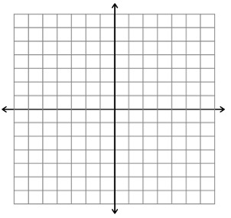  Function (circle) YES NO  Why?

