RELATIONS AND FUNCTIONS PRACTICE

- I can identify functions using a mapping diagram or a vertical line test.
- I can evaluate functions.

Describe in your own words or with a diagram.

Relation | Function
Domain | Range

Find the Domain and Range of the relation {(4,3), (-2, 1), (-1,3), (4,-2),  (-1,1)} | Find the Domain and Range of the relation {(5,3), (-4, 10), (-12,5), (4,-6), (11,5)}
Find the Domain and Range of the relation | Determine whether the relation is a function using a mapping diagram  {(11,-2), (12, -1), (13,-2), (20,7)}
  x | y
  5 | 1
  4 | 0
  3 | -1
  2 | -2
Determine whether the relation is a function using a mapping diagram  {(-2,-1), (-1, 0), (6,3), (-2,1)} | Determine whether the relation is a function using a mapping diagram  {(3,-2), (8,1), (9,2), (3,3), (-4, 0)}
Determine whether the relation is a function using a mapping diagram  {(6,0), (7,-1), (6,2), (2,6), (5, -1)} | Determine whether the relation  {(3, 0), (−2, 1), (0, −1), (−3, 2), (3, 2)} is a function using the vertical line test  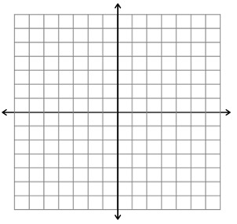
Determine whether the relation  {(3, 7), (3, 5), (3, −2), (3, 4), (3, 1)} is a function using the vertical line test. | Determine whether the relation  {(6, -7), (5, 6), (1, 4), (4, 5)} is a function using the vertical line test.

