Unit 6 REVIEW

Identify each of the equations as being in standard form, point slope form or slope intercept form.
1. y = 3x + 2 | 2. y - 1 = 2(x + 3) | 3. 8x - 2y = 16
4. y - 3 = -2(x + 3) | 5. y = -8x + 5 | 6. -4x – 6y = 12

7.  Write an equation of a line with slope -3 and passes through the point (-1,7). | Solution:_________________________
8.  Identify the slope and a point from the given equation.  y – 2 = (x – 3) | Solution:_________________________
9.  Identify the slope and a point from the given equation.  y + 3 = -2(x – 3) | Solution:_________________________
10.  The ninth grade class holds a car wash to raise money to send Mrs. Talley to try out for The Voice. A wash costs $5 per car and $6 per truck. Write an equation in standard form to relate the number of cars and trucks the students must wash to raise $3000.00. | Solution:_________________________
11.  Kevin runs at an average rate of 6 miles per hour. He walks at a rate of 3 miles per hour. Write an equation in standard form to relate the times he could spend walking and running to travel a distance of 24 miles. | Solution:_________________________
12.  Graph y + 2 = -1/2(x +3) | 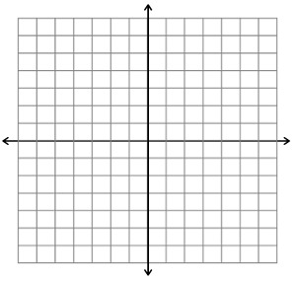
13.  Find the x and y intercepts 2x + 3y = 6 then graph the equation. | x –intercept:___________  y-intercept:___________
14.
Find the x and y intercepts of 3x +5y = 15

