6-4 Point slope form of a linear equation (Part 1)

I can graph and write linear equations in point slope form.
I can identify linear equations in slope-intercept form, standard form and point slope form.
I can identify the slope and a point on a line when given a slope and y intercept.

Point slope form:

Slope Intercept form:

Standard Form:

Identify each of the equations as being in standard form, slope-intercept form or point slope form.

y = 3x + 2 | y - 1 = 2(x + 3) | 8x - 2y = 16
y - 3 = -2(x + 3) | y = -8x + 5 | -4x – 6y = 12
y - 2 = -(x + 3) | y + 6 = -1/2(x + 5) | y = -1/4x - 9
x + y = 5 | -9x + 3y = 18 | y - 2 = -2(x -2)

Writing Equations in Point Slope Form
Write an equation of a line with slope -3 and passes through the point (-1,7)

Write an equation of a line with slope 5 and passes through the point (-2,-5)

Write an equation of a line with slope 1/2 and passes through the point (10,-8)

Write an equation of a line with slope 1/2 and passes through the point (10,-8)

Identify the slope and a point from the given equation.

y – 2 = (x – 3)

Identify the slope and a point from the given equation.

y + 2 = 2(x – 3)

Identify the slope and a point from the given equation.

y – 2 = -3/2(x + 3)

Identify the slope and a point from the given equation.

y + 3 = -2(x – 3)

Graph the equation y-5 = ½( x-2)
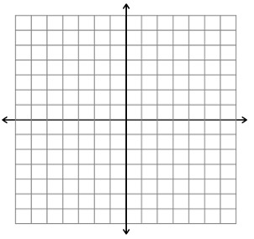
Graph the equation y + 2 = -3/2( x + 3)

Graph the equation y - 1 = -( x + 3)

Graph the equation y - 4 = -2( x - 2)

Graph the equation y + 2 = -1/2( x + 3)

Is the relationship shown by the data linear? If it is, model the data with an equation.

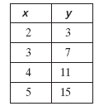

Is the relationship shown by the data linear? If it is, model the data with an equation.
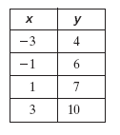

Is the relationship shown by the data linear? If it is, model the data with an equation.
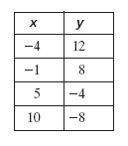

Is the relationship shown by the data linear? If it is, model the data with an equation.
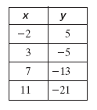

Write an equation of each line in point-slope form.

Write an equation of each line in point-slope form.

Write an equation of each line in point-slope form.

A line passes through the given points. Write an equation in point slope form. Then write the equation in slope intercept form.

(5, 7), (6, 8)
A line passes through the given points. Write an equation in point slope form. Then write the equation in slope intercept form.

(1, 2), (3, 8)
A line passes through the given points. Write an equation in point slope form. Then write the equation in slope intercept form.

(4, 2), (–4, –2)
A line passes through the given points. Write an equation in point slope form. Then write the equation in slope intercept form.

(8, –2), (14, 1)
A line passes through the given points. Write an equation in point slope form. Then write the equation in slope intercept form.

(–3, 4), (1, 6)

