6-1
82) Find the slope of the line. (Count up and over). 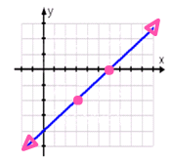
83) Find the slope of the line containing (4, -1) and (-3, 7).
Use the slope formula: $\frac{y_{2}−y_{1}}{x_{2}−x_{1}}$
6-2 and 6-3
(Remember slope-intercept form: y = mx + b; m = slope and b = y-intercept.)
Identify the slope and y-intercept for each equation.
84) y = 2x + 3 85) y = 3 – ¼ x
m = _____ b = _____ m = _____ b = _____

86) Write the equation of the line with slope 2 and y-intercept -1. _______________

For 6-8, graph each equation and tell what the slope of the line is.

87) y = -3x – 4 88) 4x – 2y = 12 89) Graph y = -2 90) Graph x = 4
