6-2 Slope intercept form of a linear equation Part 2

I can determine if an equation is linear from a table and a graph.
I can determine when an ordered pair is a solution to a linear equation.
I can evaluate linear functions.

Slope intercept form:

Every point on the _________is a ____________to the ___________ ________________.

If the _______ _______ does not lie on the ______ of a line, then it is not a ___________.

Linear? Yes No  m = _____  y-intercept = _____  equation y = mx + b: _______________ | Linear? Yes No  m = _____  y-intercept = _____  equation y = mx + b: _______________
  X | Y
  -2 | 4
  -1 | 6
  0 | 8
  1 | 10
  2 | 12
  X | Y
  0 | -3
  1 | -1
  3 | 1
  6 | 3
  7 | 5

X  Linear? Yes No  m = _____  y-intercept = _____  equation y = mx + b: _______________ | Linear? Yes No  m = _____  y-intercept = _____  equation y = mx + b: _______________
  Y
  -2 | -10
  0 | -5
  2 | 0
  4 | 5
  6 | 10
  X | Y
  -12 | 2
  -9 | 8
  -6 | 14
  -3 | 20
  0 | 26
Determine if each ordered pair is a solution to the function.

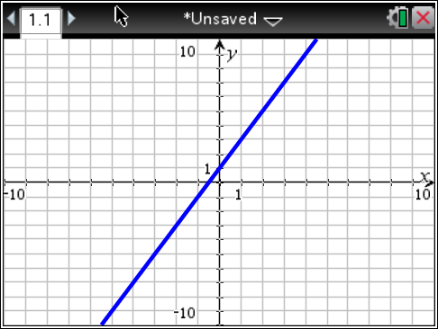
Ordered Pair | Work or Explanation | Solution?
(0, 0)

(0,1)

(2,5)

(-2, -3)

Determine if each ordered pair is a solution to the function.

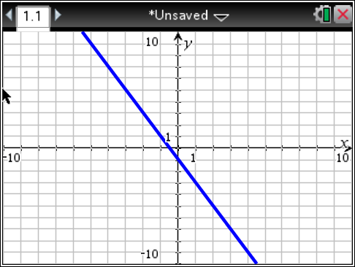
Ordered Pair | Work or Explanation | Solution?
(0, -1)

(-1,1)

(1,-1)

(-2, 3)

Determine if each ordered pair is a solution to the function.
Ordered Pair | Work or Explanation | Solution?
(0, -1)

(-1,6)

(1,5)

(-2,5)

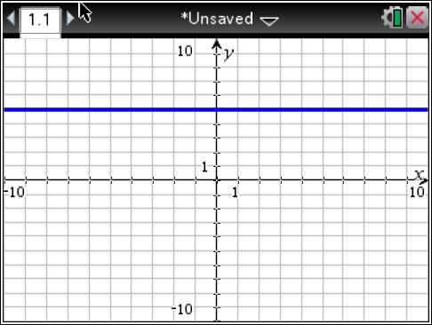

Determine if each ordered pair is a solution to the function f(x) = x + 5
Ordered Pair | Work or Explanation | Solution?
(0, 5)

(-1,4)

(1,6)

(-2,5)

Determine if each ordered pair is a solution to the function f(x) = -3x + 2
Ordered Pair | Work or Explanation | Solution?
(0, 5)

(-1,5)

(1,-1)

(-2,5)

Determine if each ordered pair is a solution to the function y = 2x - 5
Ordered Pair | Work or Explanation | Solution?
(0, 5)

(-2,-9)

(1,-3)

(4,3)

Evaluate the function f(x) = -3x + 1 for the given domain values.  {0,1,2} | Evaluate the function y = x for the given domain values.  {5,6,7}
Evaluate the function f(x) = -2x – 3 for the given domain values.  {-3,-1,0} | Evaluate the function f(x) = -x - 10 for the given domain values.  {0,1,2}
Mrs. Talley sells pencils for $0.25. Her profit for each pencil she sells is $0.05. Her profit can be represented by the function rule P(x) = 0.05x, where x represents the number of pencils sold and P(x) represents her total profit. How much profit does Mrs. Talley make if she sells 50 pencils? 100 pencils? 1000 pencils? | Julius sells slushies for $2.00. His profit for each slushie he sells is $0.50. His profit can be represented by the function rule P(x) = 0.50x, where x represents the number of slushies sold and P(x) represents his total profit. How much profit does Julius make if he sells 25 slushies? 50 slushies? 0 slushies?
Casandra sells mittens for $5.00. Her profit for each pair of mittens she sells is $2.50. Her profit can be represented by the function rule  P(x) = 2.50x, where x represents the pairs of mittens sold and P(x) represents her total profit. How much profit does Casandra make if she sells 30 pairs of mittens? 60 pairs of mittens? 75 pairs of mittens? | Thomas sells trains for $10.00. His profit for each train he sells is $4.00. His profit can be represented by the function rule P(x) = 4.00x, where x represents the number of trains sold and P(x) represents his total profit. How much profit does Thomas make if he sells 10 trains? 45 trains? 70 trains?

