6-3 Standard Form of a Linear Equation Part 2

I can write an equation in standard form.

I can graph equations in standard form using x and y intercepts.
I can graph equations in slope-intercept form.

Standard Form

The ninth grade class holds a car wash to raise money to send Mrs. Talley to try out for The Voice. A wash costs $4 per car and $5 per truck. Write an equation in standard form to relate the number of cars and trucks the students must wash to raise $1000.00

Hassan² runs at an average rate of 6 miles per hour. He walks at a rate of 3 miles per hour. Write an equation in standard form to relate the times he could spend walking and running to travel a distance of 18 miles.

Moe sells packs of gum and candy bars to raise money to go to summer math camp. A pack of gum costs .50 per pack and the candy bars cost $1.00. Write an equation in standard form to relate packs of gum and the number of candy bars Moe must sell to earn $500.00.

Alondra skips at an average rate of 6 miles per hour. She roller skates at a rate of 8 miles per hour. Write an equation in standard form to relate the times she could spend skipping and skating to travel a distance of 24 miles.

Graph x + y = 3

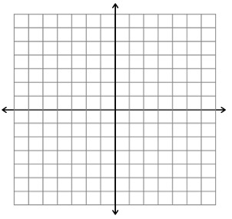

Graph x + 3y = -3

Graph y = 6

Graph 5x – 4y = -20

Graph 3x – 5y = 15

Graph -3x + 5y = 15

Graph 7x + 3y = 21

Graph x = -5

Graph 2x + 3y = 6

