1-3 Scatterplots
I can create an appropriate scatterplot for the given data.
I can draw a line of best fit using the box method.
I can write an equation of the line of best fit using slope and y intercept.

Remember:

y- intercept: ______________________________________________________________________________________________________________________________________________

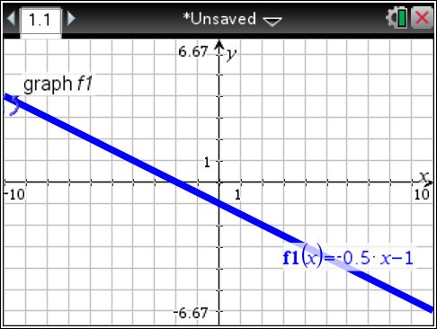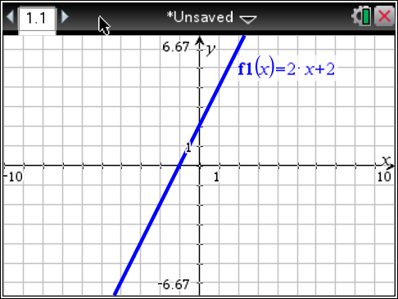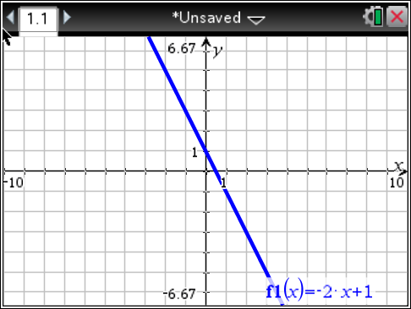

Slope intercept form: ______________________________________________________________________________________________________________________________________________

Formula for slope:

1.) For each set of data, graph the points on the grid paper. Lay your straw along your best – fit line. Approximate the value for the y-intercept. Pick 2 points that the line goes through. They do not need to be one of the given points. Apply the slope formula. Draw your line of best fit.

a.)
x | y
.9 | 3
2.5 | 2.2
2.9 | 2.8
4 | 4
5.1 | 5
6 | 6
7.2 | 7
7.9 | 5.9

Approximate y-intercept: _______________

Identify x ₁ : __________ Identify x ₂ : __________
Identify y ₁ : __________ Identify y ₂ : __________
Write out the formula for finding the slope of a line:
Apply the formula using the given points:

Equation of the line: _________________________
b.)
x | y
.8 | 3
1.5 | 2.2
2.5 | 4.4
4 | 5.3
5.1 | 5
5.5 | 6.9
6.1 | 6
7.4 | 7

Approximate y-intercept: _______________

Identify x ₁ : __________ Identify x ₂ : __________
Identify y ₁ : __________ Identify y ₂ : __________

Write out the formula for finding the slope of a line:

Apply the formula using the given points:

Equation of the line: _________________________

c.)
x | y
1.4 | 7
2.2 | 6.1
2.5 | 4.7
4 | 3.9
5 | 5.1
6 | 3.5
7.5 | 2
8.9 | 2.5

Approximate y-intercept: _______________

Identify x ₁ : __________ Identify x ₂ : __________
Identify y ₁ : __________ Identify y ₂ : __________

Write out the formula for finding the slope of a line:

Apply the formula using the given points:

Equation of the line: _________________________

d.)
x | y
.9 | 2.9
1.5 | 3.8
2.7 | 3.9
4 | 3.7
5 | 5
5.9 | 6.6
6.1 | 5.9
7.1 | 6.9

Approximate y-intercept: _______________

Identify x ₁ : __________ Identify x ₂ : __________
Identify y ₁ : __________ Identify y ₂ : __________

Write out the formula for finding the slope of a line:

Apply the formula using the given points:

Equation of the line: _________________________

e.)
x | y
.6 | 3
1.2 | 2.2
2.2 | 4.2
3.4 | 6
4.8 | 6.2
6 | 5.9
6.9 | 5.2
7.8 | 5.7

Approximate y-intercept: _______________

Identify x ₁ : __________ Identify x ₂ : __________
Identify y ₁ : __________ Identify y ₂ : __________

Write out the formula for finding the slope of a line:

Apply the formula using the given points:

Equation of the line: _________________________

f.)
x | y
1.2 | 6.3
1.5 | 8
2.1 | 7.1
2.2 | 5.8
6 | 2.9
6.5 | 1.5
7 | 3
7.2 | 1.1

Approximate y-intercept: _______________

Identify x ₁ : __________ Identify x ₂ : __________
Identify y ₁ : __________ Identify y ₂ : __________

Write out the formula for finding the slope of a line:

Apply the formula using the given points:

Equation of the line: ________________________

