5-3 Modeling Functions

I can model functions using rules, tables and graphs

Independent variable:

Dependent variable:

- Draw three separate coordinate planes on your graph paper. Label the x and y axes.
- For each table, graph the set of ordered pairs. Label your graphs A, B, and C.
- Connect the points. What shape do you see on your graph? Does your graph represent a function?
- Do you see any kind of pattern on your graph or in the table? If so, describe the pattern on your paper by the table or graph.

x | y
-3 | 9
-2 | 4
0 | 0
2 | 4
3 | 9
x | y
-3 | -7
-2 | -4
-1 | -1
0 | 2
2 | 8

x | y
-4 | 4
-2 | 2
0 | 0
2 | 2
4 | 4

Three views of a function:
Model the function rule y = ½x+3 using a table of values and a graph.
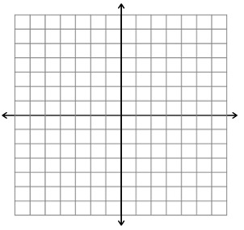

Model the function f(x) = 3x + 4 with a table of values and a graph

Graph the function f (x) = |x|
Graph the function y = x²
Model the function f(x) = 2^{x} using a table of values and a graph.

Model the function y = 2^{x} + 3 using a table of values and a graph

Model the function f(x) = |x| + 2 using a table of values and a graph
What are the three ways we can model a function?
1._______________ 2.__________________3.____________________

Describe the shape of the graph of y = x + 2

Describe the shape of the graph of y = x²

Describe the shape of the graph of y = |x|

Describe the shape of the graph of y = 2^{x}

