Algebra 1 – Final Exam Review Name ___________________
Second Semester Date __________ Hour _____

Chapter 7

For #1-3, graph each system of equations. Tell whether the system has no solution, one solution, or infinitely many solutions.

1) y = 3x – 1 2) y = 4x – 2 3) x + 3y = 9
y = 3x + 4 y = -2x + 2 2x + y = 8

4) The length of a rectangle is 2 in more than four times the width. If the perimeter of the rectangle is 64 in, what are its dimensions?

Solve each system of equations by substitution.

5) y = x + 3 6) x + 2y = -1 7) y = x - 7
y = 3x + 1 y = 3x – 11 2x + y = 8

Solve this system of equations by elimination.

8) 3x – 2y = -8 9) 3x + y = 20 10) x + 8y = 28
2x + 2y = -2 x + y = 12 -3x + 5y = 3

Chapter 8

Simplify each expression.

1) $3^{−2}$ 2) $\frac{7}{a^{−3}b^{2}}$ 3) -4x² · 5x³ 4)

5) (2rs⁴)³ (rs)⁵ 6) (3m⁶)(m²)(4k⁰) 7) (4b³)²

8) ${\left(\frac{−3a^{4}b^{−3}c^{2}}{−2a^{−8}b^{9}c^{−3}}\right)}^{0}$ 9) $\frac{−2x^{5}y^{−3}}{z^{−2}}$ 10) $−3d^{−4}⋅5d^{9}$

11)  12) $(t^{−2})^{6}$ 13) $\frac{x^{8}}{x^{−7}}$

14) $a(a^{4}b^{−2})^{3}$ 15) $\frac{x^{\text{14}}}{x^{7}}$ 16)

17) Evaluate $\frac{x^{−3}}{y^{−2}}$ if x = 3, y = -2 18) Evaluate 4x²y⁻³ for x = -2 and y = 3

Chapter 9 Name ___________________
Date __________ Hour _____
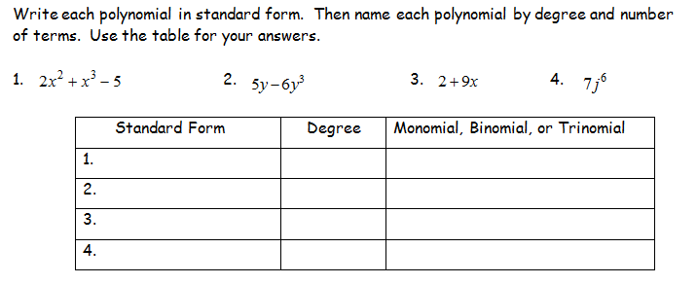

Simplify each expression. Combine like terms. Remember to write your answer in standard form.

5) $(4x^{2}−5x)−(2x^{2}−3x+3)$ 6) 9 + 11x² + 3x + 5x²

7) $(n^{4}+2n−1)+(5n−n^{4}−4)$ 8) $(6−3x^{2})+(x^{3}−x+5)$

9) (-7x – 5x³ + 5) – (-7x³ - 5 – 9x) 10) (5x² - 10x + 3) + (6x² + 4x + 3)

Simplify each expression.

11) -2n(n² - 3n + 4) 12) 5k²(3k² + 4k – 2)

Chapter 9 continued

13) Write an expression for the perimeter of the figure below.

3x

4x – 3

14) Factor the polynomial 6x³ + 3x² + 9x. (Divide out the G.C.F.)

Simplify. Use distributive property, FOIL, or the box method.

15) (4x + 3)(2x + 1) 16) (4h – 5)(5h – 6)

17) (3x – 7)(3x + 3) 18) (3x + 4)²

19) (3m² - 4)(3m² + 4) 20) (2n² + 4)(3n + 2)

Factor each expression. Use the X or X-box method. Check for G.C.F. first!

21) d² + 14d + 13 22) x² - 12x + 36

23) 2x² - 2x – 112 24) 12d² + 4d – 1

25) 3x² - 21x + 30 26) r² - 144

Chapter 10

1. Identify the vertex of each graph and tell whether it is a minimum or a maximum.
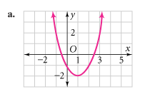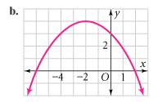

Graph each equation. Label the vertex and the axis of symmetry.

2) y = x² 3) y = -x² 4) y = ½ x²
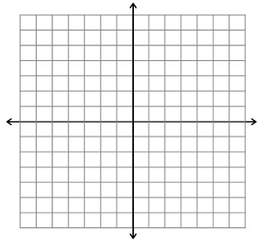
5) y = x² + 4 6) y = -2x² - 4x + 1
7) Find the equation of the axis of symmetry and the coordinates of the
vertex of the graph of the function y = 2x² + 8x – 1.

- A ball is thrown into the air with an upward velocity of 48 ft/s. Its height h in feet after t seconds is given by the function h = -16t² + 48t + 4.
  - In how many seconds does the ball reach its maximum height? Round to the nearest hundredth if necessary.
  - What is the ball’s maximum height?
Chapter 10 continued
9) Order the group of quadratic functions from widest to narrowest.

y = -4x² y = - ½ x² y = ¾ x²

Solve each quadratic equation using square roots.

10) k² = 16 11) 4x² + 6 = 10 12) x² + 15 = 9

Solve each quadratic equation using the Zero-Product Property.

13) (x – 5)(x + 3) = 0 14) (2x + 3)(4x – 5) = 0

Solve each quadratic equation by factoring. (Check for a G.C.F. first.)

15) z² + 6z – 27 = 0 16) 3x² + 3x – 6 = 0 17) c² - 3c = 0

Solve each quadratic equation using the quadratic formula.

18) -x² - 12x = 20 19) x² - 6x = 7 20) 2x² - 7x – 13= 0

