10-4 Solving Quadratic Equations
I can solve quadratic equations by graphing and using square roots
Vocab
VoV

Quadratic Equation______________________________________________________________

Standard Form of a Quadratic Equation______________________________________________________________

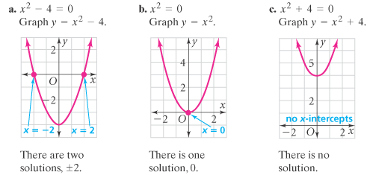

Solve by graphing the related function. If the equation has no solution, write no solution.  x² – 9 = 0 | 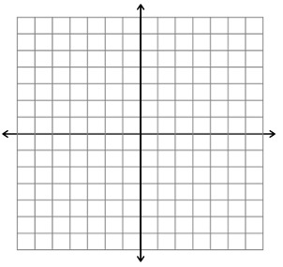
Solve by graphing the related function. If the equation has no solution, write no solution.
x² +5 = 0

Solve by graphing the related function. If the equation has no solution, write no solution.
4x² = 0

Solve by graphing the related function. If the equation has no solution, write no solution.

2x² -8 = 0

Solve by graphing the related function. If the equation has no solution, write no solution.

x² +16 = 0
Solve by finding square roots. If the equation has no solution, write no solution.  x² +16 = 0 | Solve by finding square roots. If the equation has no solution, write no solution.  x² = 80
Solve by finding square roots. If the equation has no solution, write no solution.  4x² + 9 = 41 | Solve by finding square roots. If the equation has no solution, write no solution.  4x² + 6 = 7

Solve by finding square roots. If the equation has no solution, write no solution.  3x² + 1 = 54 | Solve by finding square roots. If the equation has no solution, write no solution.  3x² - 75 = 0
Solve by finding square roots. If the equation has no solution, write no solution.  3x² - x² = 10 | Solve by finding square roots. If the equation has no solution, write no solution.  2x² - 10 = -4

- How many solutions does a quadratic equation have?

- How can you determine the number of solutions from the graph?

