10-2 Exploring Quadratic Graphs
I can graph quadratic functions in the form of y = ax² + bx + c
Vocab
VoV

Axis of Symmetry _______________________________________________________________________
Find the equation of the axis of symmetry and the coordinates of the vertex of the graph of each function.  y = x² – 10x + 2 | Find the equation of the axis of symmetry and the coordinates of the vertex of the graph of each function.  y = x² + 12x – 9
Find the equation of the axis of symmetry and the coordinates of the vertex of the graph of each function.  y = –x² + 2x + 1 | Find the equation of the axis of symmetry and the coordinates of the vertex of the graph of each function.  y = 3x² + 18x + 9
Graph each function. Label the axis of symmetry and the vertex.  y = x² – 6x + 4 | 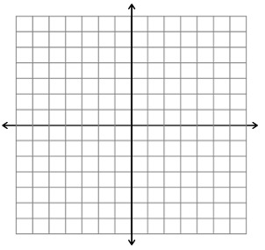
Graph each function. Label the axis of symmetry and the vertex.

y = x² + 4x – 1

Graph each function. Label the axis of symmetry and the vertex.

y = x² + 10x + 14

Graph each function. Label the axis of symmetry and the vertex.
y = x² + 2x + 1

Graph each function. Label the axis of symmetry and the vertex.
y = –3x² + 6

Graph each function. Label the axis of symmetry and the vertex.

y = –x² – 4x + 4

Graph each function. Label the axis of symmetry and the vertex.

y = –4x² + 24x + 13

Graph each function. Label the axis of symmetry and the vertex.

y = 4x² – 16x + 10

Graph each function. Label the axis of symmetry and the vertex.

y = –x² + 6x + 5

